Project Report

|  |  |
| --- | --- |
| **Product Name** | Applied Degree in Software Engineering (BDSE) |
| **Qualification Name** | Applied Degree in Software Engineering/ Higher Diploma in Software Engineering |
| **Assignment title** | Meals on Wheels Web Application |
| **Module Name (BDSE)** | Develop Enterprise Applications |

|  |  |  |  |
| --- | --- | --- | --- |
| **Student Name** | | **Assessor Name** | |
| **Wildan Luqmanul Hakim** | |  | |
| **Date issued** | **Completion date** | | **Submitted on** |
| January 13, 2023 | February 06, 2023 | | February 07, 2023 |

|  |  |
| --- | --- |
| **Project Title** | Meals on Wheels Web Application |

|  |
| --- |
| **Learner declaration** |
| I certify that the work submitted for this assignment is my group work, and research sources are fully acknowledged.      Student signature: Date: February 07, 2023 |

**1. Introduction** **5**

a. Project Background: 5

b. Pain Points 5

Business Analysis 5

SWOT Table Analysis of Meals on Wheels 9

c. Project Goal, Objectives, & Scope 10

Project Goal: 10

Project objective: 10

General Constraints: 10

Project Scope: 10

**2. Project Initiation** **12**

a. Project Stakeholders 12

b. Feasibility Study 13

Four elements of a feasibility analysis 14

Technical Feasibility 15

Operational Feasibility 17

Financial Feasibility 17

Legal Feasibility 19

c. UI/UX Design Considerations 19

d. Project Assumptions 20

e. Project Constraints 21

f. Project Milestones 22

g. Project Deliverables 22

h. Functional Description 23

i. Website Structure 23

j. Risk Analysis & Evaluation 24

Types of Risk Analysis 24

Analyze and evaluate: 26

Prepare Risk Matrix: 26

Risk Response Analysis: 27

**3. Project Requirements** **28**

**Software Development Life Cycle** **28**

SDLC models 28

Waterfall Model 28

Spiral Model 28

V-Model 28

Agile 28

SDLC Comparison 29

Waterfall 29

Spiral 29

V-Model 30

Agile 30

When to use 31

SDLC Chosen Method 31

**Front-End Framework:** **32**

AngularJs 32

ReactJS 33

VueJS 33

Comparison 34

Chosen Framework: 35

**Back-end Framework:** **35**

Spring boot 35

**Database:** **36**

MongodB 36

MySQL 37

**Integrated Development Environment:** **38**

IntelliJ 38

Eclipse 38

STS 38

**4. Project Team** **41**

Team Member’s Information: 41

Tools & Technology Used: 41

**5. Project Planning** **42**

Gantt Chart 42

Optimal Scheduling 42

Test Schedule 43

Budget Analysis 44

Communication Matrix 45

Test Planning 46

Scenario 1 46

Scenario 2 46

Scenario 3 47

Scenario 4 47

**6. Project Design** **48**

Application Flowchart: 48

**Use Case Diagram** **50**

**Module Wireframe** **51**

**Module Storyboard** **61**

**Login as a:** **61**

**DB Design:** **62**

**Project Prototype** **63**

**7. Project Stakeholder Presentation** **79**

Stakeholders Review Statements & Document 79

**8. Project Execution** **80**

**9. Module Testing** **81**

**Result Analysis** **85**

**Conclusion** **85**

**Application Future Recommendations** **86**

**Bibliography** **87**

# 

# Introduction

## Project Background:

Our team was tasked by a company named MerryMeal to submit proposals for software development. The proposal includes design suggestions, development plans, functional application, and developing the application based on the company business plan.

The company “MarryMeal” is a charitable organization that prepares and delivers a hot noon meal to qualified adults living at home who are unable to cook for themselves or maintain their nutritional status due to age, disease, or disability. The service will be available Monday through Friday. Frozen meals will be provided to members who are not within a 10-kilometer radius of their outsourced kitchens and support over the weekend. MerryMeal has partnered with several food service providers across the country to provide the quickest delivery possible.

## Pain Points

### **Business Analysis**

Based on the description above there are several problem statements that need to be addressed. There are several strategies available: SWOT Analysis, MOST Analysis, VMOST Analysis, & PESTLE Analysis.

**SWOT** stands for Strength, Weakness, Opportunity, & Threat. The purpose of this analysis method is to identify the strength and weakness of the organization's business plan, as well as, to find opportunities and threats (CTC, 2022). It helps in developing awareness of the situation so that the organization can make definitive strategic planning and decision making. In other words, SWOT analysis helps the company to explore new possibilities or solutions to problems, making the best decision for the company, determining where change is possible, and identifying threats (CTC, 2022). The purpose of SWOT itself is to reveal positive forces that work together and potential problems that need to be addressed. This can be done through listing internal and external factors.

Every SWOT analysis will include the following four categories. Though the elements and discoveries within these categories will vary from company to company. Kenton, Murray, & Courage (2022) said that SWOT analysis is not complete without each of these elements:

* **Strengths** describe what an organization excels at and what separates it from the competition.
* **Weaknesses** stop an organization from performing at its optimum level.
* **Opportunities** refer to favorable external factors that could give an organization a competitive advantage.
* **Threats** refer to factors that have the potential to harm an organization.

The second analysis method is **MOST** analysis, this method of analysis takes a top-down approach where the organization analyzes based on the four elements, namely mission, objectives, strategy, and tactics (Kholghi, 2022).

* **Mission** describes what the organization wants to achieve.
* **Objective** describes what are the goals that the organization is working towards?
* **Strategy** describes the long-term approach to achieving the objectives.
* **Tactics** describes the activities that need to be carried out to ensure the organization is able to achieve the strategy.

The MOST Analysis helps with the overview of the critical workings of the business and aids in identifying wastage, streamlining processes, and achieving goals. MOST analysis allows the organization to align its long-term goals with day to day tasks, and MOST analysis is designed to ensure internal processes of the business move in the same direction towards the organization or company mission (Cook, 2022; Kholghi, 2022).

Third analysis method is **VMOST** analysis. VMOST Analysis is a structured strategic planning tool used by organizations and teams to define, align, and measure progress toward their long-term goals (Cio, 2023). VMOST consists of five elements, which are:

* **Vision:** Describe the long-term goal or desired future state of the organization. It provides a clear picture of what the organization envision or wants to achieve, and it serves as a guideline for all decision-making and actions.
* **Mission:** Describe the purpose or reason for the organization’s existence which consists of core values and what it seeks to accomplish.
* **Objectives:** Describe the specific, achievable, and relevant goals to help the organization move towards its vision. The objectives should be aligned with the organization’s mission.
* **Strategies:** Describe the organization's broad plans or approaches to achieve its objectives.
* **Tactics:** Describe the specific actions or tasks that the organization will take to implement its strategies and should be aligned with the organization’s objectives.

Using the VMOST framework can help organizations clarify their goals, develop effective strategies and tactics, and ensure that all actions are aligned and working towards the same desired outcomes. It can also help organizations to monitor and measure progress toward their goals and make any necessary adjustments along the way (Cio, 2023)..

Based on The Chartered Institute of Personnel and Development (2021) A **PESTLE** analysis studies the key external factors (Political, Economic, Sociological, Technological, Legal and Environmental) that influence an organization. It can be used in a range of different scenarios, and can guide people, professionals and senior managers in strategic decision-making. PESTLE analysis is a broad fact-finding activity around the external factors that could affect an organization’s decisions, help to reduce threats and maximize opportunities, and consists of six elements which are:

* **Political:** Factors may be altered by the government’s influence on a country’s infrastructure. This may include tax policy, employment laws, environmental regulations, trade restrictions, tariffs, reform and political stability. Charities may need to consider where a government does not want services or goods to be provided.
* **Economic:** Factors include economic growth, interest rates, exchange rates, inflation, wage rates, working hours and cost of living. These factors may have major impacts on how charities operate and make decisions.
* **Sociological:** Factors include cultural aspects, health and safety consciousness, population growth rate and various demographics.
* **Technological:** Factors include ecological and environmental aspects and available products and services. Charities may need to innovate, having considered the compatibility with their own technologies and whether they are transferable internationally.
* **Legal:** Factors include any law which may impact on the charities’ operations, including NGO regulation and criminal and terrorist legislation which will differ from country to country
* **Environmental:** Factors include an awareness of climate change or seasonal or terrain variations which may affect charities’ service delivery methods.

By analyzing the six factors above, organizations can assess any risks specific to their industry and make informed decisions, and it can also highlight the potential for additional cost and prompt further research to be built into the future plans (CIPD, 2021).

For this project, our team uses SWOT analysis because SWOT analysis is suitable for the project since it is simple and straightforward, does not require technical expertise, or formal training, anybody with an understanding of the organization in a situation and the sector in which it operates can conduct it. Also by examining each of the four components of the SWOT, we may learn vital information to achieve our goals. SWOT analysis also encourages strategic planning, provides in-depth analysis of internal and external complex aspects, flexible, and versatile (Javatpoint, 2022).

### **SWOT Table Analysis of Meals on Wheels**

|  |  |
| --- | --- |
| **Strength** | **Weaknesses** |
| * Already have clear goals. * Have several collaborative partners. * Employee morale high | * Services unable to reach members that live more than 10 km away from the company. * Not open full week. * Since its charity, it heavily relies on sponsorships and donations. |
| **Opportunity** | **Threat** |
| * Rising health consciousness in selecting foods. * Helping in maintaining the psychological well-being of the qualified adults. * Open donation. | Driver safety.  Possible defect on food quality.  Possibility in which the food becomes bad or rotten which may cost negatively on the members. |

## Project Goal, Objectives, & Scope

### **Project Goal:**

The purpose of Meals on Wheels is to provide hot noon meals for qualified adults, those who are too old, have a disease, or disability, to maintain a healthy diet. Meals on Wheels itself is a charitable organization thus, has partnered with several food service providers and donations. The meals services are managed by a caregiver and the meals will be delivered by a rider from the company. The company also accepts those who want to volunteer as a rider or caregiver to help with the charity.

### **Project objective:**

Develop an enterprise application that prepares and delivers a hot noon meal to adults due to age, disease, or disability.

### **General Constraints:**

The general constraint for the Meals on Wheels project is time. There is roughly less than one month allocated to the development, testing, and documentation of this project. This may result in fewer risks, but the core functionality of the system will be unaffected.

### **Project Scope:**

**System Overview -** The application will have the following functionality:

1. Members and Caregivers registration with their requirements

2. Partners and Volunteers registration with their details

3. Fund raising through Donors / Supporters

4. Menu Planning and Preparation

5. Meal Delivery Management of partners and riders

6. Food Safety Management

7. Reassessment of need evaluation, and,

8. Management Information System for effective management

# Project Initiation

## Project Stakeholders

Stakeholders are individuals or groups who have a vested interest in the success or failure of a project. Stakeholders in a project can include the project manager, team members, customers, clients, shareholders, suppliers, and others who are directly or indirectly affected by the project. Stakeholders play an important role in defining project goals, making decisions, and providing resources to ensure the project's success. Effective stakeholder relationship management is critical to project success because stakeholders can influence project outcomes and ultimately determine the project's success or failure.

**Internal Stakeholders**

|  |  |  |  |
| --- | --- | --- | --- |
| **No** | **Role** | **Description** | **Name** |
| 1 | Project Manager | Implementing project management strategy to achieve the project objectives. | Arvinder Kaur |
| 2 | Senior Management | Planning and directing the work of team members. | Grace Sullivan |
| 3 | Manager | A leader who manages a specific team. | Mr. David |
| 4 | Resource Manager | Helping project managers with planning and allocating resources for a project. | Nathan Grande |
| 5 | Executive | Responsible for maintaining functional operation within their departments. | John Doe |
| 6 | Team Members | Employees who work as a team to handle all tasks assigned by manager. | Wildan, Norman, Bagus, & Steffan. |

**External Stakeholders**

|  |  |  |  |
| --- | --- | --- | --- |
| **No** | **Role** | **Description** | **Name** |
| 1 | Customer | One who uses the application. | Qualified Adult |
| 2 | Sponsors | Helping with the project resources. | WHO |
| 3 | Government regulators | Managing regulations based on the law or policy. | Singapore |

## Feasibility Study

A feasibility study—sometimes called a feasibility analysis or feasibility report—is a way to evaluate whether or not a project plan could be successful. A feasibility study evaluates the practicality of your project plan in order to judge whether or not you’re able to move forward with the project (Martins, 2022).

It does so by answering two questions:

* Does our team have the required tools or resources to complete this project?
* Will there be a high enough return on investment to make the project worth pursuing?

Feasibility studies are important for projects that represent significant investments for your business. Projects that also have a large potential impact on your presence in the market may also require a feasibility study.

A feasibility study should be conducted after the project has been pitched but before any work has actually started. The study is part of the project planning process. In fact, it’s often done in conjunction with a SWOT analysis or project risk assessment, depending on the specific project.

Feasibility studies help:

* Confirm market opportunities before committing to a project.
* Narrow your business alternatives.
* Create documentation about the benefits and detriments of your proposed initiative.
* Provide more information before making a go/no go decision.

You likely don’t need a feasibility study if:

* You already know the project is feasible.
* You’ve run a similar project in the past.
* Your competitors are succeeding with a similar initiative in market.
* The project is small, straightforward, and has minimal long-term business impact.
* Your team ran a similar feasibility study within the past three years.

Martina (2022) said one thing to keep in mind is that a feasibility study is not a project pitch. During a project pitch, you’re evaluating whether or not the project is a good idea for your company, and whether the goals of the project are in line with your overall strategic plan. Typically, once you’ve established that the project is a good idea, you’d then run a feasibility study to confirm the project is possible with the tools and resources you have at your disposal.

### **Four elements of a feasibility analysis**

There are four main elements that go into a feasibility study: technical feasibility, financial feasibility, market feasibility (or market fit), and operational feasibility. You may also see these referred to as the four types of feasibility studies, though most feasibility studies actually include a review of all four elements. (Martins, 2022)

**Technical feasibility** A technical feasibility study reviews the technical resources available for your project. This study determines if you have the right equipment, enough equipment, and the right technical knowledge to complete your project objectives. For example, if your project plan proposes creating 50,000 products per month, but you can only produce 30,000 products per month in your factories, this project isn’t technically feasible.

**Operational feasibility** an operational feasibility study evaluates whether or not your organization is able to complete this project. This includes staffing requirements, organizational structure, and any applicable legal requirements. At the end of the operational feasibility study, your team will have a sense of whether or not you have the resources, skills, and competencies to complete this work.

**Financial feasibility** financial feasibility describes whether or not your project is fiscally viable. A financial feasibility report includes a cost/benefit analysis of the project. It also forecasts an expected return on investment (ROI), as well as outlines any financial risks. The goal at the end of the financial feasibility study is to understand the economic benefits the project will drive.

**Legal feasibility** is the process of examining a proposed restructuring or set of steps from a legal standpoint for any potential problems and creating a plan to be carried out during the restructuring's implementation stage so that the proposed restructuring includes a consolidated and integrated tax and legal assessment.

### **Technical Feasibility**

1. Hardware Requirements

|  |  |  |  |
| --- | --- | --- | --- |
| **No** | **Hardware** | | |
| **Type** | **Server** | **Client** |
| 1 | Processor | Intel Xeon E5-2620 V4 2.1 Ghz | Intel Core i3 |
| 2 | Memory | 32 GB | 8 GB |
| 3 | Hard Drive | 4 TB | 1 TB |
| 4 | Network | Gigabit Network | Gigabit Network |
| 5 | Monitor | Monitor 24” | Monitor 24” |
| 6 | Keyboard | USB Keyboard | USB Keyboard |
| 7 | Mouse | USB Optical Mouse | USB Optical Mouse |

1. Software Requirements

|  |  |  |
| --- | --- | --- |
| **No** | **Software** | **Functionality** |
| 1 | Windows 10 | Operating System |
| 2 | Bootstrap, CSS, React JS | Web Creation |
| 3 | MySQL | Database Server |
| 4 | Tomcat | Web Server |
| 5 | Figma | Design |
| 6 | Google Chrome, Mozilla Firefox | Web Browser |

1. Network Requirements

|  |  |  |
| --- | --- | --- |
| **No** | **Network Device** | **Functionality** |
| 1 | Switch | Cable connecting network from workstation |
| 2 | UTP Cable | Connecting Medium |
| 3 | RJ 45 Connector | Cable connecting network with LAN Card |

1. Cloud Requirements

|  |  |  |
| --- | --- | --- |
| **No** | **Cloud Service** | **Functionality** |
| 1 | AWS |  |
| 2 | Azure |  |

1. Contractors

|  |  |  |
| --- | --- | --- |
| **No** | **Schedule** | **Contractor** |
| 1 | January 13, 2023 - February 06, 2023 | Unity One Solution |

1. Skills & Human Resource

|  |  |  |
| --- | --- | --- |
| **No** | **Requirements** | **Skills** |
| 1 | UI/UX Designer | Figma |
| 2 | Web Developer | HTML, CSS, JavaScript, Bootstrap, React JS, Java, MySQL. |

### **Operational Feasibility**

|  |  |  |
| --- | --- | --- |
| **No** | **Requirements** | **Descriptions** |
| 1 | Performance | Can serve 1.000 requests at the same time. |
| 2 | Information | More accurate information with an accuracy of 5 decimal places. |
| 3 | Economy | Costs incurred are relatively lower due to errors reporting can be minimized. |
| 4 | Control | System control is carried out by limiting user rights. |
| 5 | Efficiency | More time-saving because the same data entry can be avoided by using a database. |
| 6 | Services | The level of satisfaction with services can be increased because the system presents information in a consistent format. |
| 7 | Operational Feasibility Value | Locally based system (for organizations only), with Layout common as possible, so it has a value of 8.5. |

### **Financial Feasibility**

|  |  |  |  |  |  |  |
| --- | --- | --- | --- | --- | --- | --- |
| **No** | **Type Cost** | **Development Cost** | **Annual Cost** | **Time** | **Note** | **Total** |
| **1** | **System Aspect** | | | | | |
| System Information | $4.000 | $2.000 | 1 Month | Main System |  |
| **Project Manager** |  |  |  |  |  |
| Analyst System | $4.000 | $2.000 |  |  |  |
| Programmer | $8.000 | $2.000 |  |  |  |
| Documentation & Accommodation | $3.000 | $1.500 |  |  |  |
| **Sub Total** | $19.000 | $7.500 |  |  | $26.600 |
|  | | | | | | |
| **2** | **Infrastructure Aspect** | | | | | |
| Server Computer | $2.000 | $0 |  |  |  |
| Workstation Computer (3 Unit) | $3.000 | $0 |  |  |  |
| Installation Network & Tools | $1.000 | $500 |  |  |  |
| **Sub Total** | $6.000 | $500 |  |  | $6.500 |
|  | | | | | | |
| **3** | **Maintenance Aspect, ETC** | | | | | |
| System Usage Training | $0 | $300 |  |  |  |
| Consultation | $500 | $0 |  |  |  |
| Maintenance | $500 | $250 |  |  |  |
| Human Resource Supplier | $700 | $0 |  |  |  |
| **Sub Total** | $1.700 | $550 |  |  | $2.250 |
| Total | | | | | | $35.250 |

### 

### **Legal Feasibility**

Legal Feasibility Analysis:

Legal feasibility is feasibility related to legality or legal force. Means that the information system proposed may not violate applicable law, either law determined by the government or established by law according to organizational regulations.

Legal Eligibility Value:

Since all the software used is software open source or software that has been purchased legally, then the value of legal feasibility is 9.5.

## **UI/UX Design Considerations**

UI (User Interface) design is the process of designing the visual and interactive elements of a product, such as buttons, icons, and layout, to create an intuitive and user-friendly experience for the end-user. The focus of UI design is on how the product looks and feels and how it guides the user through their tasks (Usability, 2022).

UX (User Experience) design is the broader, more holistic process of designing the complete experience of using a product, taking into account all elements of the user's interaction with the product, including usability, accessibility, and overall enjoyment. The focus of UX design is on understanding the user's needs and creating an experience that is both functional and enjoyable for the user (Interaction Design Foundation, 2022).

In short, UI design is concerned with the visual appearance and interactions, while UX design is concerned with the overall experience of using a product. Both are important components of the product design process and are often used together to create a seamless and satisfying experience for the user.

|  |  |  |
| --- | --- | --- |
| **No** | **Considerations** | **Descriptions** |
| 1 | Visual | The visitors are mostly adults not children, the visual display will be simple aesthetic & not too many color patterns. |
| 2 | Text & Button | Since the audience of MOW are elderly, the button and text used will not be stylish, but simplistic with text mostly in bold. |
| 3 | Interactive Elements | The overall website application should be user-friendly for the elderly. |
| 4 | Layout | Layout is very necessary to help make it easier for the user |

### 

## **Project Assumptions**

A project assumption is an underlying belief or premise about a specific aspect of a project that is thought to be true, real, or certain, and that serves as the foundation for project planning and decision-making. Project assumptions are used to manage risk and uncertainty while also simplifying complex situations. They are typically documented in a project charter, business case, or project management plan and may include, among other things, assumptions about resources, timelines, budgets, technology, and stakeholders. However, it is critical to review and validate assumptions on a regular basis to ensure that the project stays on track and the assumptions remain valid (Espy, 2018).

|  |  |  |
| --- | --- | --- |
| **No** | **Categories** | **Descriptions** |
| 1 | Payment | The Meals on Wheels website is supported by Third Party for Payment Transactions. |
| 2 | License | Outsourced kitchens have FSSAI Approval Licenses. |
| 3 | Schedule | Duration of the development is starting from January 17, 2023 until February 06, 2023. |
| 4 | Resource | End users will be available to test during the time they agree to. |
| 5 | Finance | The funding to develop the project will be handled by the manager. |
| 6 | Scope | The project scope will not change once the stakeholders sign off on the scope statement. |
| 7 | Methodology | Project will use waterfall methodology throughout the development process. |
| 8 | Technology | The team will write the solution with SpringBoot & React Js. |

## **Project Constraints**

Project constraints are limitations or risks based on resources allocated for the project. It can be internal such as limited resources or skills, or external such as regulatory requirements or market conditions.

|  |  |  |
| --- | --- | --- |
| **No** | **Constraints** | **Descriptions** |
| 1 | Individual Requirements | The skills required for the development of the project are React Js, Spring Boot, & MySQL. |
| 2 | Time | The deadline for the project is roughly two weeks, which can impact the scope of the project & its overall cost. |
| 3 | Cost | Budget for this project is around $35.000, any changes on financial planning will impact the development process |
| 4 | Scope | The project scope is based on MerryMeal Charity organization, any changes during the process may result in development delays. |

## **Project Milestones**

Project milestones are significant events or accomplishments in a project that signal the completion of key phases or deliverables. Milestones serve as progress markers and aid in tracking the project's progress toward completion. They are typically defined as part of the project plan and reflect significant accomplishments such as completing a critical task, delivering a key deliverable, or reaching a major decision point.

Project milestones help to communicate progress to stakeholders such as project team members, managers, clients, and investors by providing a visual representation of the project schedule. They are also used to initiate key events like approvals, resource allocation, and budget releases.

**Meals-On-Wheels Project Milestone**

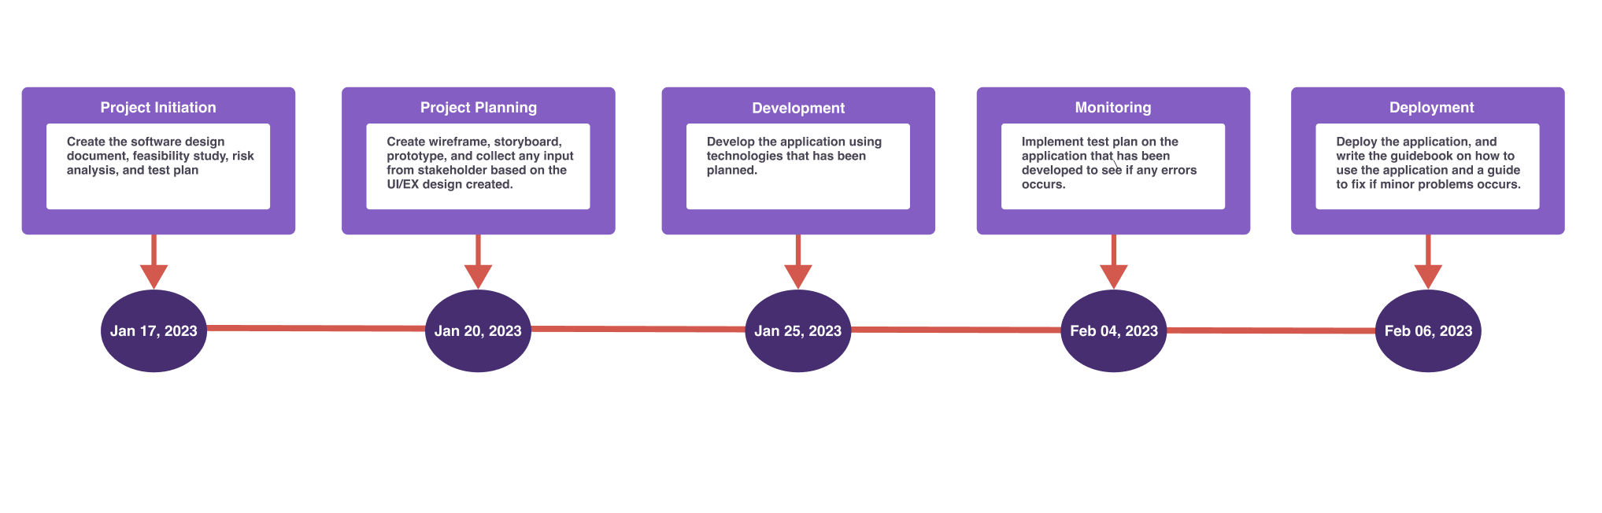

## **Project Deliverables**

* Create Project Proposal.
* Create Development plan for the MerryMeal Website Project.
* Design the wireframe, storyboard, and prototype.
* Design the database structures.
* Develop Meals On Wheels website.

## **Functional Description**

|  |  |  |  |
| --- | --- | --- | --- |
| **No** | **User Type** | **Description** | **Role Based Access** |
| 1 | Member | For qualified Adults. | Required to register & login. View daily meals & profile. Able to send feedback or evaluation about the meals. |
| 2 | Caregiver | Workers who cook meals and provide services. | Required to register & login. View daily meals & profile. Edit or add meals on the website. |
| 3 | Rider | Provide delivery services. | Required to register & login. View delivery schedule that has been assigned. Edit or view profile page. |
| 4 | Volunteer | People who want to help as a rider or caregiver. | Required to register & login. Based on the roles that they choose, either as a caregiver or rider, they are able to access its role. |
| 5 | Partner | For outside organizations that want to collaborate. | Required to register for partnership. If both companies agree to collaborate, the company brand will be mentioned on the website. |

## **Website Structure**

General structure for Meals on Wheels Website.

|  |  |
| --- | --- |
| **Pages** | **Descriptions** |
| Landing Page | Only appears once if the visitor haven’t registered or login yet |
| Register Page | Registration for member, rider, & caregiver candidates.  Added a new page for companies or organizations who want to become a partner. |
| Login Page | Login functionality, forgot/update password. |
| Member: Home page | Today’s meal & have a list of today’s meal packages. |
| Caregiver: Homepage | See order notification, add meal package card, & table for requesting meal to partner and assign driver. |
| Driver: Homepage | Have a profile card, card to view items that they need to deliver to the customer (member). |
| Donation page | Form for donations or support. |
| Feedback & Evaluation Page | An input form contains: feedback about the meals today, about our services, or a specific request from members. |
| Contact Us Page | Contain Meal on Wheels contact info like email, phone number, location, and user feedback form. |
| About Us Page | Contain Meal on Wheels organization info like vision, mission, teams, partners, and sponsor. |
| Admin Page | Menu Planning & Preparation for next day meal.  Food Safety management.  Manage the food delivery ( the admin/caregivers assign the delivery schedules to the riders and partners ). |

## **Risk Analysis & Evaluation**

A multi-step process called risk analysis is used to lessen the impact of hazards on corporate operations. Risk analysis is a tool used by executives from a variety of sectors to make sure that all facets of their companies are secure from potential dangers. Regular risk analysis reduces the business's susceptibility to unanticipated events (Francisco, 2022).

### **Types of Risk Analysis**

Francisco (2022) said that risk analysis covers a wide range of topics, there are many approaches to analyzing risks or types of risk analysis. These include, but are not limited to, the following:

* **Risk Benefit & Cost Benefit Analysis**

A risk benefit analysis involves weighing the pros and cons (benefits and risks) of an action. Elements are ranked and evaluated against the impact of their potential success or failure. Meanwhile, a cost benefit analysis sums the projected or estimated costs of an action and weighs the total cost against the potential benefits and opportunities.

Both types of analysis help leaders carefully weigh their decision in pursuing a plan or action. Choosing to pursue a risk-heavy or cost-heavy action can result in losses.

* **Needs Assessment**

A needs assessment is a systematic process of identifying and evaluating organizational needs and gaps. It gives leaders an idea of where the business may be lacking and helps them refocus resources towards achieving goals more efficiently.

* **Business Impact Analysis**

A business impact analysis entails planning for operational disruptions caused by natural disasters and other external factors. It is the basis for investment in recovery, prevention, and mitigation strategies.

* **Failure Mode and Effect Analysis**

A failure mode and effects analysis is a systematic method of anticipating potential failures in business processes and mitigating their impact on customers. It improves product and service reliability and reduces the cost of failures.

* **Root Cause Analysis**

A root cause analysis focuses on identifying and eliminating root causes to solve problems. It helps in the prevention of recurring problems by targeting the ineffective systems behind them. Aside from failure mode and effects analysis, other root cause analysis tools are 5 Whys, 8D, and DMAIC (part of Six Sigma).

As we know Risk analysis is a multi-step process aimed at mitigating the impact of risks on business operations. In this project, we need to design a software for the company named “Meals on Wheels” that provides food service and delivery for qualified adults. During the planning phase, our team needs to identify possible areas of risks in the application development process.

#### **Analyze and evaluate:**

|  |  |  |  |  |
| --- | --- | --- | --- | --- |
| **S.No.** | **Risk Type** | **Risk Description** | **Risk Likelihood** | **Risk Impact** |
| 1 | Schedule Risk | Deadline got extended due to unclear requirements | Very unlikely | Very high |
| 2 | Technical Risks | SQLI/Invalid data inserted into the database through registration form | Unlikely | Very High |
| 3 | Technical Risks | Webpage fail to load on certain browsers, user cannot view page | Unlikely | Very High |
| 4 | Technical Risks | During peak hours, pages take longer than 6 seconds to load | Likely | Medium |
| 5 | Usability Risk | User takes too long to learn or fails to complete desired task | Likely | High |

#### **Prepare Risk Matrix:**

|  |  |  |  |  |  |
| --- | --- | --- | --- | --- | --- |
| Risk ID | Risk | Likelihood (1-5) | Impact (1-5) | Risk Rating | Risk Level |
| 1 | Deadline got extended due to unclear requirements | 1 | 5 | 5 | Low |
| 2 | SQLI/Invalid data inserted into the database through registration form | 4 | 5 | 20 | High |
| 3 | Webpage fail to load, user cannot view page | 2 | 5 | 10 | Medium |
| 4 | During peak hours, pages take longer than 6 seconds to load | 3 | 4 | 12 | Medium |
| 5 | User takes too long to learn or fails to complete desired task | 3 | 5 | 15 | Medium |

#### **Risk Response Analysis:**

|  |  |  |  |
| --- | --- | --- | --- |
| S.No. | Risk Type | Risk Description | Risk Response Plan |
| 1 | Schedule Risk | Deadline got extended due to unclear requirements | Extend all next schedule |
| 2 | Technical Risks | SQLI/Invalid data inserted into the database through registration form | Use prepared statement for database queries |
| 3 | Technical Risks | Webpage fail to load on certain browsers, user cannot view page | Perform compatibility testing with multiple major browsers |
| 4 | Technical Risks | During peak hours, pages take longer than 6 seconds to load | Perform load testing with expected peak hour traffic |
| 5 | Usability Risk | User takes too long to learn or fails to complete desired task | Perform usability testing to improve UI/UX |

# Project Requirements

## **Software Development Life Cycle**

Software development life cycle or SDLC for short is a methodology for designing, building, and maintaining information and industrial systems. So far, there exist many SDLC models, such as the Waterfall model, which comprises five phases to be completed sequentially in order to develop a software solution; another model called the Spiral model, which is visualized as a process passing through some number of iterations.

### **SDLC models**

#### **Waterfall Model**

In the waterfall model, the whole process of Software Development is divided into phases where the output of one phase acts as the input to the next phase. The next phase begins only when the previous phase gets completed

#### **Spiral Model**

This model is a combination of a Waterfall and Spiral model, and it works in an iterative manner. Based on the risk involved in the project, this model guides the team to adopt elements of one or more SDLC models such as a waterfall or Iterative model. Here the lifecycle of Software is divided into smaller parts, and new functionality can be added to the software even at the late stages of SDLC.

#### **V-Model**

V model is basically an expansion to the waterfall model where the testing and the development phases are planned in parallel. One side consists of the verification phase, while the other one consists of the validation phase, which is finally joined by coding. The next state starts only when the previous state gets completed.

#### **Agile**

Agile methodology is a practice which promotes continued interaction of development and testing during the SDLC process of any project. In the Agile method, the entire project is divided into small incremental builds. All of these builds are provided in iterations, and each iteration lasts from one to three weeks.

### **SDLC Comparison**

#### **Waterfall**

|  |  |
| --- | --- |
| Strengths | Weaknesses |
| Simple to use and understand. | The software is ready only after the last stage is over. |
| Management simplicity thanks to its rigidity: every phase has a defined result and process review. | High risks and uncertainty. |
| Development stages go one by one | Not the best choice for complex and object-oriented projects. |
| Perfect for the small or mid-sized projects where requirements are clear and not equivocal. | Inappropriate for the long-term projects |
| Easy to determine the key points in the development cycle. | The progress of the stage is hard to measure while it is still in the development |
| Easy to classify and prioritize tasks. | Integration is done at the very end, which does not give the option of identifying the problem in advance. |

#### **Spiral**

|  |  |
| --- | --- |
| Strengths | Weaknesses |
| Lifecycle is divided into small parts, and if the risk concentration is higher, the phase can be finished earlier to address the threats. | Can be quite expensive |
| The development process is precisely documented yet scalable to the changes. | The risk control demands involvement of the highly skilled professionals. |
| The scalability allows to make changes and add new functionality even at the relatively late stages. | Can be ineffective for small projects. |
| The earlier working prototype is done, sooner users can point out the flaws. | Big number of the intermediate stages requires excessive documentation. |

#### 

#### **V-Model**

|  |  |
| --- | --- |
| Strengths | Weaknesses |
| Every stage of V-shaped model has strict results so it’s easy to control. | Lack of flexibility. |
| Testing and verification take place in the early stages. | Bad choice for the small projects. |
| Good for small projects, where requirements are static and clear. | Relatively big risks. |

#### **Agile**

|  |  |
| --- | --- |
| Strengths | Weaknesses |
| Corrections of functional requirements are implemented into the development process to provide competitiveness. | Difficulties with measuring the final cost because of permanent changes. |
| Project is divided by short and transparent iterations. | The team should be highly professional and client oriented. |
| Risks are minimized thanks to the flexible change process. | New requirements may conflict with the existing architecture. |
| Fast release of the first product version. | With all the corrections and changes there is a possibility that the project will exceed expected time. |

#### 

#### 

#### **When to use**

Waterfall Model:

* The requirements are precisely documented.
* Product definition is stable
* The technologies stack is predefined, which makes it not dynamic.
* No ambiguous requirements
* The project is short

Spiral Model:

* The client isn’t sure about the requirements.
* Significant edits are expected during the software development life cycle.
* Risk management is highly essential for the project.

V-Model:

* For the projects where accurate product testing is required.
* For the small and mid-sized projects, where requirements are strictly predefined.
* The engineers of the required qualification, especially testers, are within easy reach.

Agile Model:

* The users needs change dynamically
* Less price for the changes implemented because of the numerous iterations.
* It requires only initial planning to start the project.

### **SDLC Chosen Method**

**Waterfall Model**

Because in the waterfall model, the whole process is divided into phases where the output of one phase acts as the input to the next phase. It makes waterfall simple to use and we can easily classify and prioritize tasks and easily determine the key points in the development cycle.

Management simplicity thanks to its rigidity: every phase has a defined result and process review, development stages go one by one, and this model is perfect for the small or mid-sized projects where requirements are clear and not equivocal, also refer to table above waterfall is worth to use.

## Front-End Framework:

### **AngularJs**

AngularJS is not a single piece in the overall puzzle of building the client-side of a web application. It handles all of the DOM and AJAX glue code you once wrote by hand and puts it in a well-defined structure. This makes AngularJS opinionated about how a CRUD (Create, Read, Update, Delete) application should be built. But while it is opinionated, it also tries to make sure that its opinion is just a starting point you can easily change. AngularJS comes with the following out-of-the-box:

* Everything you need to build a CRUD app in a cohesive set: Data-binding, basic templating directives, form validation, routing, deep-linking, reusable components and dependency injection.
* Testability story: Unit-testing, end-to-end testing, mocks and test harnesses.
* Seed application with directory layout and test scripts as a starting point.

### 

### **ReactJS**

React is a life-changing frontend framework that comes to the rescue of many UI developers. Using React for front-end development, you get access to the community of more than 56,000 developers, and at least 8,787 industry leaders use the popular JavaScript library.

React works with a virtual DOM. It doesn’t need to refresh all the components on a page whenever the user interacts with it. This gives React the edge for dynamic websites which suffer a drop in performance with the conventional DOM refresh.

There’s also no coding nightmare with React frontend framework. It’s built with reusability in mind, and developers can build new features without rewriting existing codes. UI components built with React are also easy to debug.

With all these benefits, It didn’t take long for React to cement itself as the preferred UI development tool amongst JavaScript developments. The highly-popular framework was downloaded 7 million times weekly.

React Features:

* SEO Friendly, the clean and simple code of React minimizes page load time and page load time is a critical factor in SEO.
* React JS apps are created as a series of components, with functionalities being passed from parent component to child component in the form of arguments. This is called one-way data binding or the unidirectional flow of data. Because of this one characteristic, it is very convenient to make changes in React apps.
* Since React JS is essentially a library, you can just plug the React code wherever you need it, irrespective of infrastructure. This will have absolutely no effect on performance.

### **VueJS**

VueJS is a framework and ecosystem that covers most of the common feature needed in frontend development. But the weeb is extremely diverse - the things we build on the web may vary drastically in form and scale. With that in mind, Vue is designed to be flexible and incrementally adoptable. Depending on your use case, Vue can be used in different way:

* Enhancing static HTML without a build step
* Embedding as Web Components on any page
* Single-Page Application (SPA)
* Fullstack / Server-Side Rendering (SSR)
* Jamstack / Static Site Generation (SSG)
* Targeting desktop, mobile, WebGL, and even the terminal

### **Comparison**

|  |  |  |  |
| --- | --- | --- | --- |
| **Parameter** | **Angular** | **React** | **Vue** |
| Initial Release | 2016 | 2011 | 2014 |
| Support | Google | Facebook | Community |
| Type | Framework | Library | Framework |
| Size | Medium | Small | Very small |
| Language | TypeScript | JavaScript | JavaScript |
| Performance | Good | Good | Good |
| Data Binding | Both | Unidirectional | Bidirectional |
| Popular Websites | Paypal, Samsung, Upwork | Netflix, Twitter, Amazon | Alibaba, Grammarly, GitLab |

### 

### **Chosen Framework:**

**ReactJS**

* React offers an easy debugging process. The code is reusable.
* It’s easy to learn because of its easy and simple design.
* It has faster updates with both server-side and front-end support.
* React has great performance.
* Broad community support from github and stackoverflow

## **Back-end Framework:**

### **Spring boot**

Java Spring Framework (Spring Framework) is a well-liked, open-source, enterprise-level framework for building standalone, high-quality Java Virtual Machine applications (JVM). It is built on top of the conventional spring framework. So, it provides all the features of spring and is yet easier to use than spring.

Through its three main features, Java Spring Boot (Spring Boot) is a tool that accelerates and simplifies the development of web applications and microservices with the Spring Framework.

**Autoconfiguration**

Applications are initialized with pre-set dependencies through autoconfiguration, so you don't have to manually configure them.

**An opinionated approach to configuration**

Based on the requirements of our project, Spring Boot takes an opinionated approach to adding and configuring starter dependencies. Instead of requiring you to make all those decisions and configure everything manually, Spring Boot decides which packages to install and which default values to use.

**The ability to create standalone applications**

Spring Boot enables programmers to build ready-to-use applications. By integrating a web server like Tomcat or Netty into your app during the initialization process, it specifically enables you to create standalone applications that run independently, without relying on an external web server. As a result, by simply selecting the Run command, you can run your application on any platform. To create applications without an embedded Web server, you can disable this feature.

## **Database:**

### **MongodB**

MongoDB is built on a scale-out architecture that has become popular with developers of all kinds for developing scalable applications with evolving data schemas.

As a document database, MongoDB makes it easy for developers to store structured or unstructured data. It uses a JSON-like format to store documents. This format directly maps to native objects in most modern programming languages, making it a natural choice for developers, as they don’t need to think about normalizing data. MongoDB can also handle high volume and can scale both vertically and horizontally to accommodate large data loads.

MongoDB was built for people building internet and business applications who need to evolve quickly and scale elegantly. Companies and development teams of all sizes use MongoDB for a wide variety of reasons.

### **MySQL**

The most widely used open-source database worldwide is MySQL. MySQL is the second-most popular database, after Oracle Database, according to DB-Engines. Numerous of the most popular apps, such as Facebook, Twitter, Netflix, Uber, Airbnb, Shopify, and Booking.com, are powered by MySQL.

Because MySQL is open source, it has many features that have been created over more than 25 years in close collaboration with users. Therefore, it is very likely that MySQL Database supports your preferred application or programming language.

**MySQL advantages**

MySQL is quick, trustworthy, scalable, and simple to use. It was initially created to quickly handle large databases and has long been used in extremely demanding production environments. Despite being constantly improved, MySQL offers a comprehensive and suited for due to its connectivity, speed, and security.

### practical set of functions. Accessing databases on the internet is a task that MySQL is well

**Comparison**

Chosen database:

**MySQL**

* Open-source and compatible, it is highly compatible with a wide range of systems, programming languages and database models.
* Fast and reliable.
* Easy to use and administer.
* Large online support and documentation with [dev.mysql.com](https://dev.mysql.com/)

## **Integrated Development Environment:**

### **IntelliJ**

IntelliJ IDEA is undoubtedly the top-choice IDE for software developers. Efficiency and intelligence are built into the design, which enables a very smooth development workflow experience, from design, implementation, building, deploying, testing, and debugging, to refactoring! It is loaded with features and also offers a plethora of plugins that we can integrate into the editor. I switched to using IntelliJ IDEA 5 years ago and have never looked back. It has certainly made my life easier. I am producing more with less effort (Mary Grygleski).

### **Eclipse**

Released by IBM in 2001, the open-source IDE Eclipse was initially created to eclipse Microsoft’s Visual Studio. Since then, Eclipse has become a major platform used in both open source and commercial projects. Highly versatile and flexible, Eclipse was designed to serve the needs of complex enterprise projects and embedded system application development. It offers support for a variety of programming languages in addition to Java, as well as popular frameworks. With a plethora of plugins, thorough documentation and a large developer community, Eclipse has rightfully gained a loyal following.

### **STS**

STS is an Eclipse-based development environment that is customized for the development of Spring applications. It provides a ready-to-use environment to implement, debug, run and deploy your applications. It also includes integration for Pivotal tc Server, Pivotal Cloud Foundry, Git, Maven and AspectJ. STS is built as an addition on top of the latest Eclipse releases.

**Features Overview:**

Eclipse STS validates your project and provides quick fixes for your applications. For example, when working with Spring Data JPA, the IDE may be used to validate query method names

STS also provides a graphical view on all bean methods and their mutual relationships. You may want to have a closer look at the graphical editors that come with STS by looking into the views that are available under the menus window, show view and then Spring respectively. STS also offers other additional useful features that are not limited to Spring applications only.

**Chosen IDE:**

**STS**

The Spring Tool Suite understands your Spring projects. It parses your configuration files and displays detailed information about the beans that are being defined, their dependencies among each other, used namespaces, and extracts overviews for certain stereotypes like request controllers, aspects, services, and more.

Because the Spring Tool Suite understands your Spring projects, it provides a comprehensive set of validations that are being applied automatically. Those validations indicate errors in your configurations directly within the IDE, long before you actually run the app. Finding problems and misconfigurations gets a lot easier.

Refactoring support is one of the most important parts of today's software engineering. Therefore the Spring Tool Suite provides advanced support for refactoring Spring applications. Not only the well-known Java refactorings are reflected in your Spring config files, the IDE adds new refactorings for Spring elements (like renaming of Spring beans, for example).

It doesn't matter whether you are writing Spring XML configuration files or implement JavaConfig Spring apps, whether you are using the core Spring framework alone or together with all the various additional Spring projects, the Spring Tool Suite provides you with meaningful content-assist all over the place, together with quick-fixes for common errors and problems.

**Code Editor:**

**Visual Studio Code**

Visual Studio Code is a lightweight but powerful source code editor which runs on your desktop and is available for Windows, macOS and Linux. It comes with built-in support for JavaScript, TypeScript and Node.js and has a rich ecosystem of extensions for other languages and runtimes (such as C++, C#, Java, Python, PHP, Go, .NET). We will be using Visual Studio Code for editing our React JS source code.

# Project Team

## **Team Member’s Information:**

**Stakeholder :** Merry Meal, Unity One Solution

**Manager :** Mr. David

**Project Lead :** Arvinder Kaur

**Project Member:**

* [Wildan Luqmanul Hakim](mailto:WildanLuqmanul@gmail.com)
* [Bagus Nanda](mailto:gusnanda0703@gmail.com)
* [Steffansim](mailto:steffansim@gmail.com)
* [Norman Tseu](mailto:normantmhwork@gmail.com)

|  |  |
| --- | --- |
| **Member’s Name** | **Module Assigned** |
| I Putu Bagus Nanda Widnyana | Back-end Modules |
| Norman Tseu Min Hong | Back-end Modules |
| Steffansim | Front-end Modules |
| WIldan Luqmanul Hakim | Front-end Modules |

## **Tools & Technology Used:**

**Front-end:** React Js, Bootstrap.

**Back-end:** SpringBoot, ServerJs

**Database:** MySQL

# Project Planning

## **Gantt Chart**

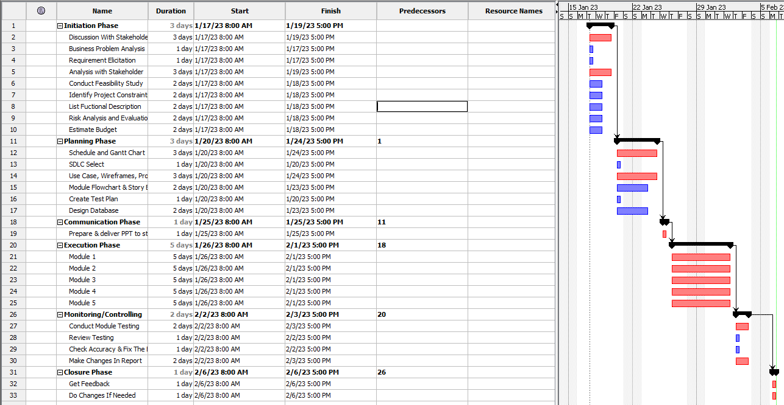

## **Optimal Scheduling**

|  |  |  |  |
| --- | --- | --- | --- |
| **Web page** | **Weighting**  (1-5) | **Functional Points** (1-10) | **Total** |
| Landing | 1 | 5 | 5 |
| About Us | 1 | 1 | 1 |
| Contact Us | 1 | 2 | 2 |
| Register | 2 | 6 | 12 |
| Partner Request | 2 | 6 | 12 |
| Login | 3 | 10 | 20 |
| Donation | 2 | 5 | 10 |
| Member Home | 4 | 10 | 40 |
| Member: Meal Detail | 3 | 8 | 24 |
| Member: Feedback | 4 | 5 | 20 |
| Caregiver Home | 4 | 10 | 40 |
| Driver Home | 4 | 10 | 40 |
| Partner Home | 4 | 10 | 40 |
| Admin Home | 5 | 10 | 50 |
| Admin: Manage Users | 3 | 7 | 21 |
| Admin: Manage Partner | 3 | 7 | 21 |
| Admin: Meal Order History | 3 | 4 | 12 |
|  | Total functional points  Estimated person hour per FP  Total hours needed  Total days needed | | 364 |
|  | 1 |
|  | 364 |
|  | **21.4** |

## **Test Schedule**

|  |  |  |
| --- | --- | --- |
| **Test Schedule ID:** | **TS0001** |  |
| Product ID / Name: | Meals On Wheels |  |
| Product Version or Build: | v0.0.1 |  |
| Present Owner: | Group 02 | Software Engineers |
| Created On: | January 25, 2023 |  |
| Review On: | January 25, 2023 |  |
| Review By: | Mr. David | Manager |
| Review Comments: | Good |  |
| Current Version: | v.1.0.2 |  |
| Change Details: | Added features: partner able to send meal complete notification to caregiver & admin. |  |
| Current Status: | Approved |  |
| Signing Off Authority: | Group 02 | Software Engineers |

## **Budget Analysis**

|  |  |  |  |  |  |  |
| --- | --- | --- | --- | --- | --- | --- |
| **No** | **Type Cost** | **Development Cost** | **Annual Cost** | **Time** | **Note** | **Total** |
| **1** | **System Aspect** | | | | | |
| System Information | $4.000 | $2.000 | 1 Month | Main System |  |
| **Project Manager** |  |  |  |  |  |
| Analyst System | $4.000 | $2.000 |  |  |  |
| Programmer | $8.000 | $2.000 |  |  |  |
| Documentation & Accommodation | $3.000 | $1.500 |  |  |  |
| **Sub Total** | $19.000 | $7.500 |  |  | $26.600 |
|  | | | | | | |
| **2** | **Infrastructure Aspect** | | | | | |
| Server Computer | $2.000 | $0 |  |  |  |
| Workstation Computer (3 Unit) | $3.000 | $0 |  |  |  |
| Installation Network & Tools | $1.000 | $500 |  |  |  |
| **Sub Total** | $6.000 | $500 |  |  | $6.500 |
|  | | | | | | |
| **3** | **Maintenance Aspect, ETC** | | | | | |
| System Usage Training | $0 | $300 |  |  |  |
| Consultation | $500 | $0 |  |  |  |
| Maintenance | $500 | $250 |  |  |  |
| Human Resource Supplier | $700 | $0 |  |  |  |
| **Sub Total** | $1.700 | $550 |  |  | $2.250 |
| Total | | | | | | $35.250 |

## **Communication Matrix**

|  |  |  |  |  |
| --- | --- | --- | --- | --- |
| **Speaker** | **Audience** | **Purpose** | **Method** | **Frequency** |
| Team Member | Mr David | Development progress | MS. Teams Meeting | Twice a week |
| Mr David | MerryMeal Org | Explain the current development process on initial project objective to keep track if the project still on what the stakeholder wants or not | MS. Teams Meeting & Face to Face Meeting | Once a week |

## **Test Planning**

**Test Scenarios:**

|  |  |  |
| --- | --- | --- |
| **Test Scenario ID** | **Test Scenario** | **Number of test cases** |
| TS001-Integration Testing | Ensure account authorization with JWT Token | 1 |
| TS002-UAT testing | 1. Ensure user navigation is easy | 3 |
| TS003-UAT testing | 1. Ensure caregiver can add meals easily | 1 |
| TS004-UAT testing | Ensure SQLI is prevented | 3 |
| TS005-Cross Browser testing | Ensure application works across multiple major browsers | 6 |

**Scenario 1: Integration Testing**

|  |  |
| --- | --- |
| **Test Scenario** | Ensure account authorization with JWT Token |
| **TS001** |
| **Test Cases** | Integration Testing |
| **IT001** | Check if the user can access the website if there is no bearer token. |

#### 

|  |  |  |  |  |  |  |
| --- | --- | --- | --- | --- | --- | --- |
| Test Scenario ID | Test Case | Risk | Preconditions | Expected Result | Actual Result | Final Result |
| TS001 | IT001 | 5 | * Open Postman API * Register to get Bearer token | The user without their bearer token authorization will not be able to access the website. |  |  |

**Scenario 2: User Acceptance Testing**

|  |  |
| --- | --- |
| **Test Scenario** | 1. Ensure user navigation is easy |
| **TS002** |
| **Test Cases** | UAT Test |
| **UAT001** | Check to see if member can navigate easily |
| **UAT002** | Check to see if caregiver can navigate easily |
| **UAT003** | Check to see if rider can navigate easily |

#### 

|  |  |  |  |  |  |  |
| --- | --- | --- | --- | --- | --- | --- |
| Test Scenario ID | Test Case | Risk | Preconditions | Expected Result | Actual Result | Final Result |
| TS002 | UAT001 | 3 | * Logged in as Member / Caregiver / Rider | Members can easily see meal card packages after they log in, and order meals if they choose based on the card, & they can send feedback on the meal. |  |  |
| UAT002 | 3 | Caregivers can see their dashboard, and add meals easily on the dashboard page also, and assign drivers & assign partners also. |  |  |
| UAT003 | 3 | Drivers can see any delivery request on their dashboard. |  |  |

**Scenario 3: User Acceptance Testing**

|  |  |
| --- | --- |
| **Test Scenario** | Ensure caregiver can add meals easily |
| **TS003** |
| **Test Cases** | UAT Test |
| **UAT001** | Check to see if the caregiver is able to add a meal package easily. |

#### 

|  |  |  |  |  |  |  |
| --- | --- | --- | --- | --- | --- | --- |
| Test Scenario ID | Test Case | Risk | Preconditions | Expected Result | Actual Result | Final Result |
| TS003 | UAT001 | 3 | Logged in as Caregiver | Caregivers can easily add a meal package by accessing a Popup card to add that package. |  |  |

**Scenario 4: User Acceptance Testing**

|  |  |
| --- | --- |
| **Test Scenario** | Ensure Login Validation |
| **TS004** |
| **Test Cases** | UAT Test |
| **UAT001** | Check to see if the login validation able to function properly |

#### 

|  |  |  |  |  |  |  |
| --- | --- | --- | --- | --- | --- | --- |
| Test Scenario ID | Test Case | Risk | Preconditions | Expected Result | Actual Result | Final Result |
| TS004 | UAT001 | 5 | Type in URL  Click on login  Enter fields with test data  Click submit | Login fail if the account is not activated yet & popup message will appear |  |  |
| UAT002 | 5 | Login fail if the input password or email is wrong & popup message will appear |  |  |
| UAT003 | 5 | Suggestion message appear if the user missing @ on email input |  |  |

**Scenario 5: Cross Browser Testing**

|  |  |
| --- | --- |
| **Test Scenario** | Ensure application works across multiple major browsers |
| **TS005** |
| **Test Cases** | Cross Browser Test |
| **CBT001** | Check to see if register works on Firefox |
| **CBT002** | Check to see if register works on Internet Explorer |
| **CBT003** | Check to see if register works on Google Chrome |
| **CBT004** | Check to see if login works on Firefox |
| **CBT005** | Check to see if login works on Internet Explorer |
| **CBT006** | Check to see if login works on Google Chrome |

#### 

|  |  |  |  |  |  |  |
| --- | --- | --- | --- | --- | --- | --- |
| Test Scenario ID | Test Case | Risk | Preconditions | Expected Result | Actual Result | Final Result |
| TS005 | CBT001 | 3 | Downloaded required browser | Register save data to database and redirect user to login page |  |  |
| CBT002 | 3 | Register save data to database and redirect user to login page |  |  |
| CBT003 | 3 | Register save data to database and redirect user to login page |  |  |
| CBT004 | 3 | Downloaded required browser | Login validate with database and redirect user to home page |  |  |
| CBT005 | 3 | Login validate with database and redirect user to home page |  |  |
| CBT006 | 3 | Login validate with database and redirect user to home page |  |  |

# 

# Project Design

## **Application Flowchart:**

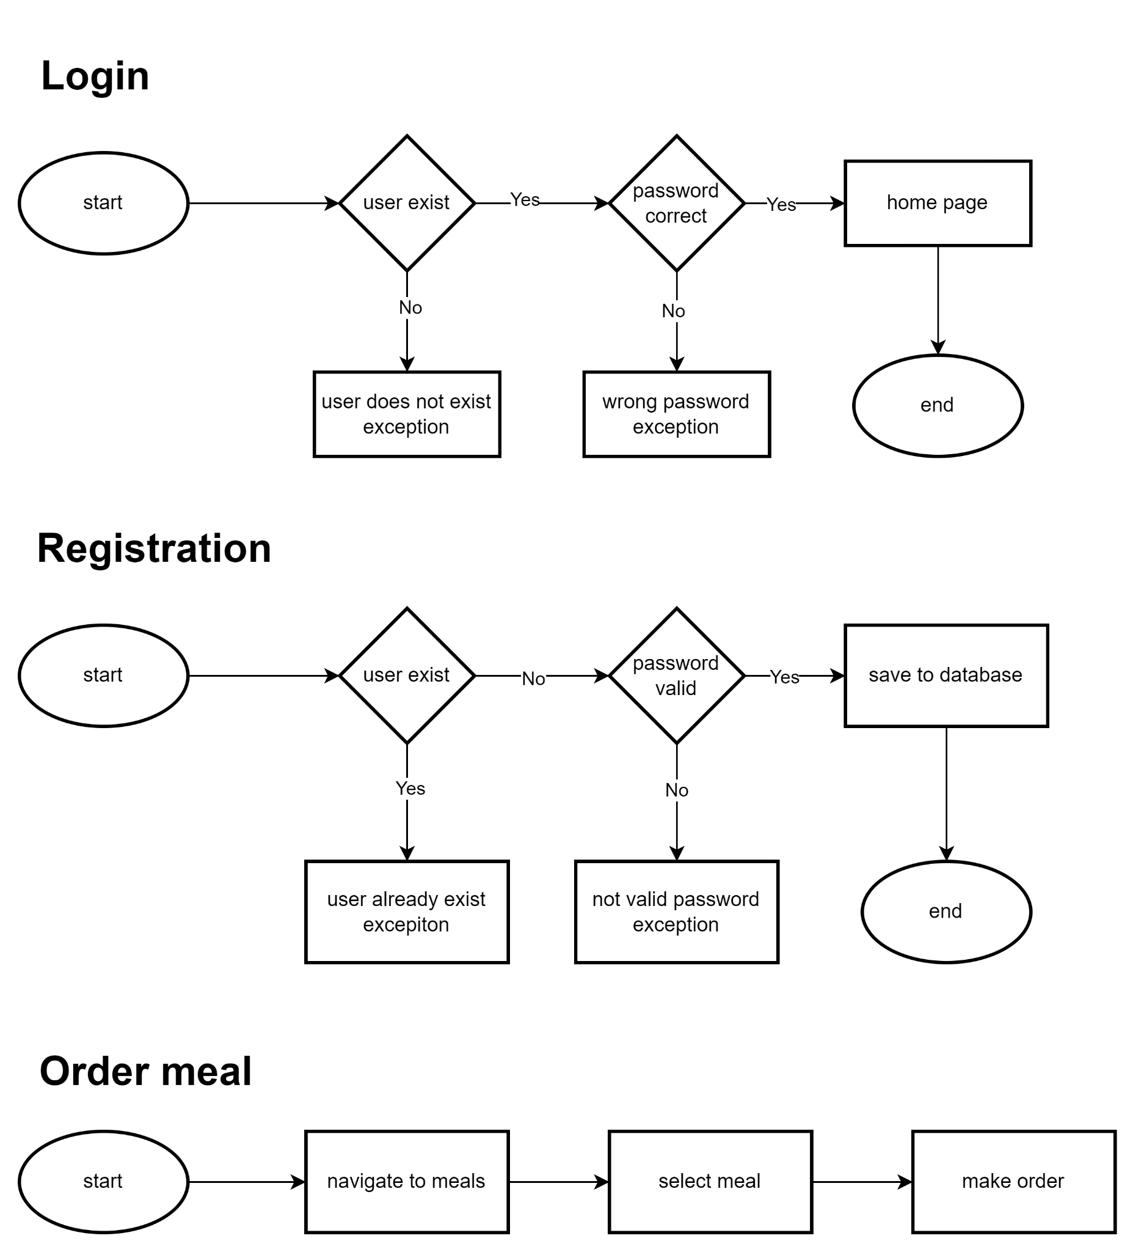

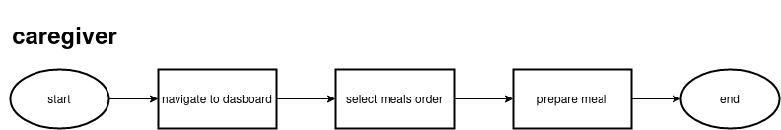

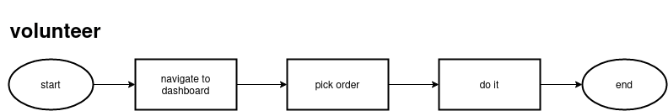

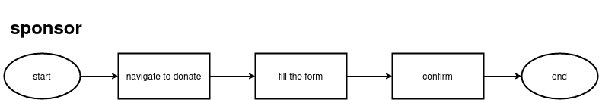

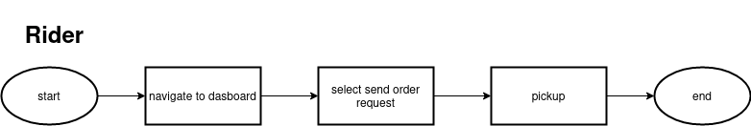

## **Use Case Diagram**

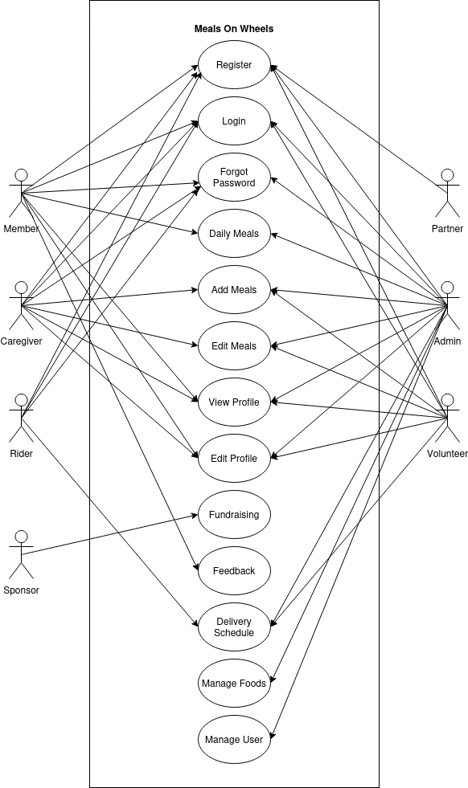

## **Module Wireframe**

Landing Page

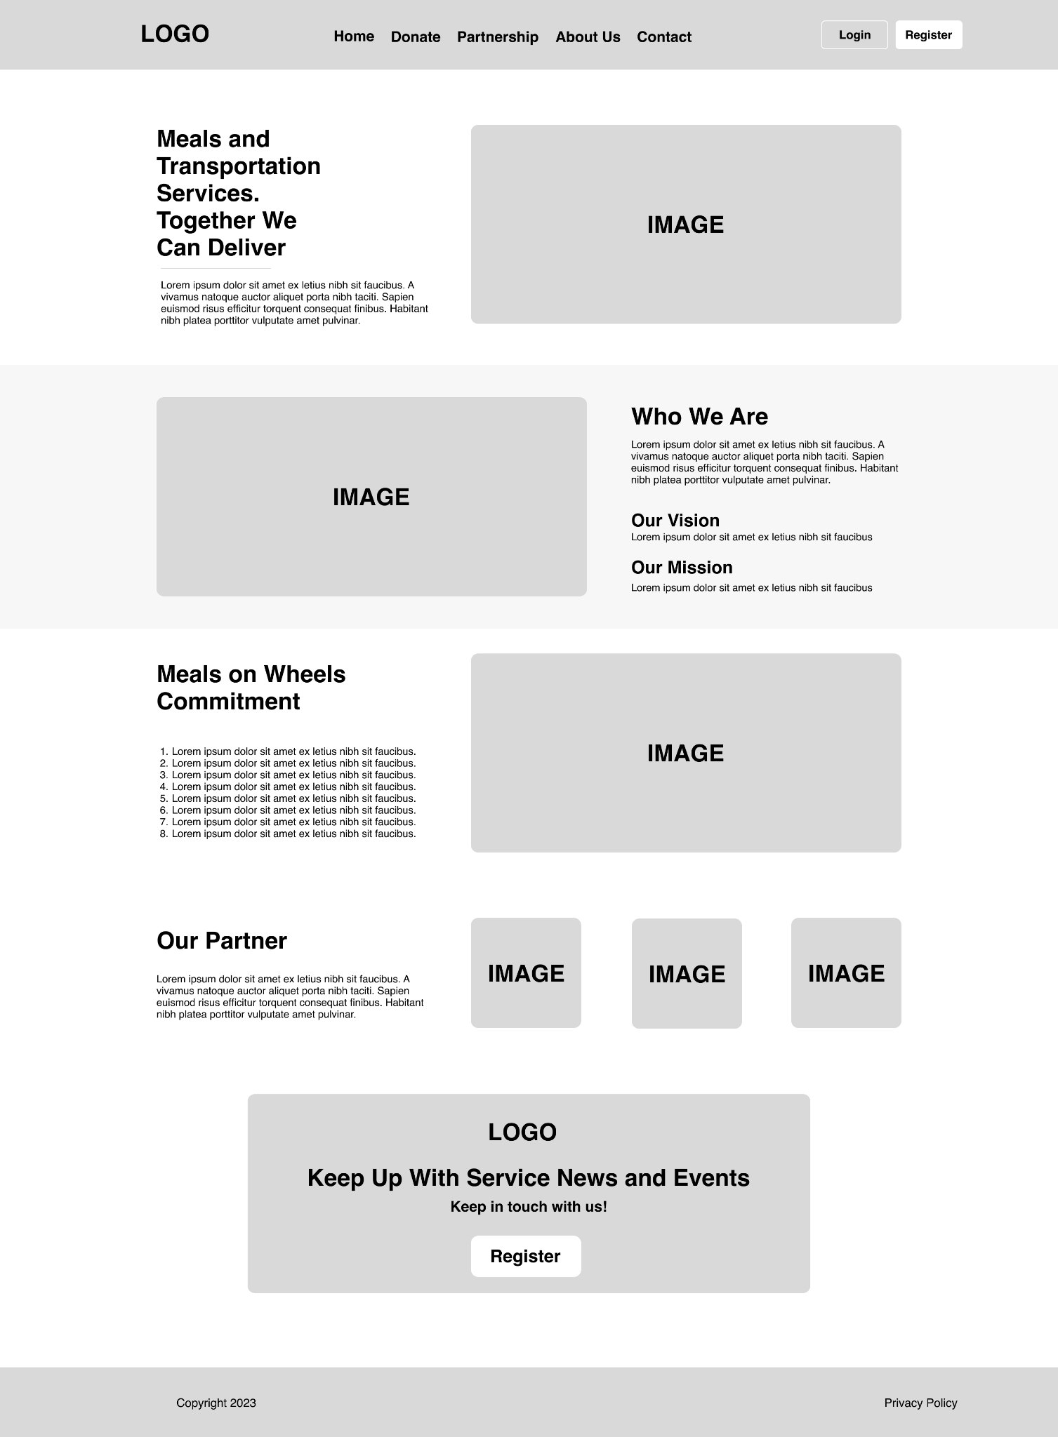

Register Page

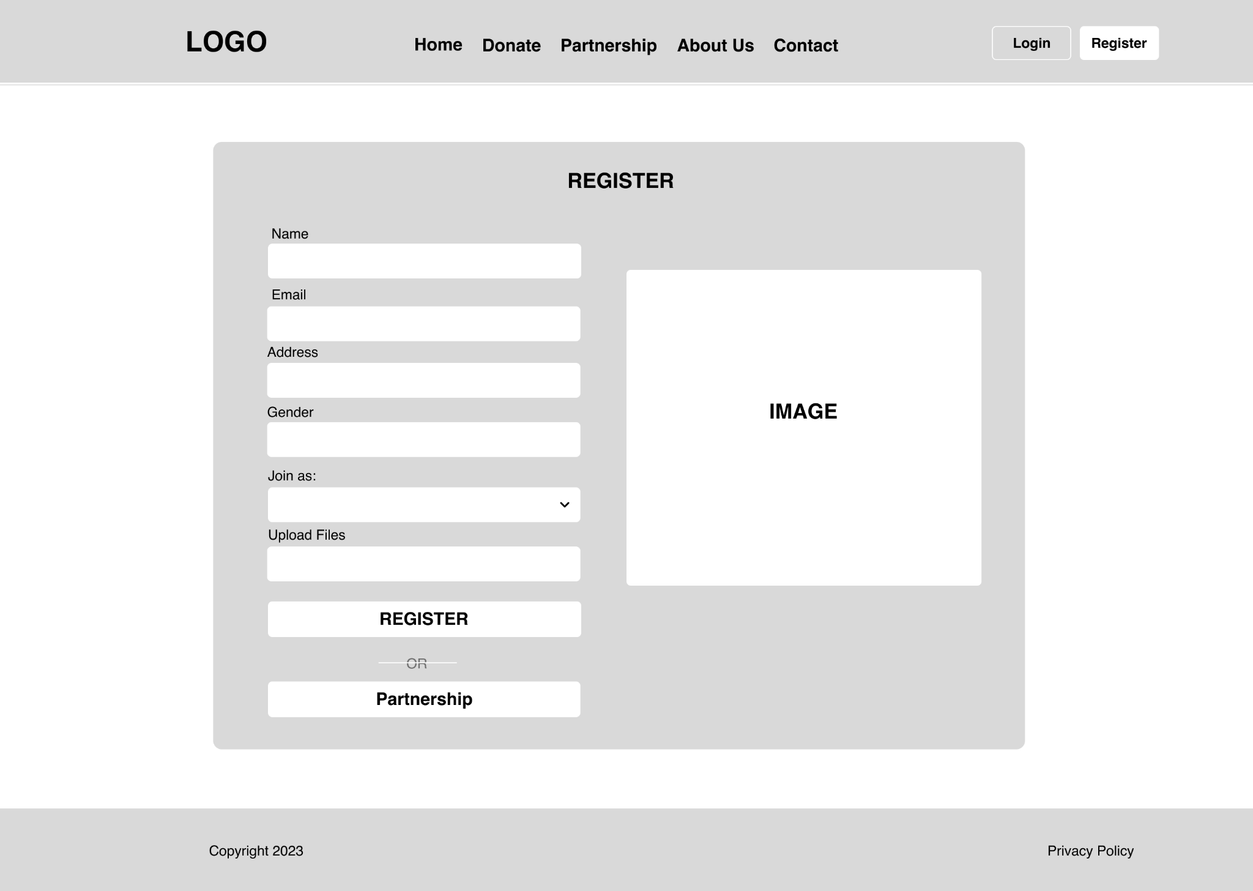

Login Page

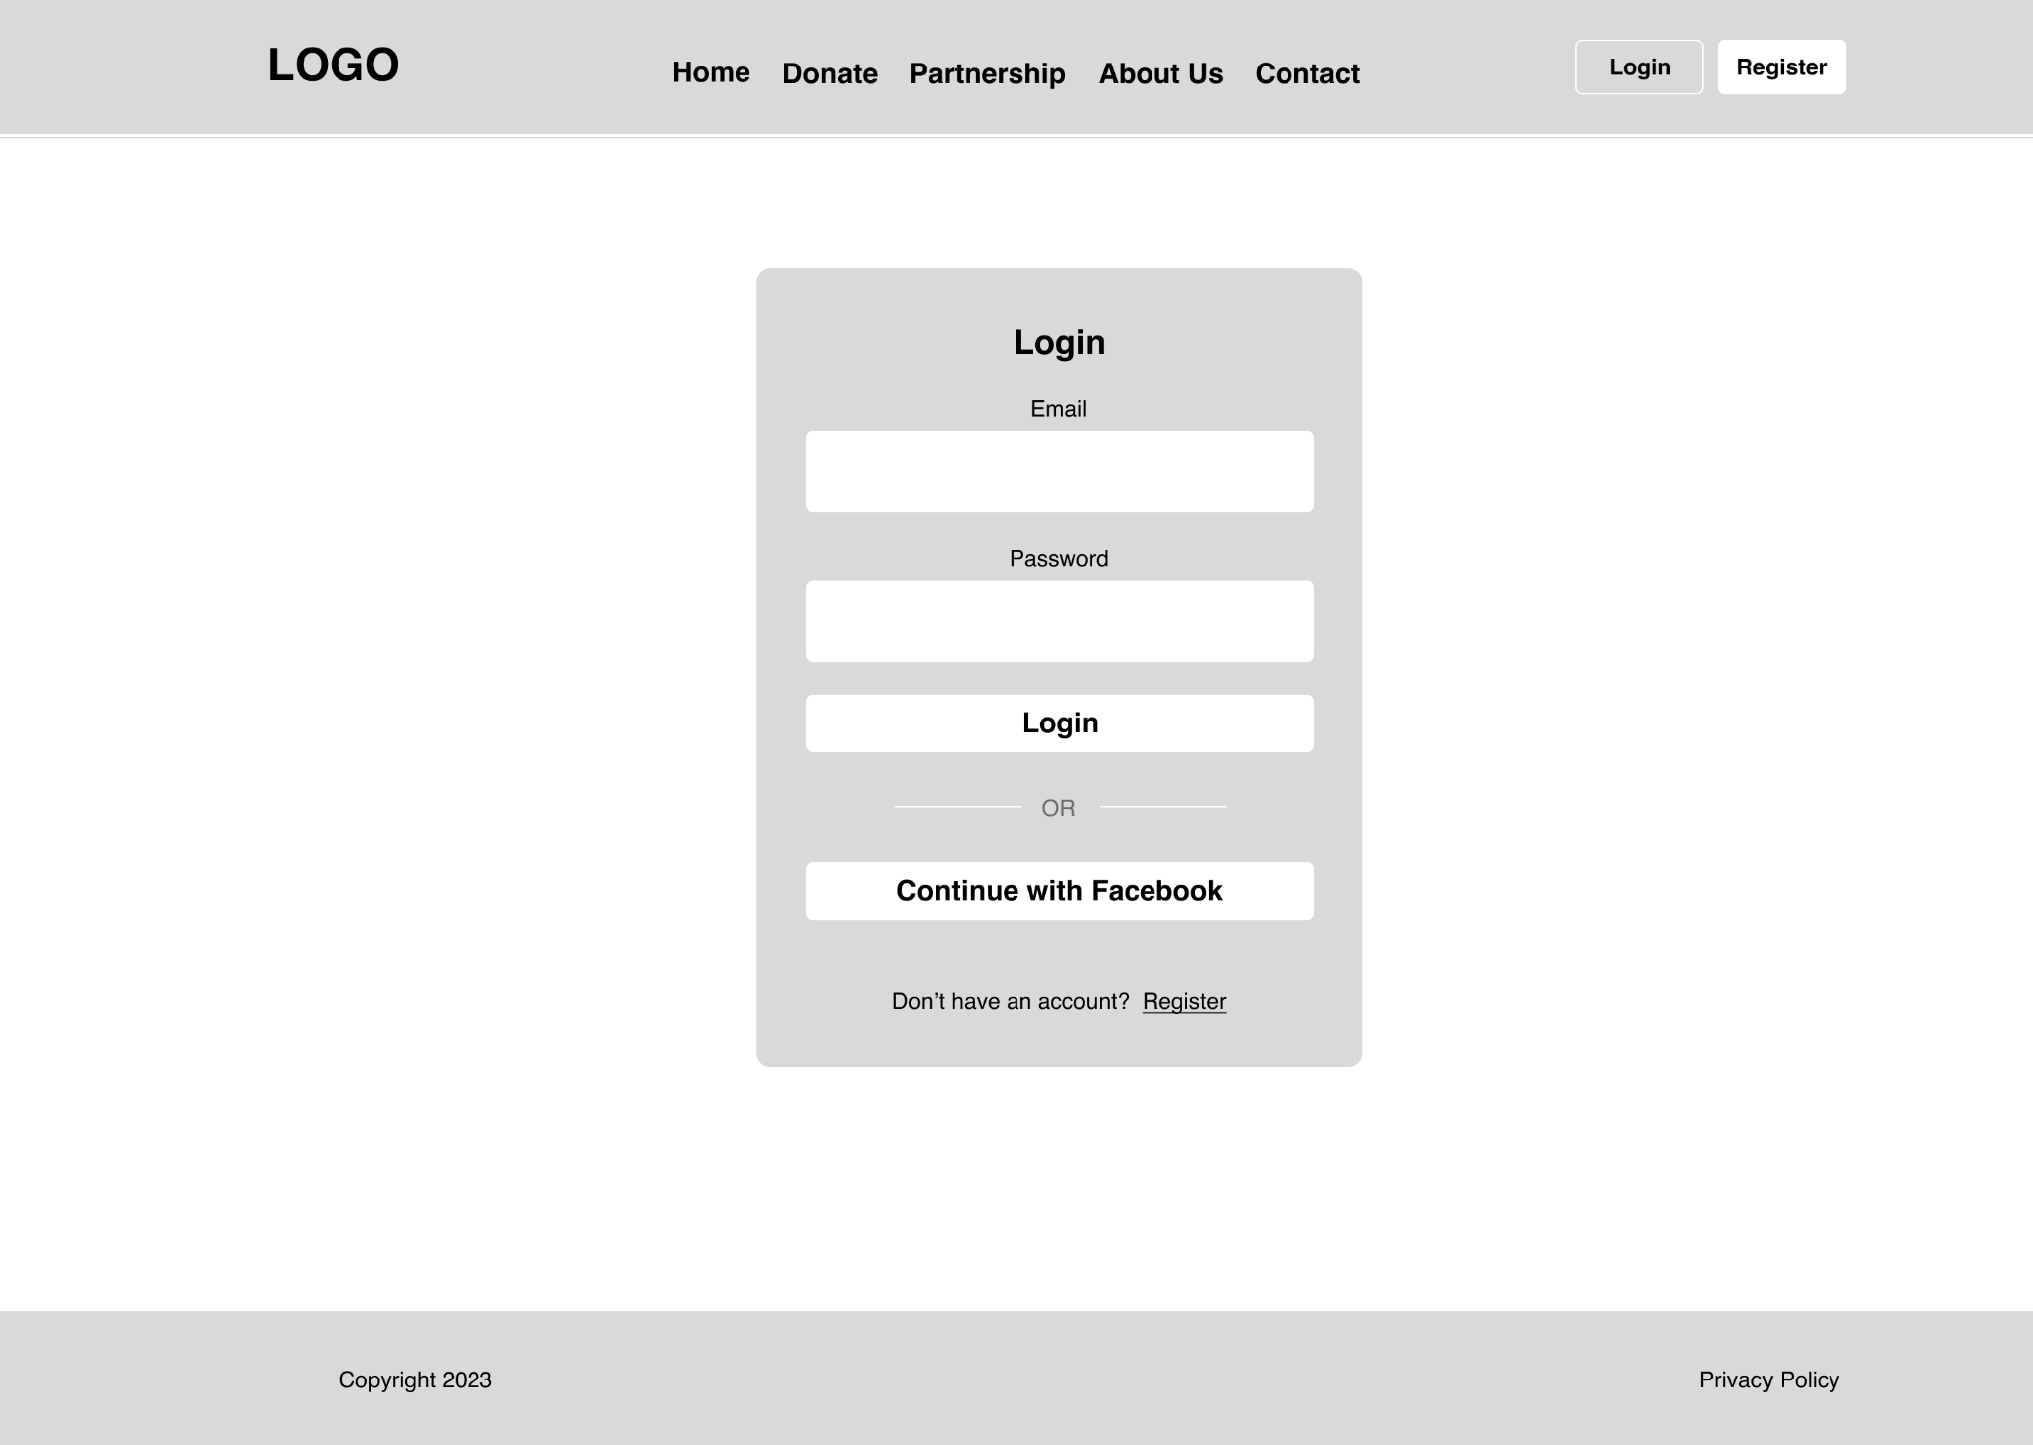

Partnership Request Page

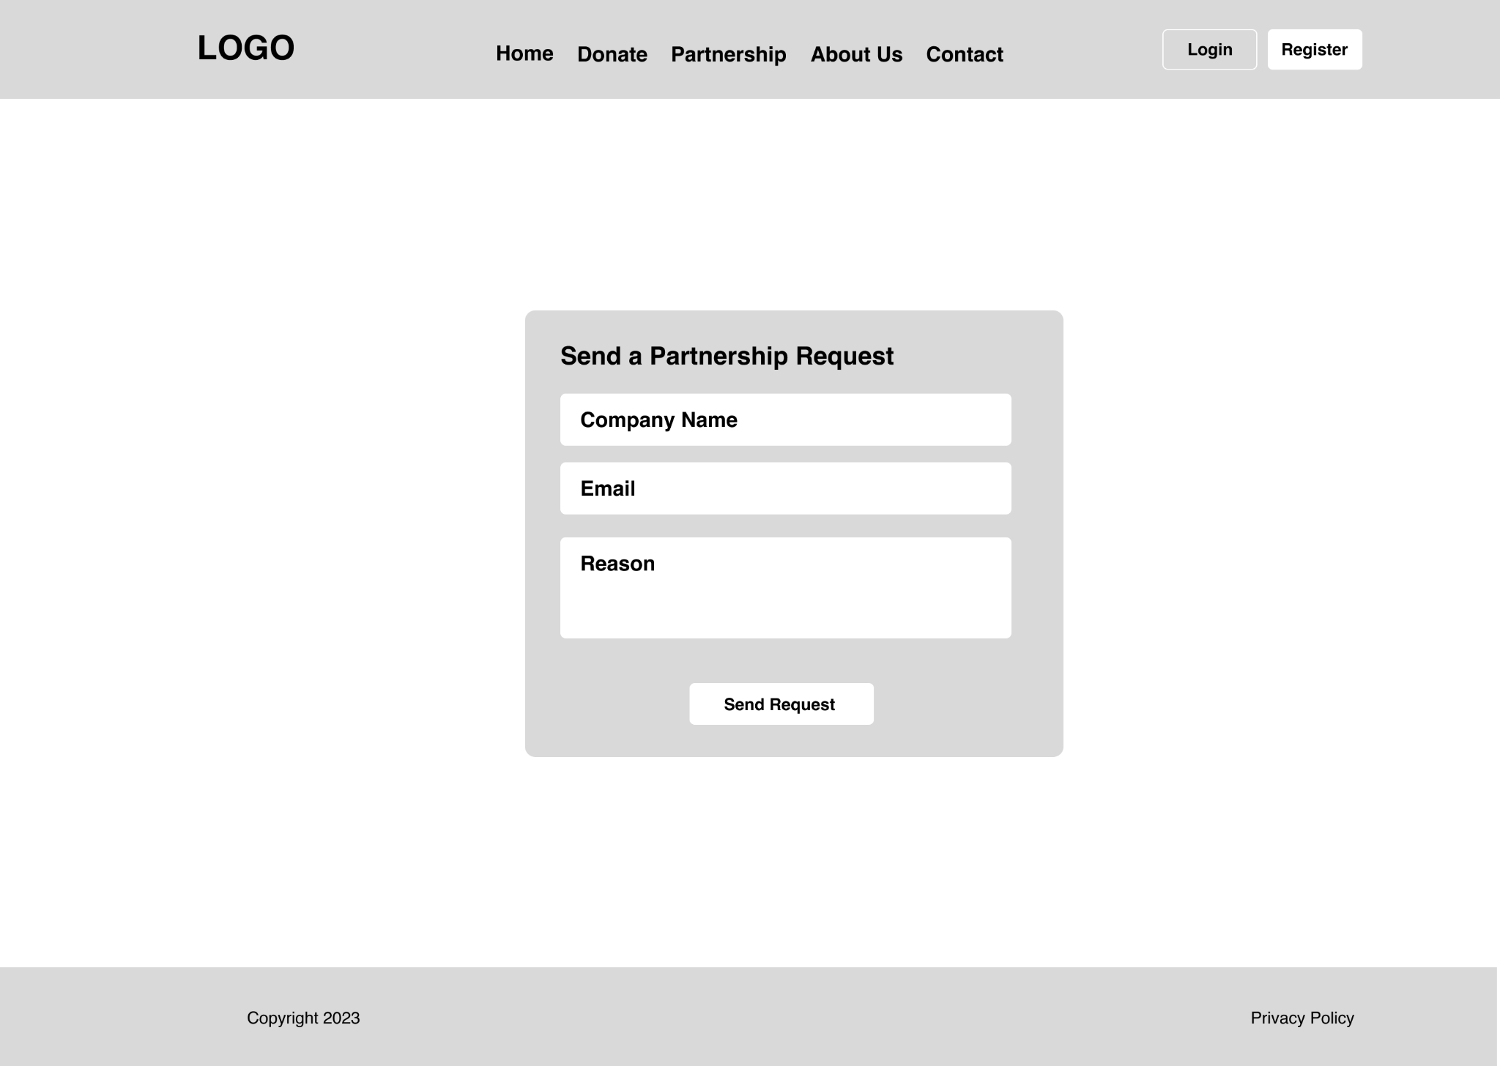Contact Page

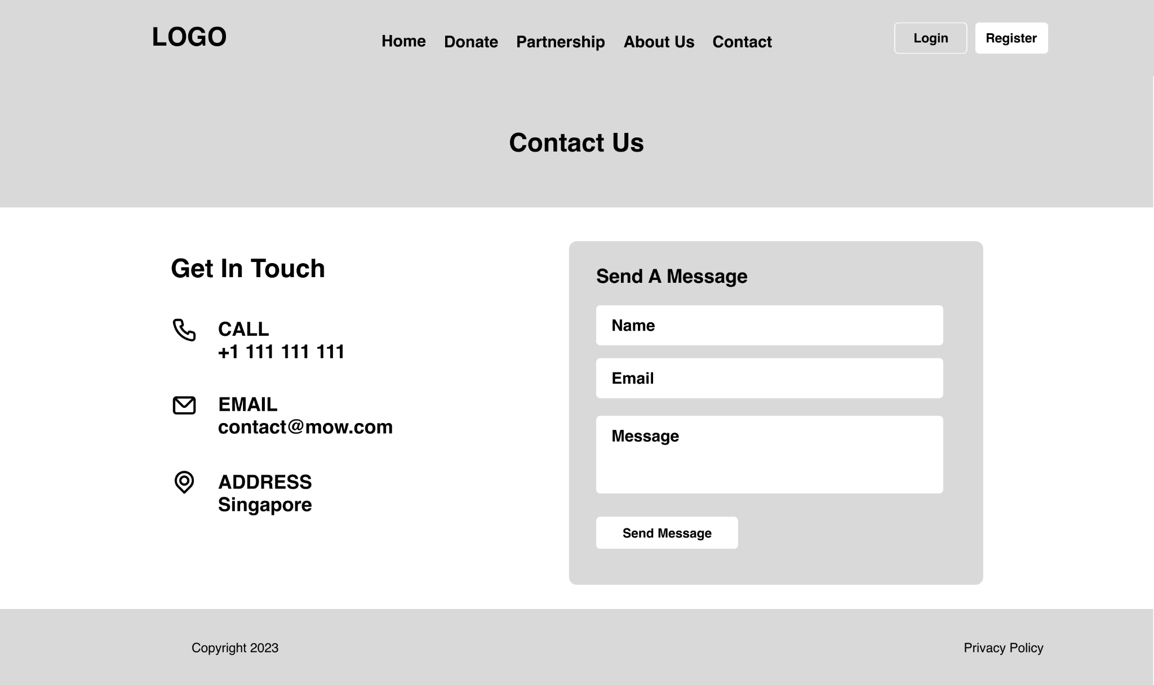

About Us Page

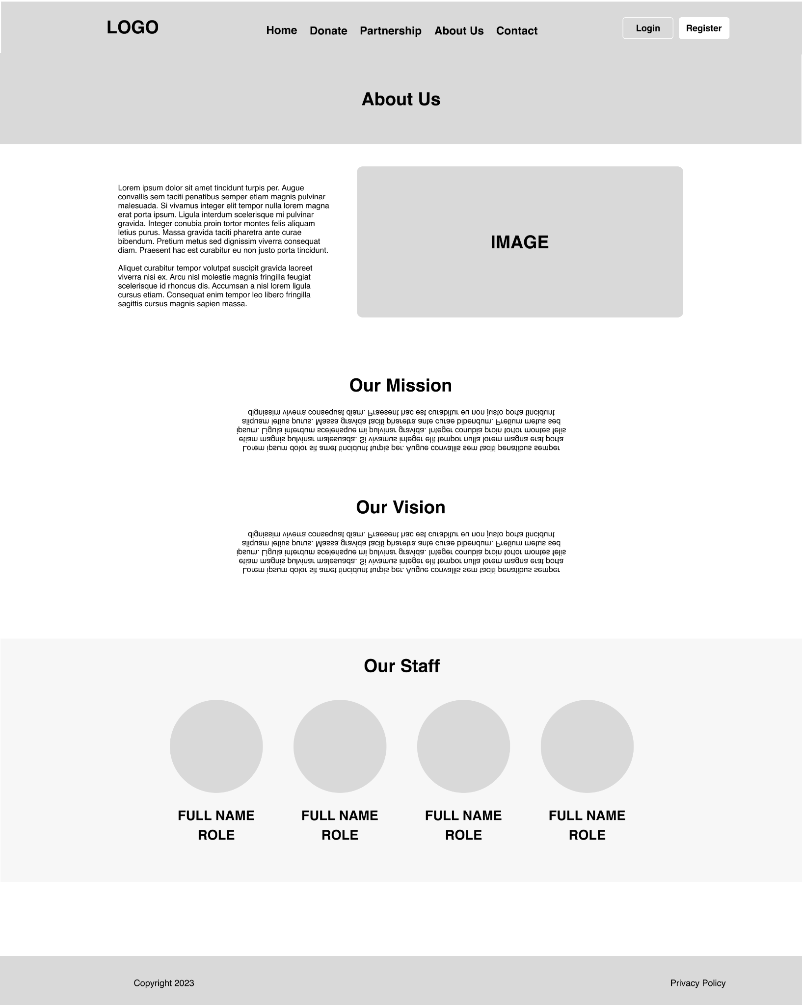

Fundraising Page

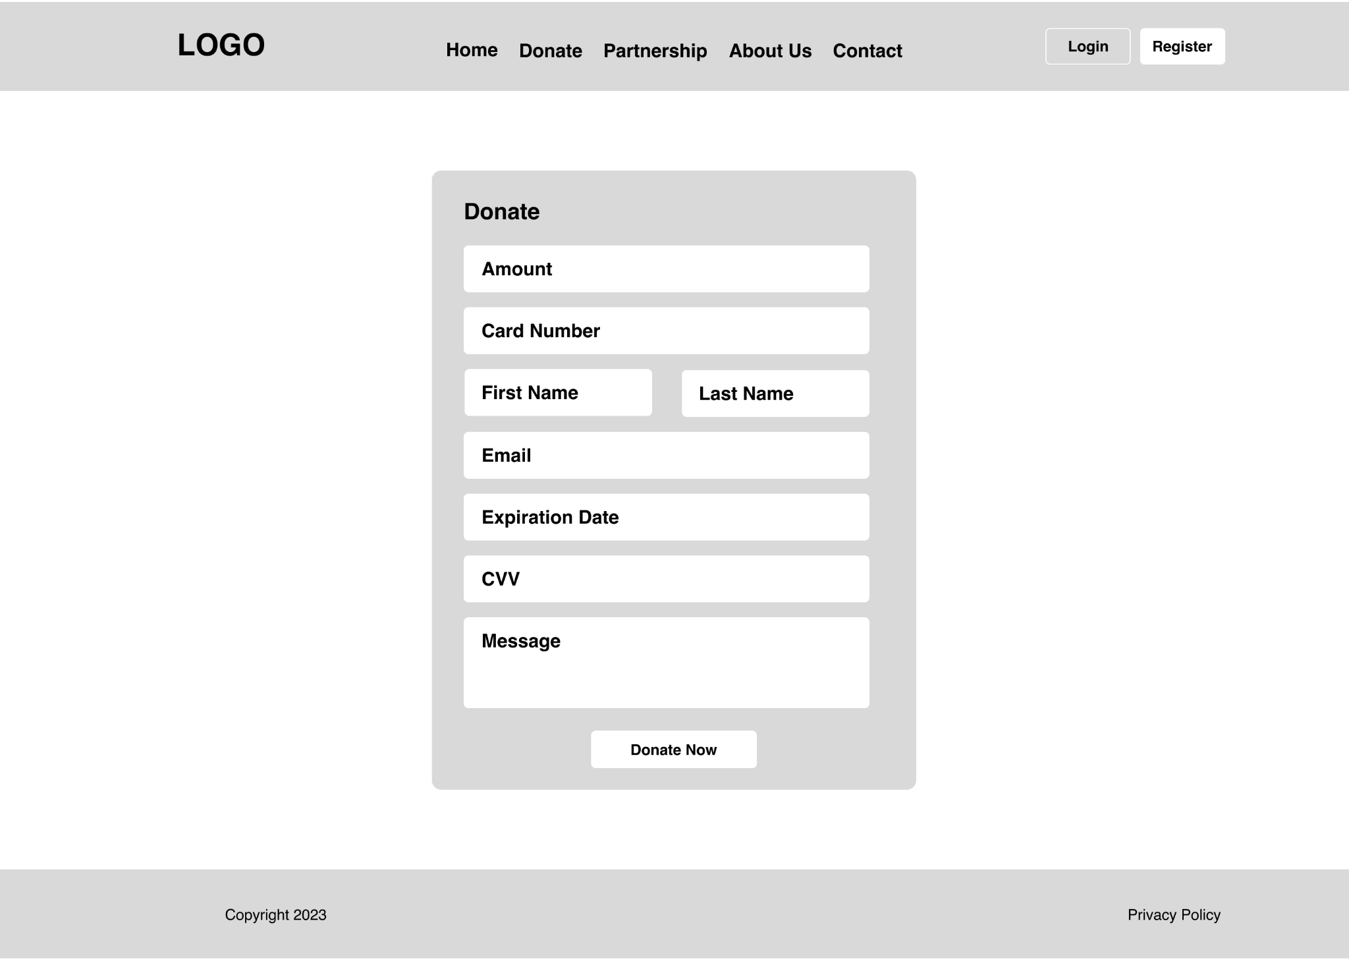

Member: Homepage

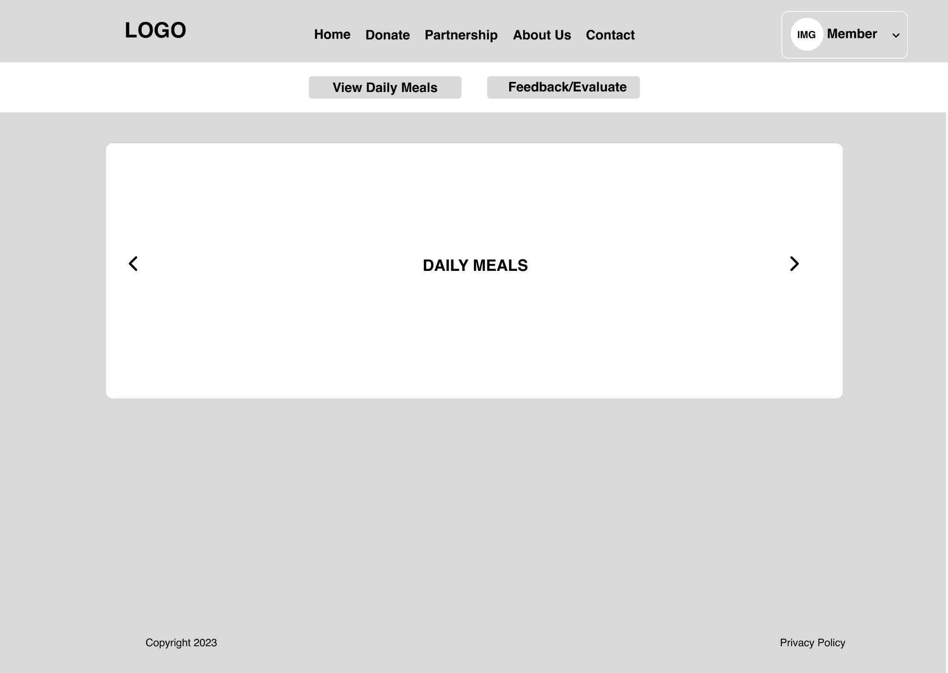

Member: Feedback & Evaluation Page

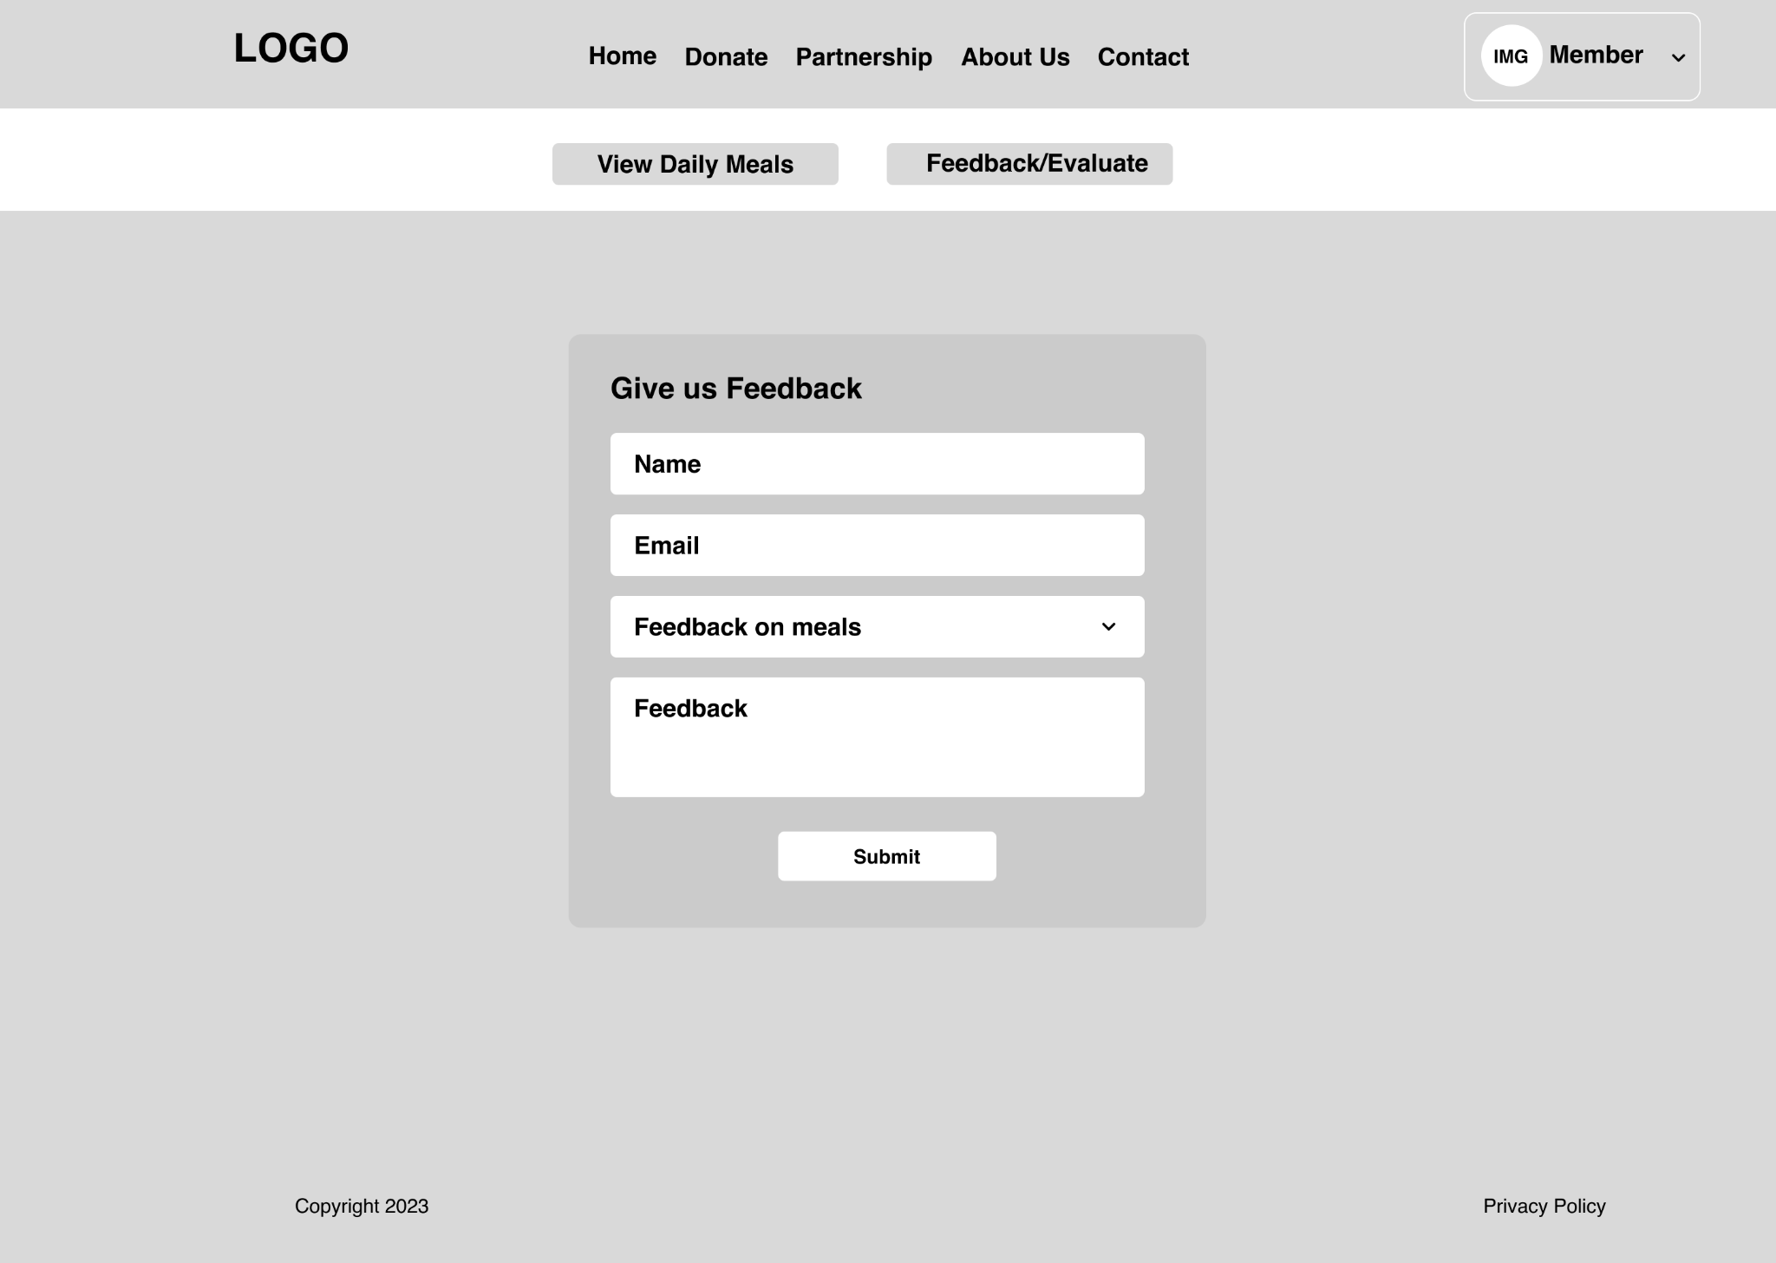

Driver: Homepage

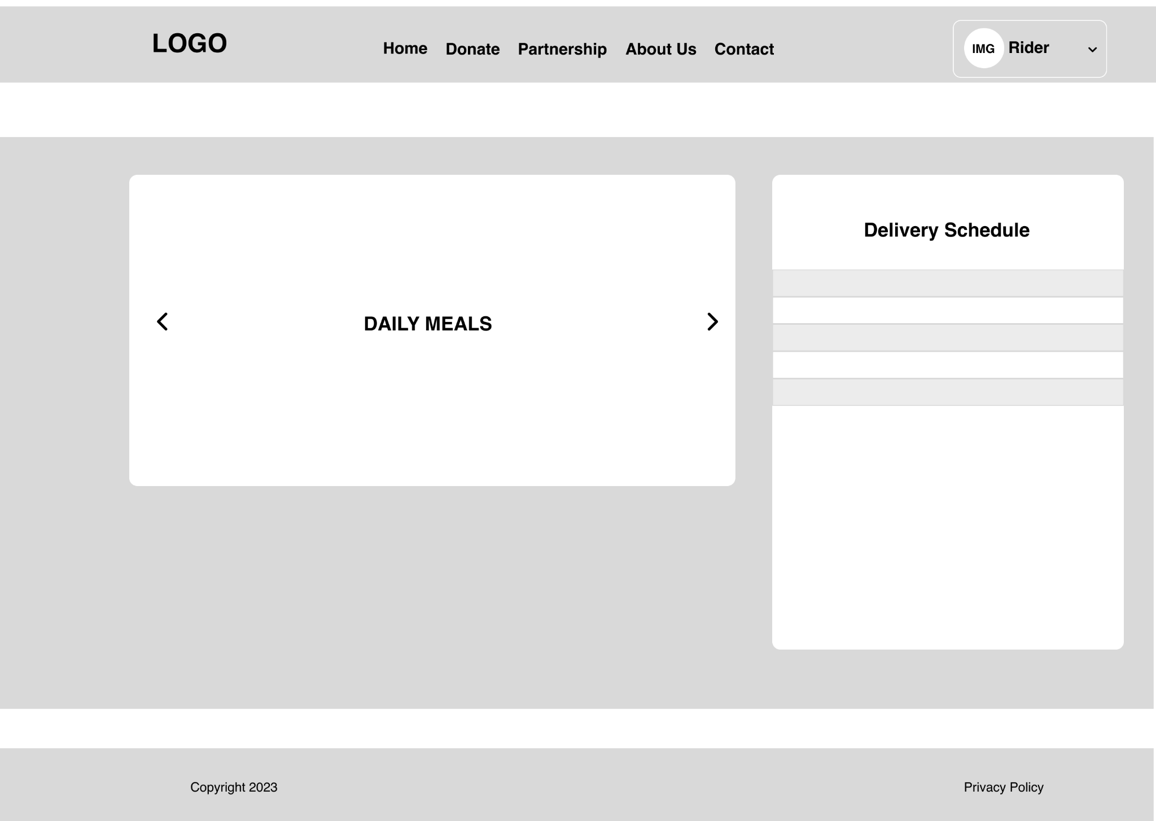

Caregiver: Homepage

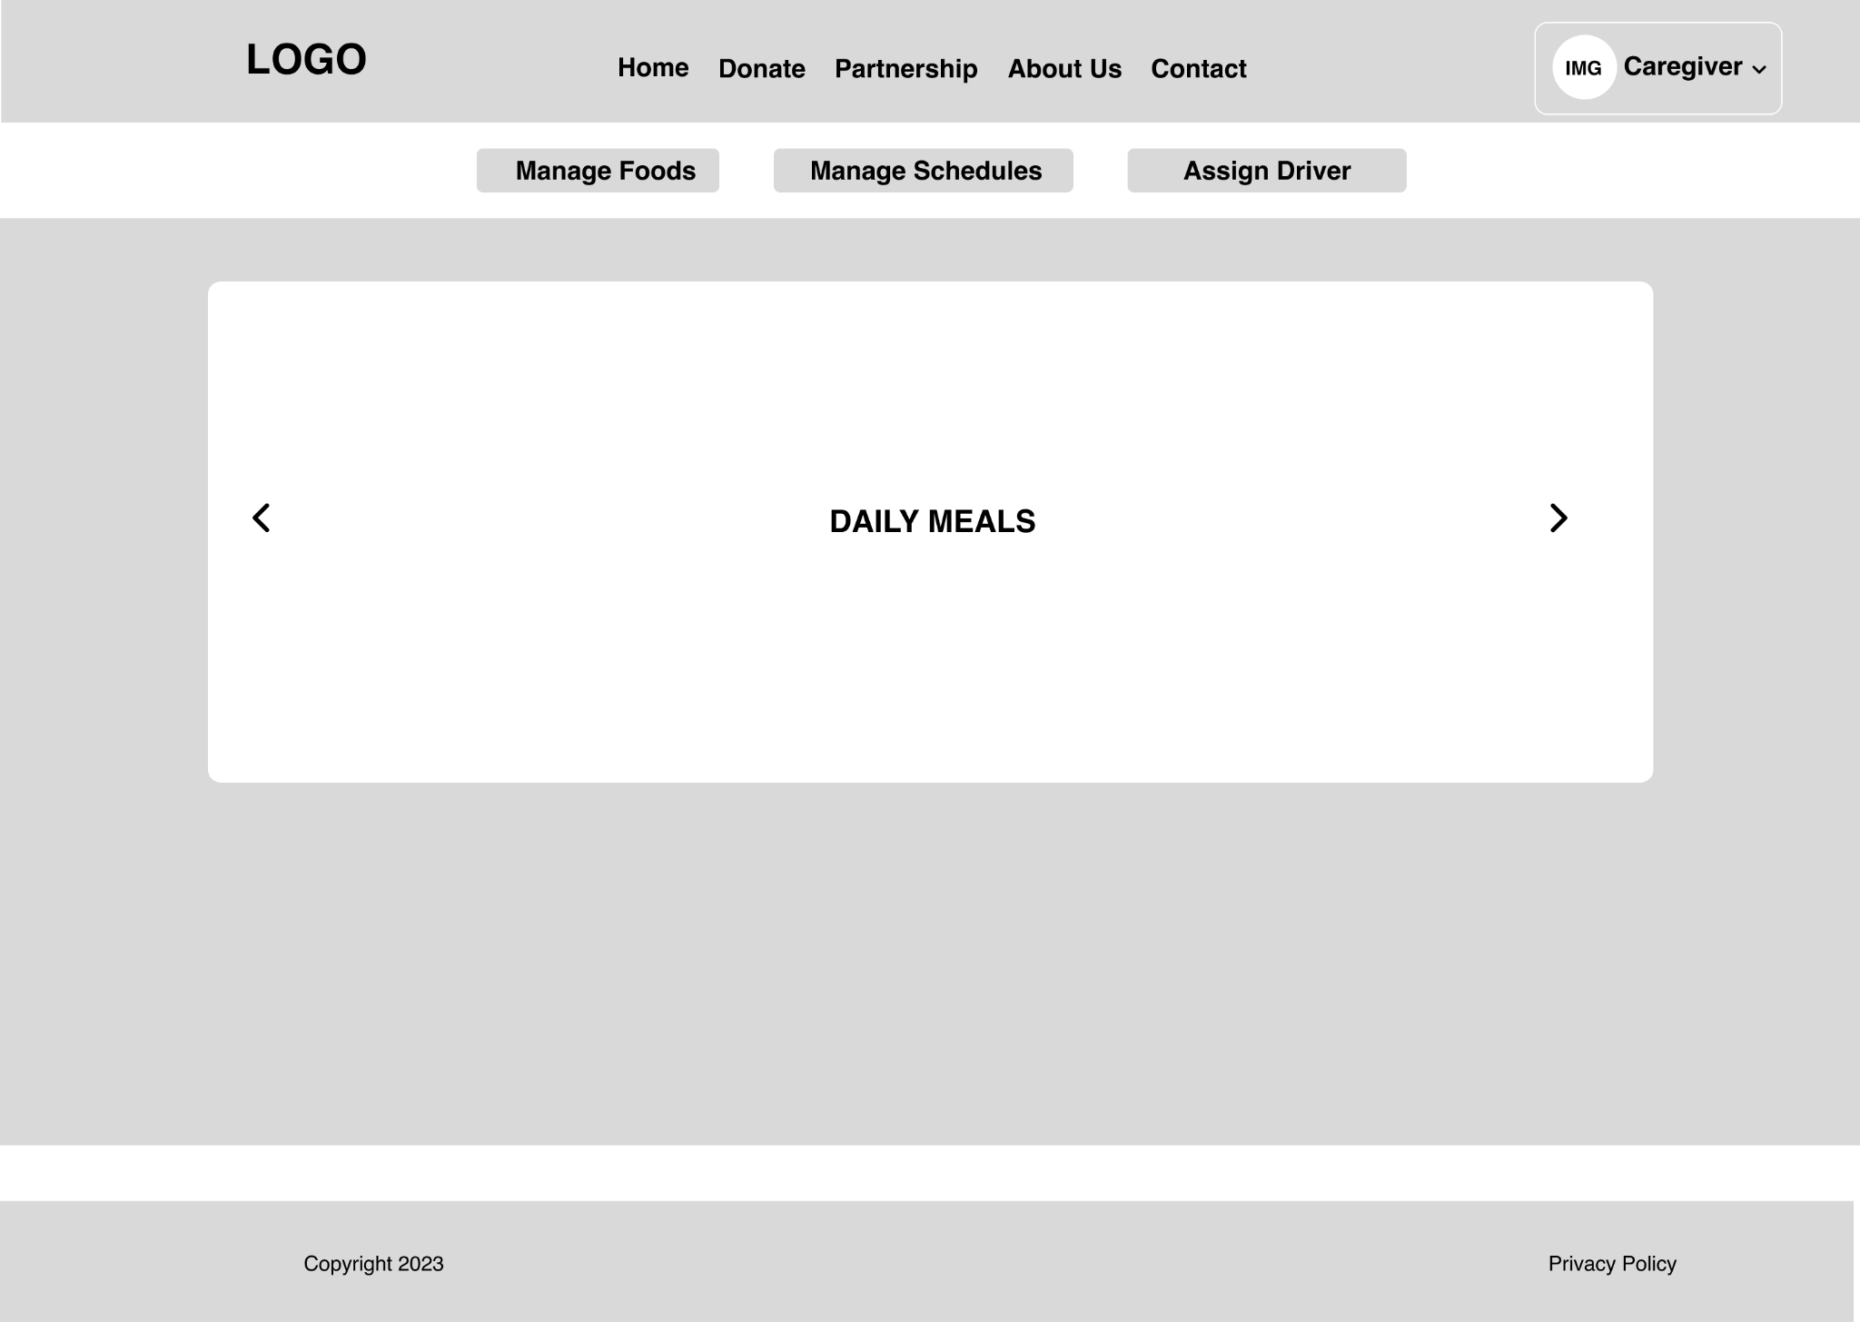

Caregiver: Manage Food Page

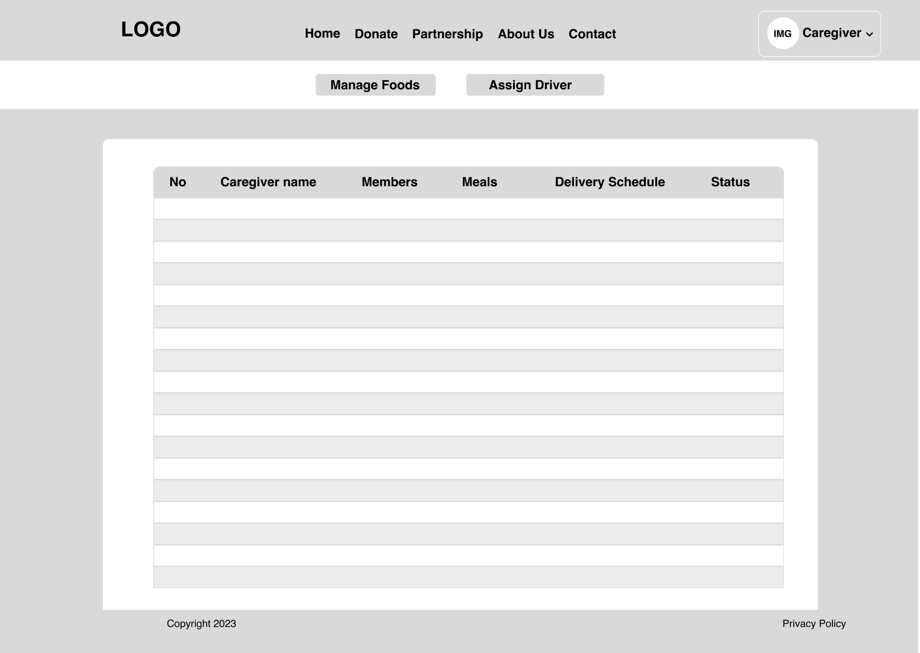

Caregiver: Assign Driver Page

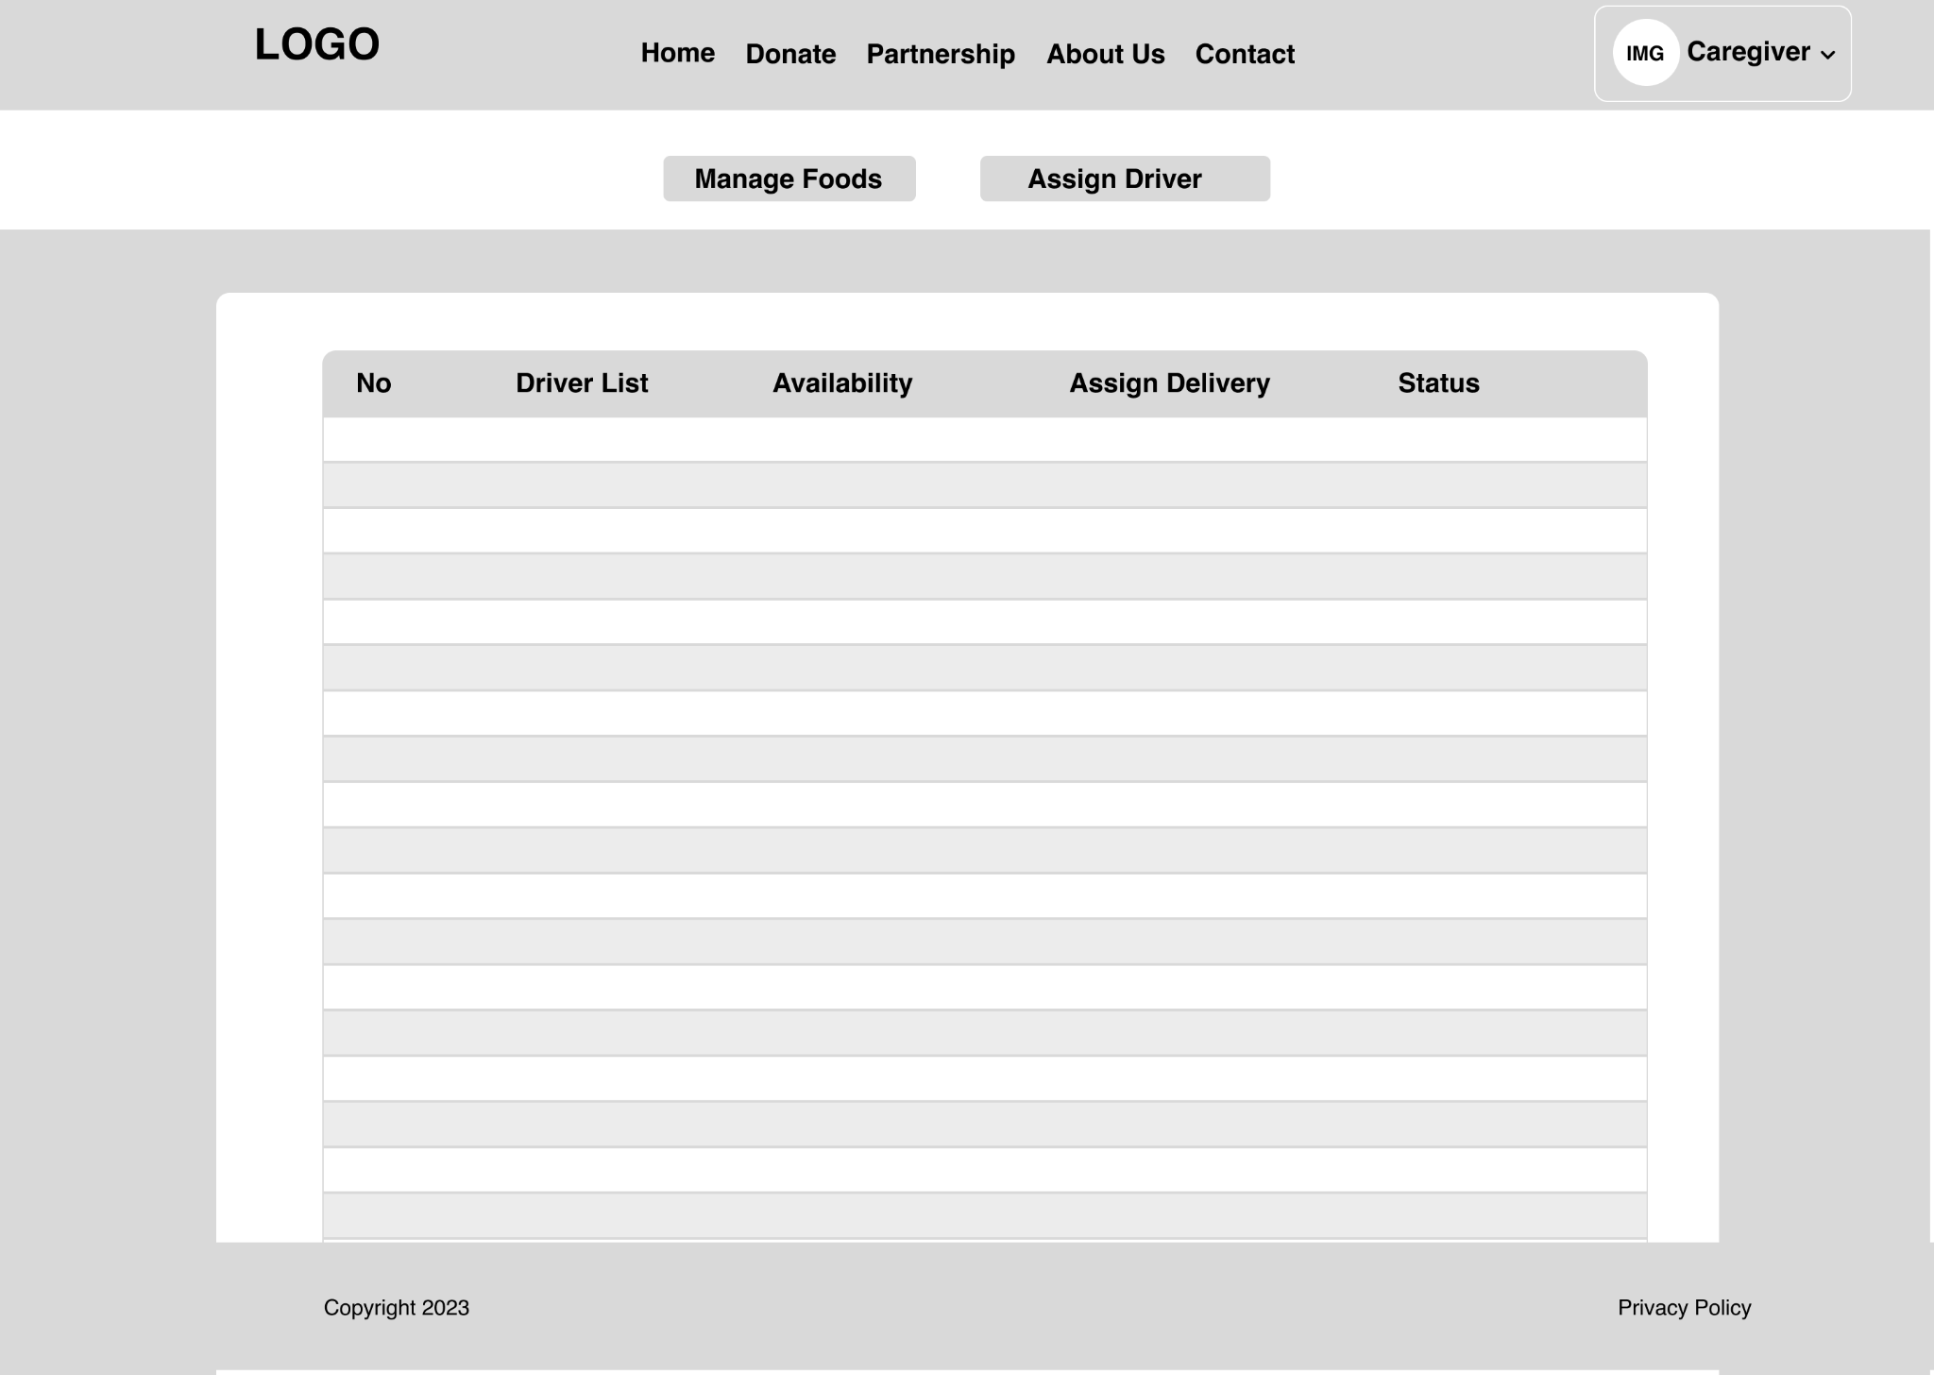

Admin: Homepage

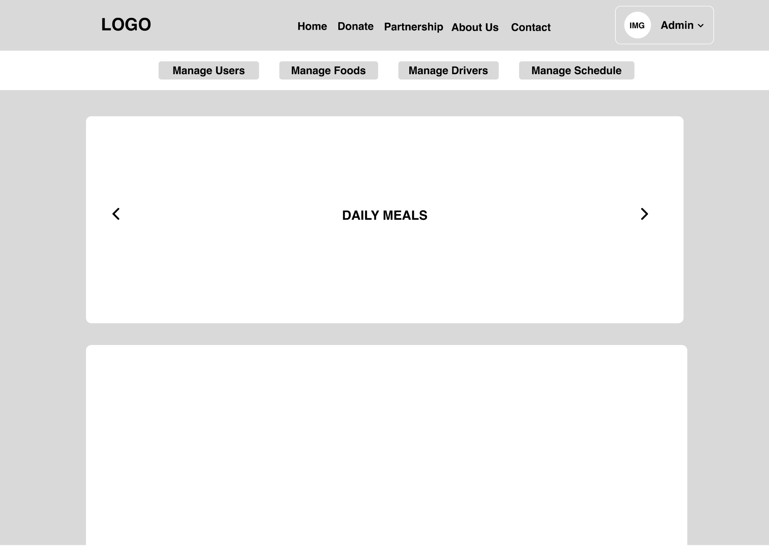

Admin: Manage Members Page

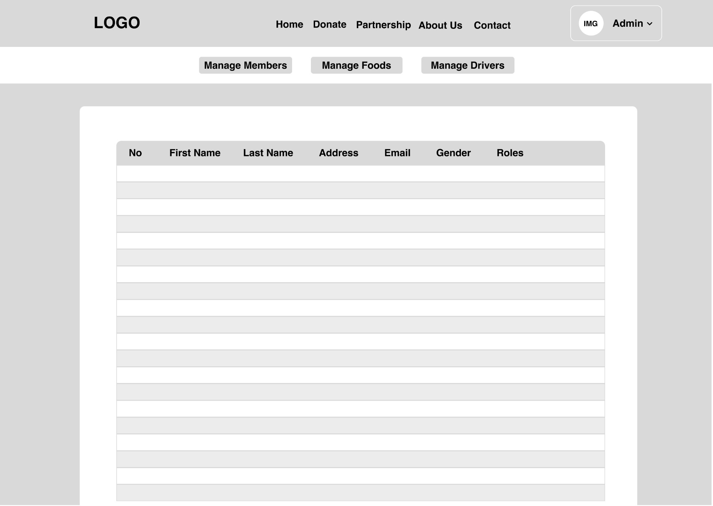

Admin: Manage Food Page

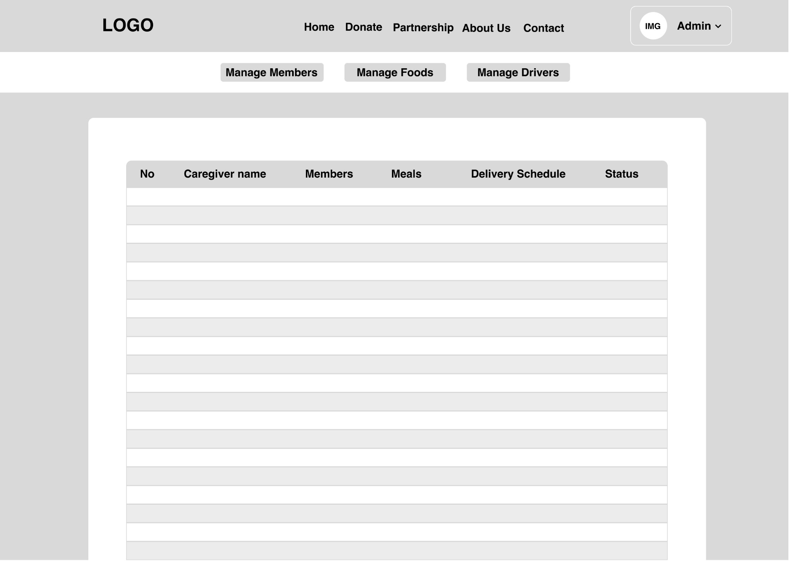

Admin: Manage Driver Page

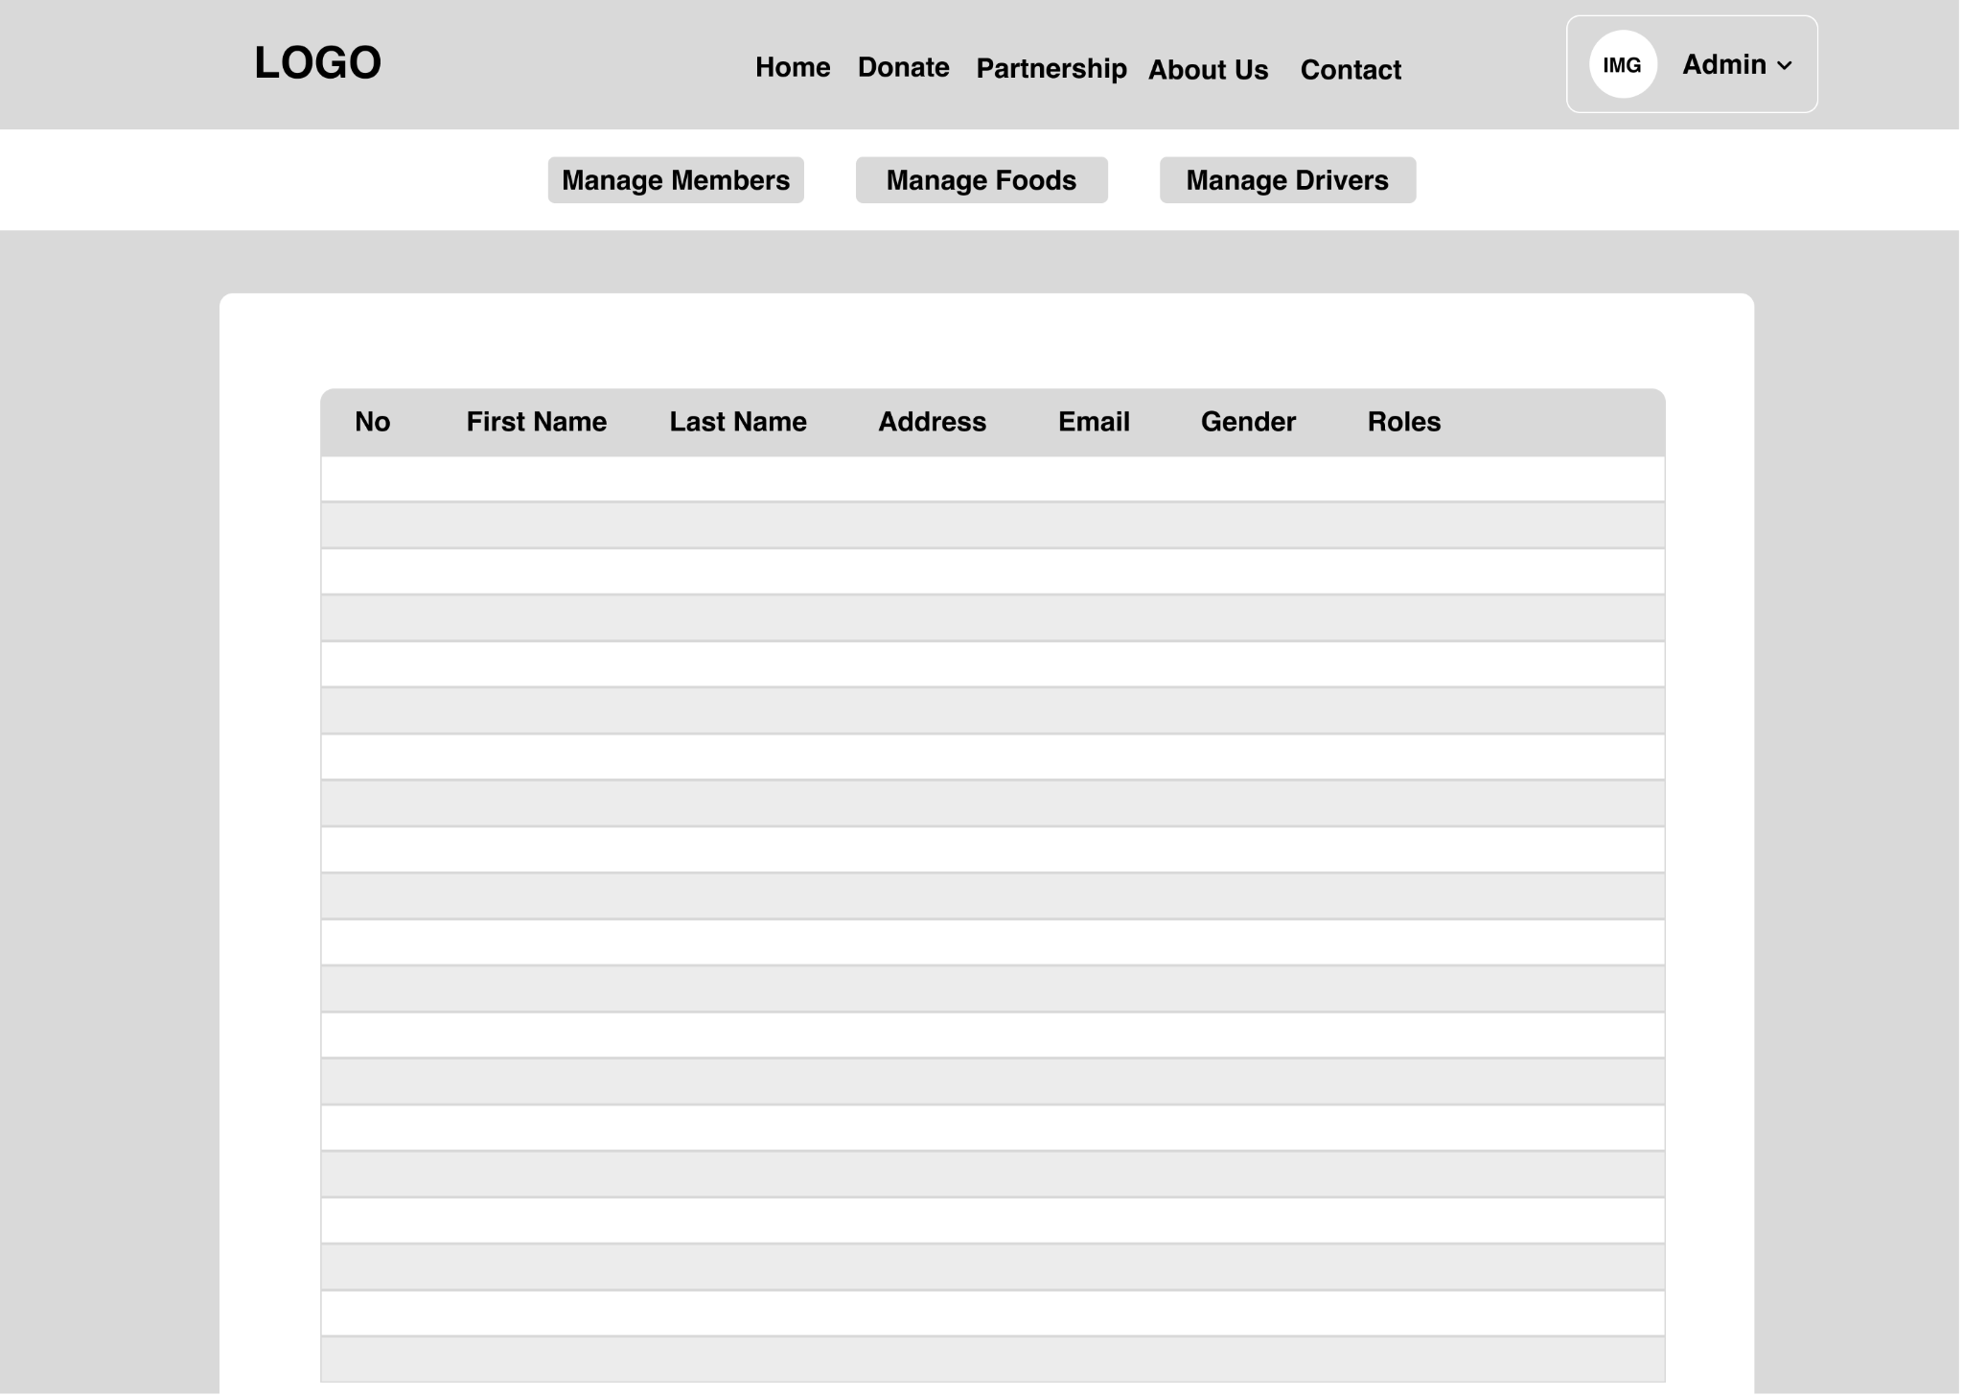

## **Module Storyboard**

**All Users before login**

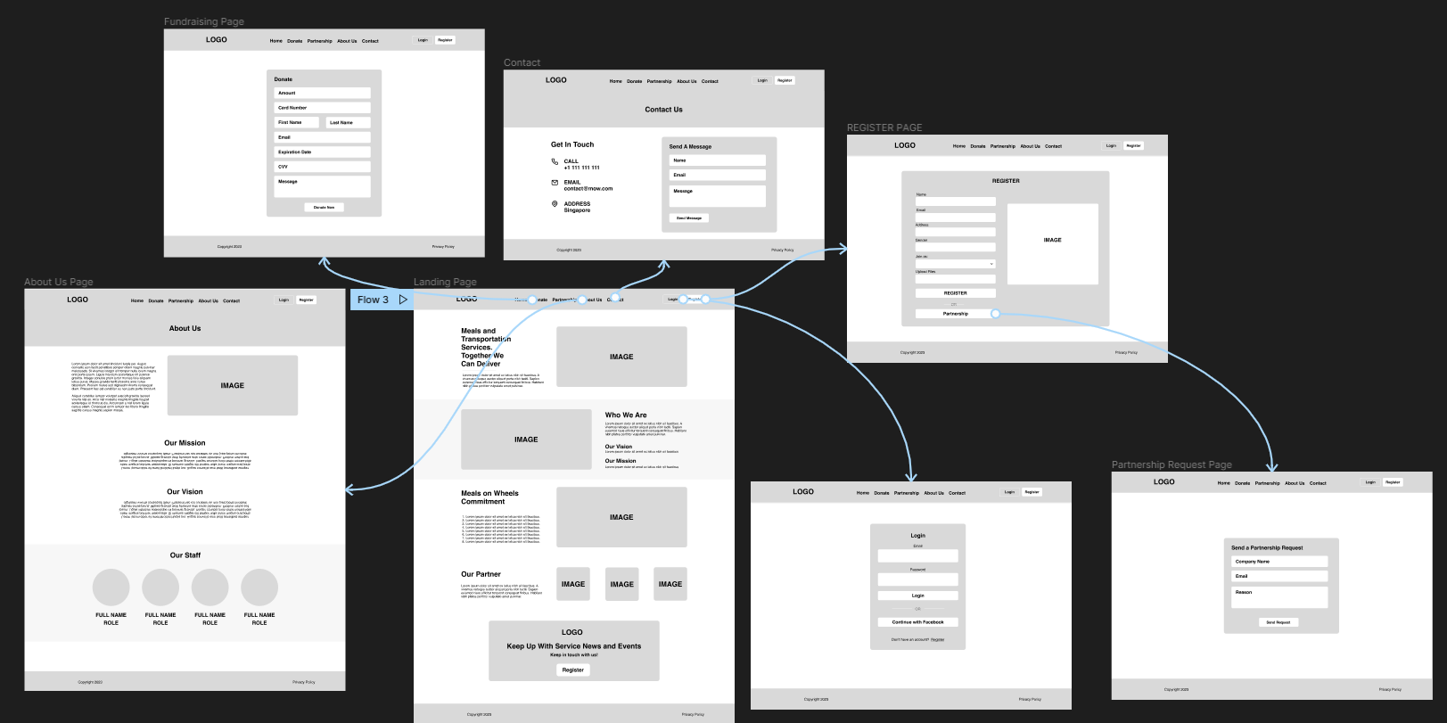

## **Login as a:**

## 

## **DB Design:**

## 

## 

# **Project Prototype**

View Flow of the Prototype Here: <https://www.shorturl.at/aFVZ7>

Landing Page

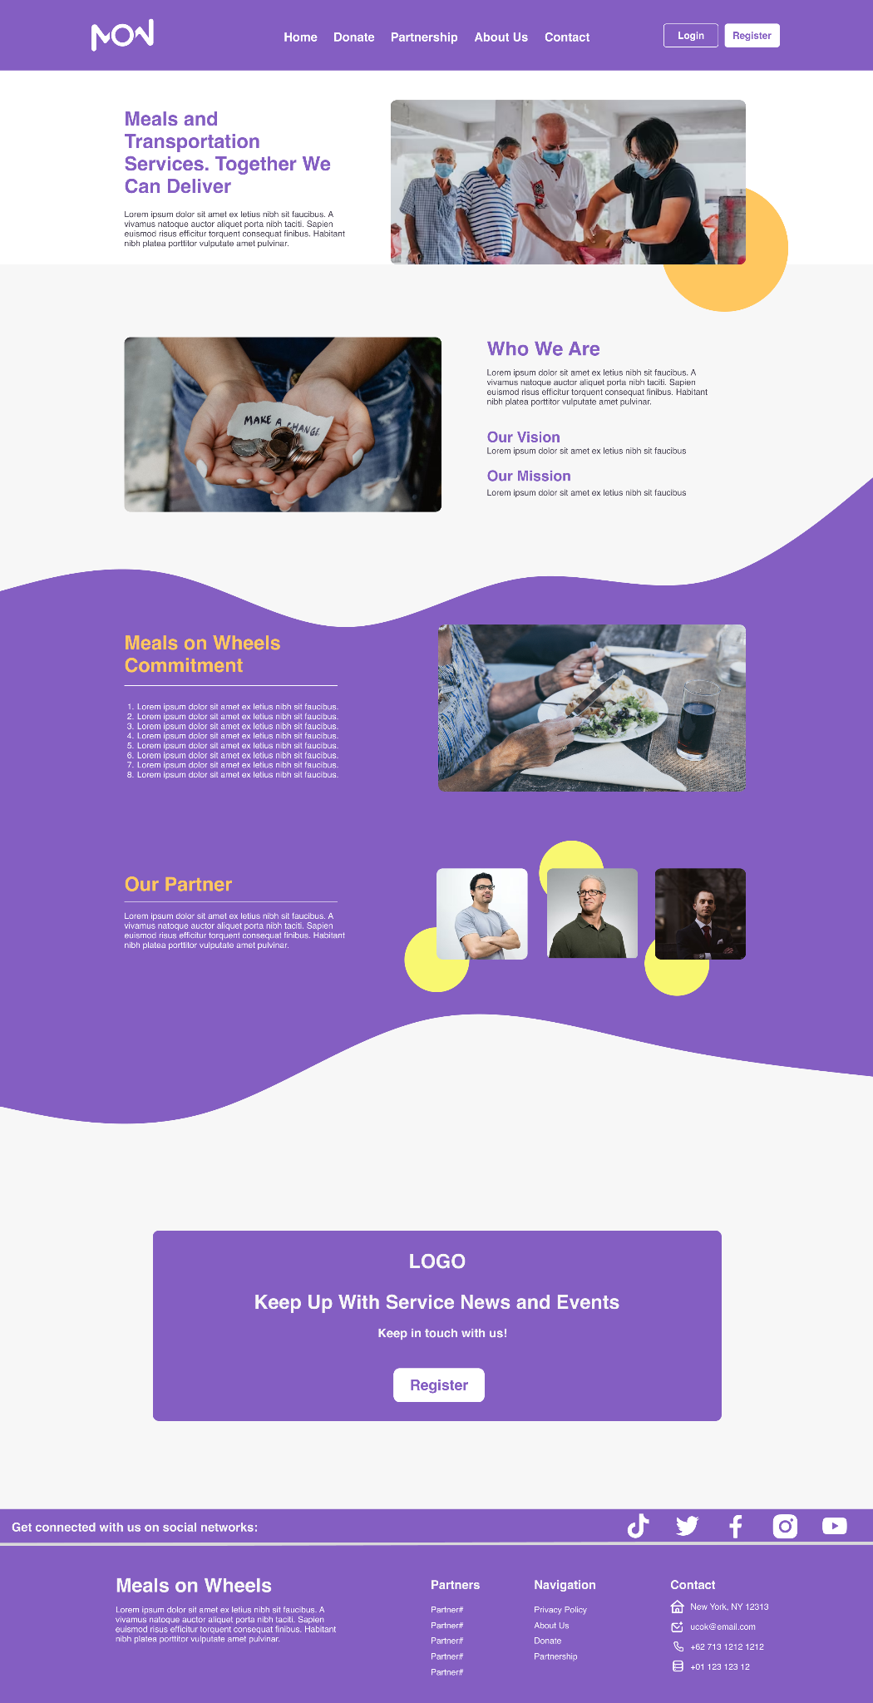

Register Page

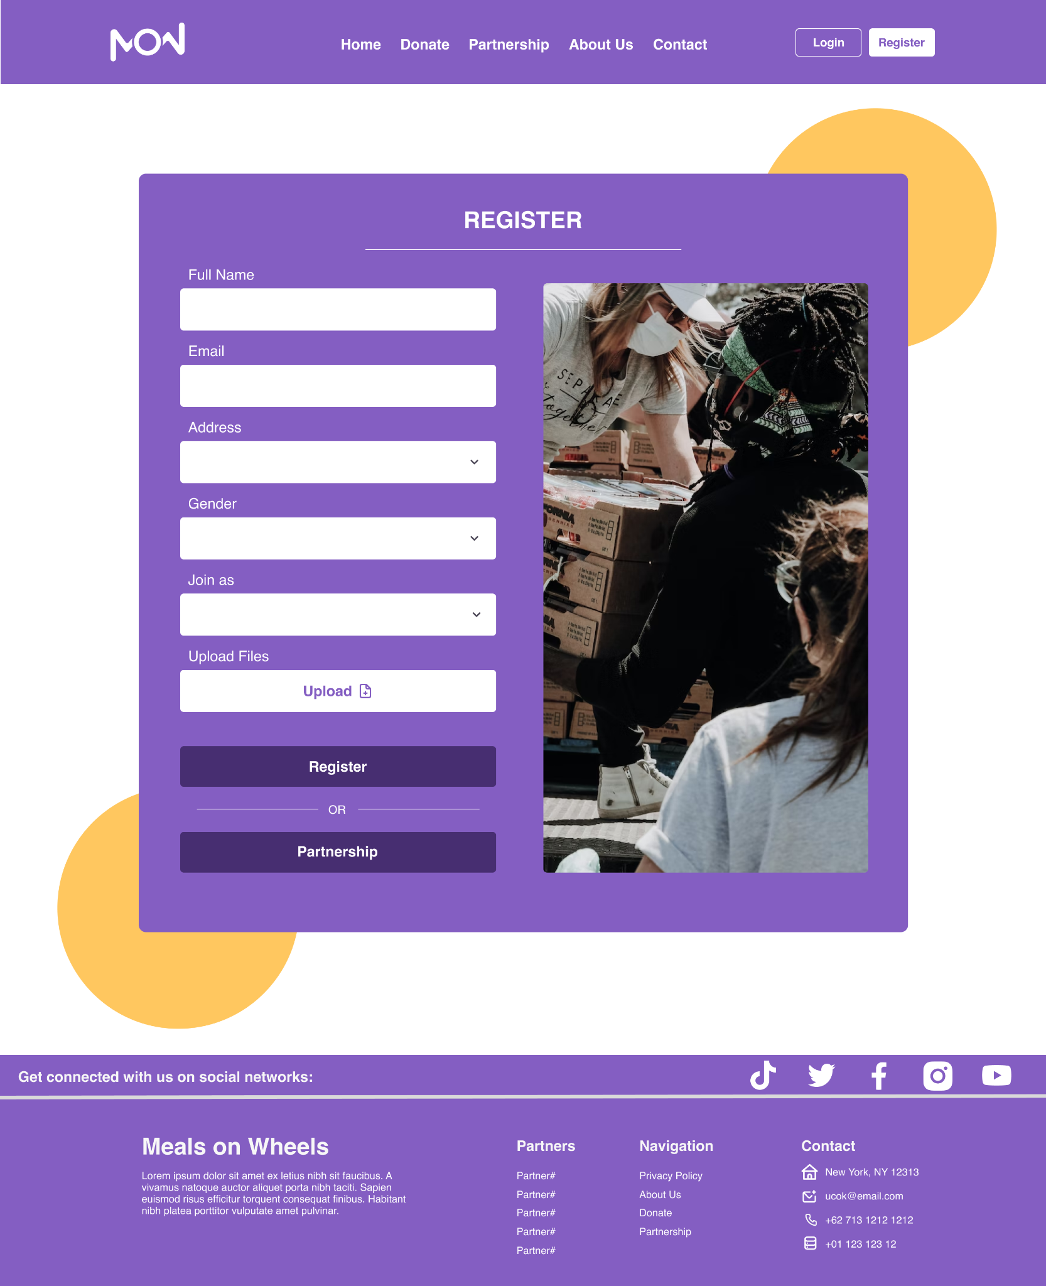

Login Page

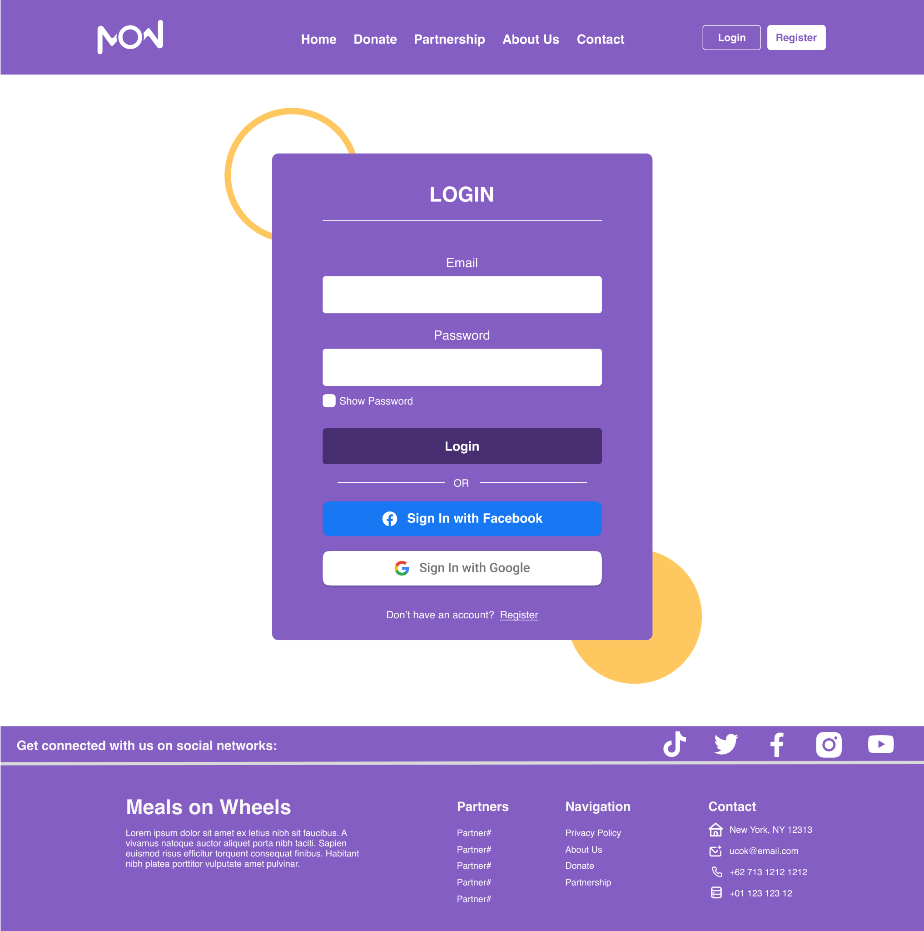

Request Partnership Page

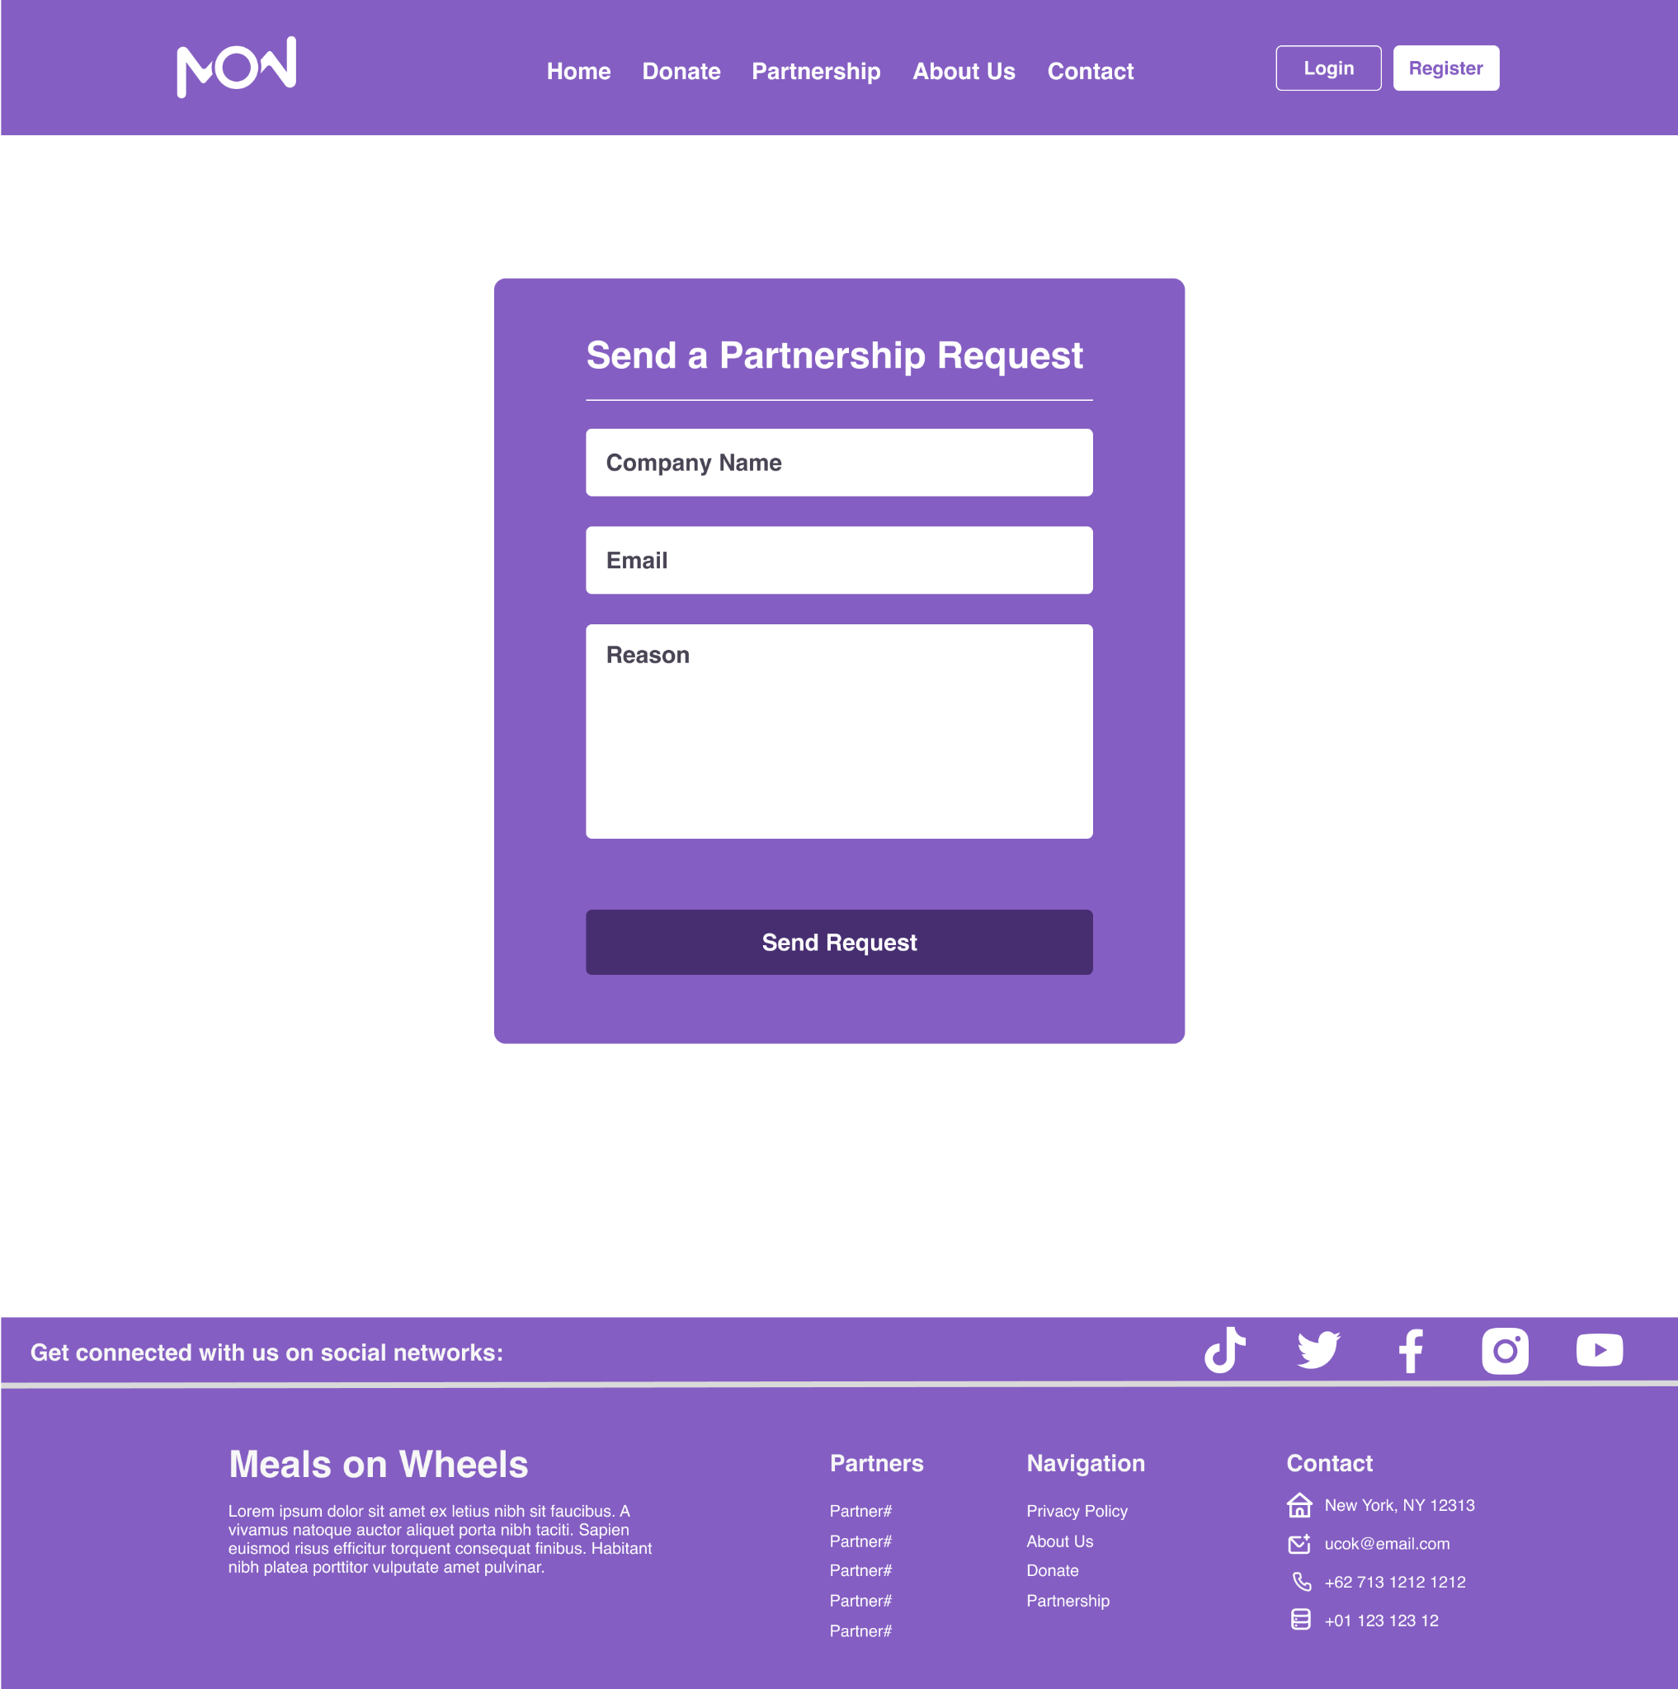

Fundraising Page

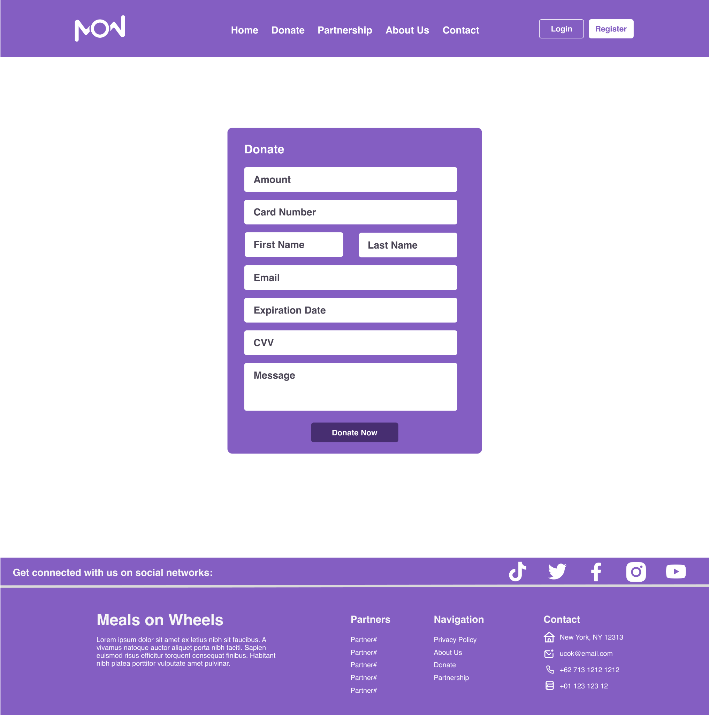

About Us Page

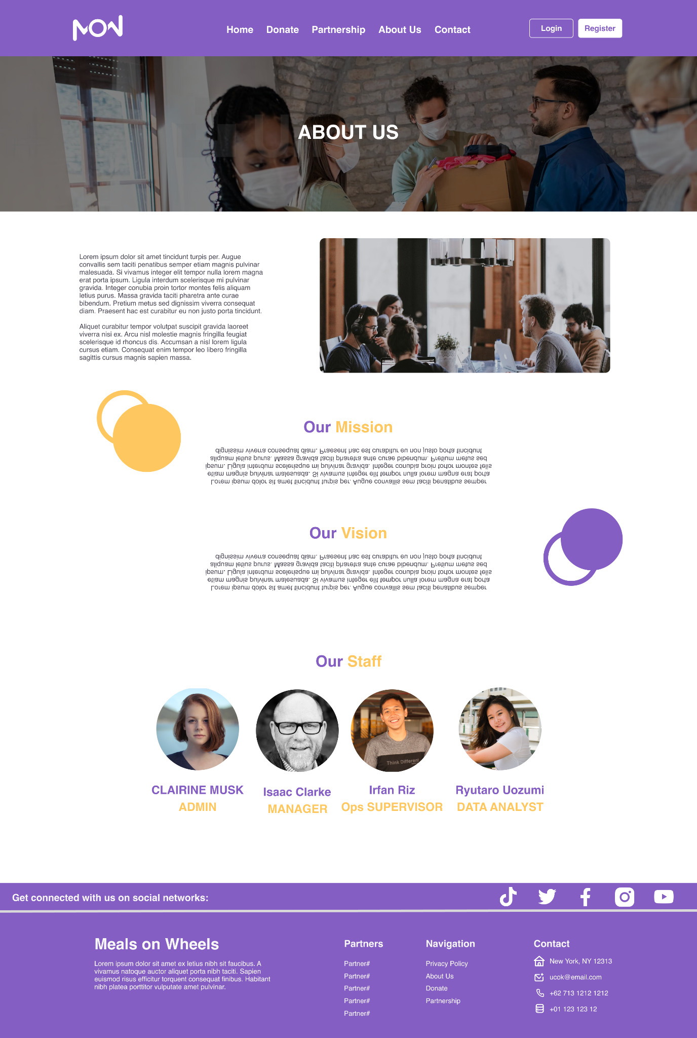

Contact Us Page

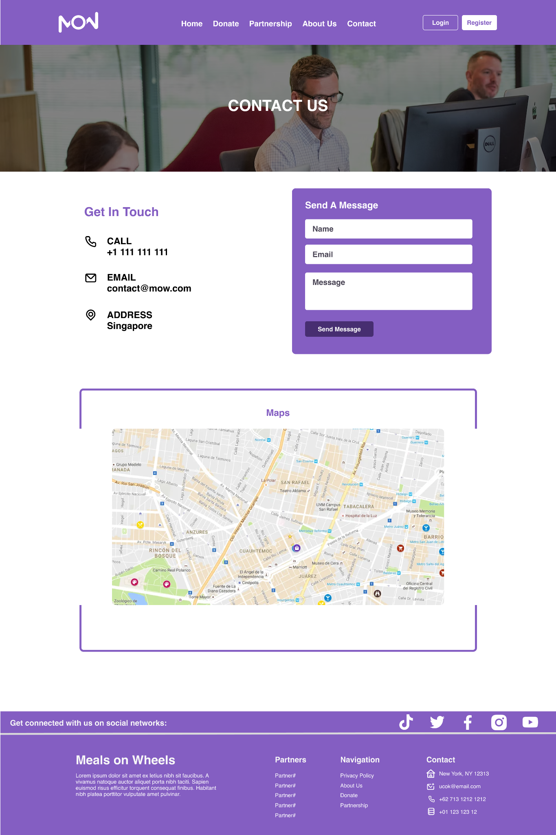

Terms & Condition Page

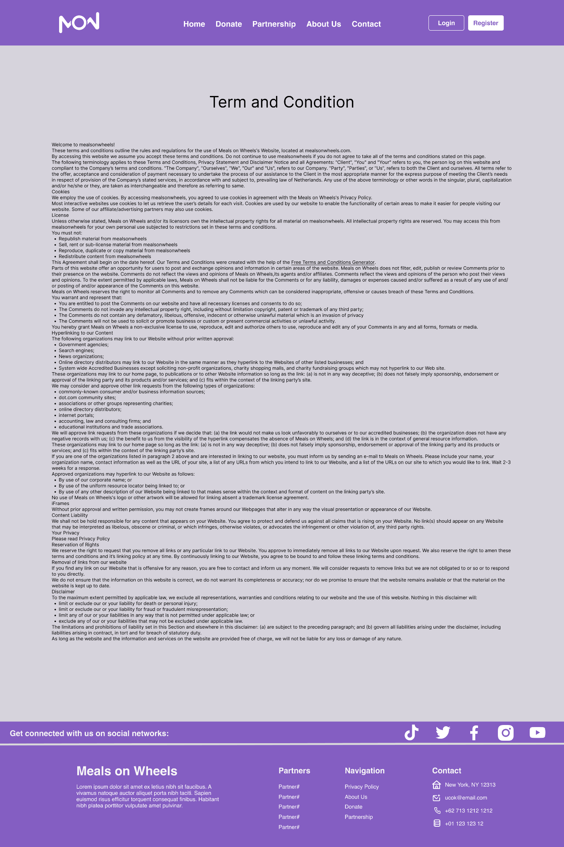

Member: Homepage

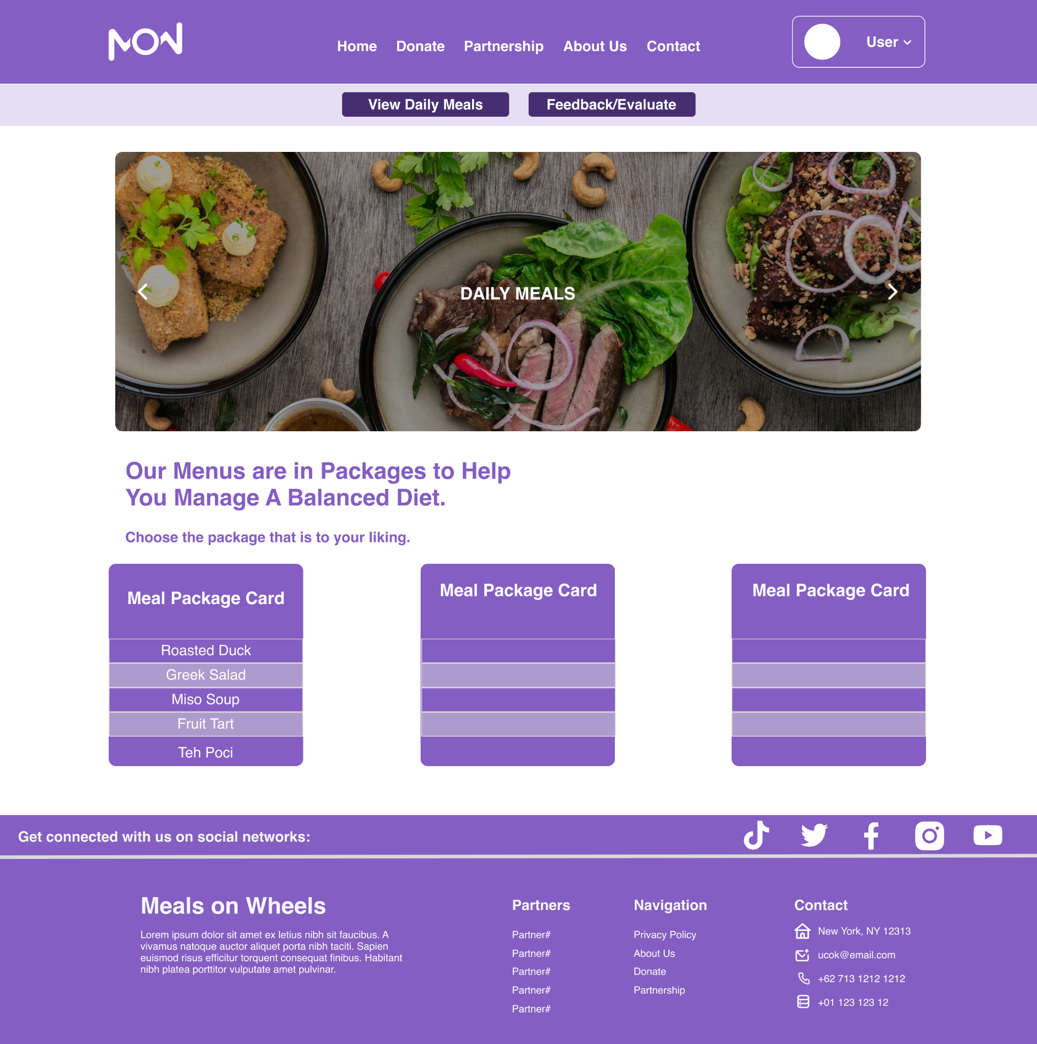

Member: Meal Package Detail

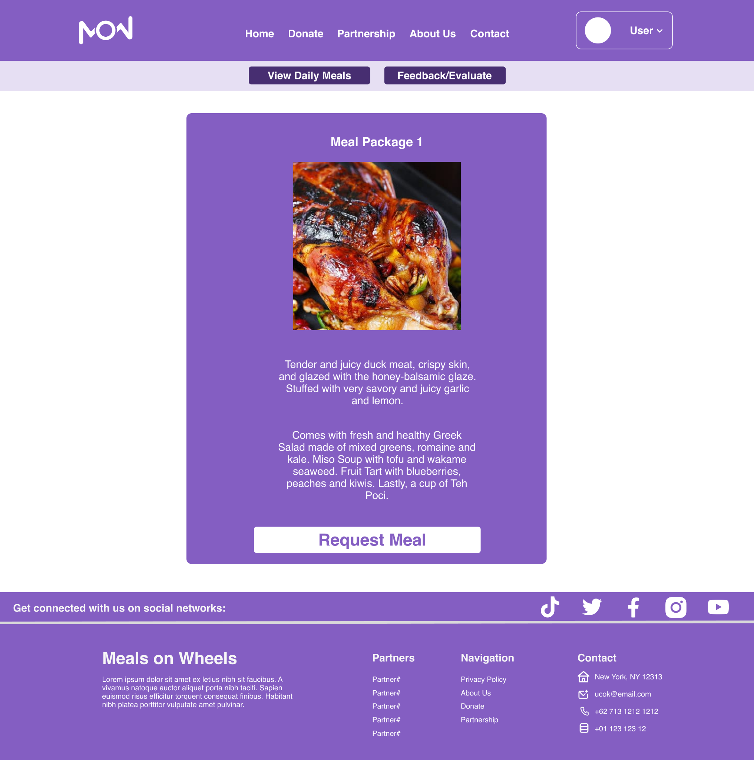

Member: Feedback & Evaluation

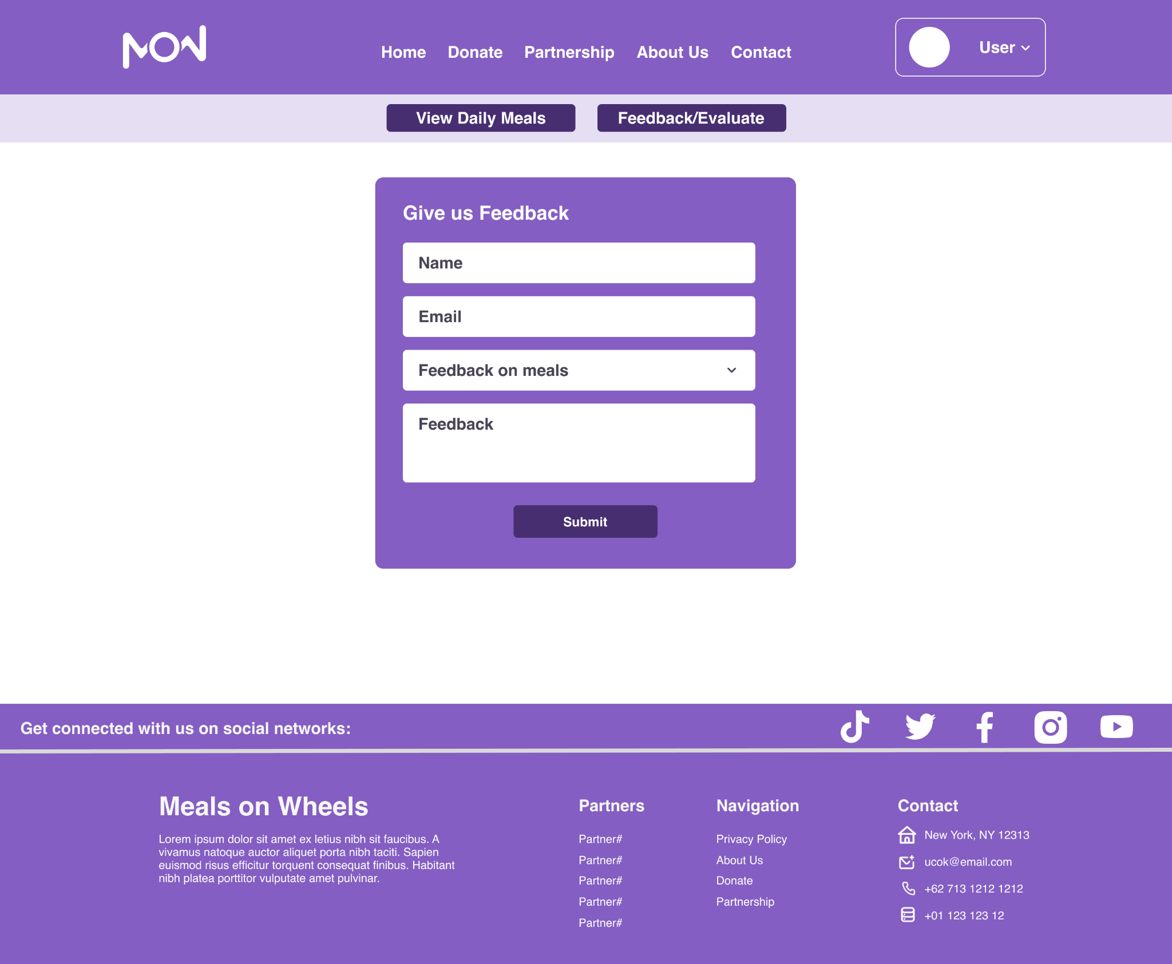

Driver: Homepage

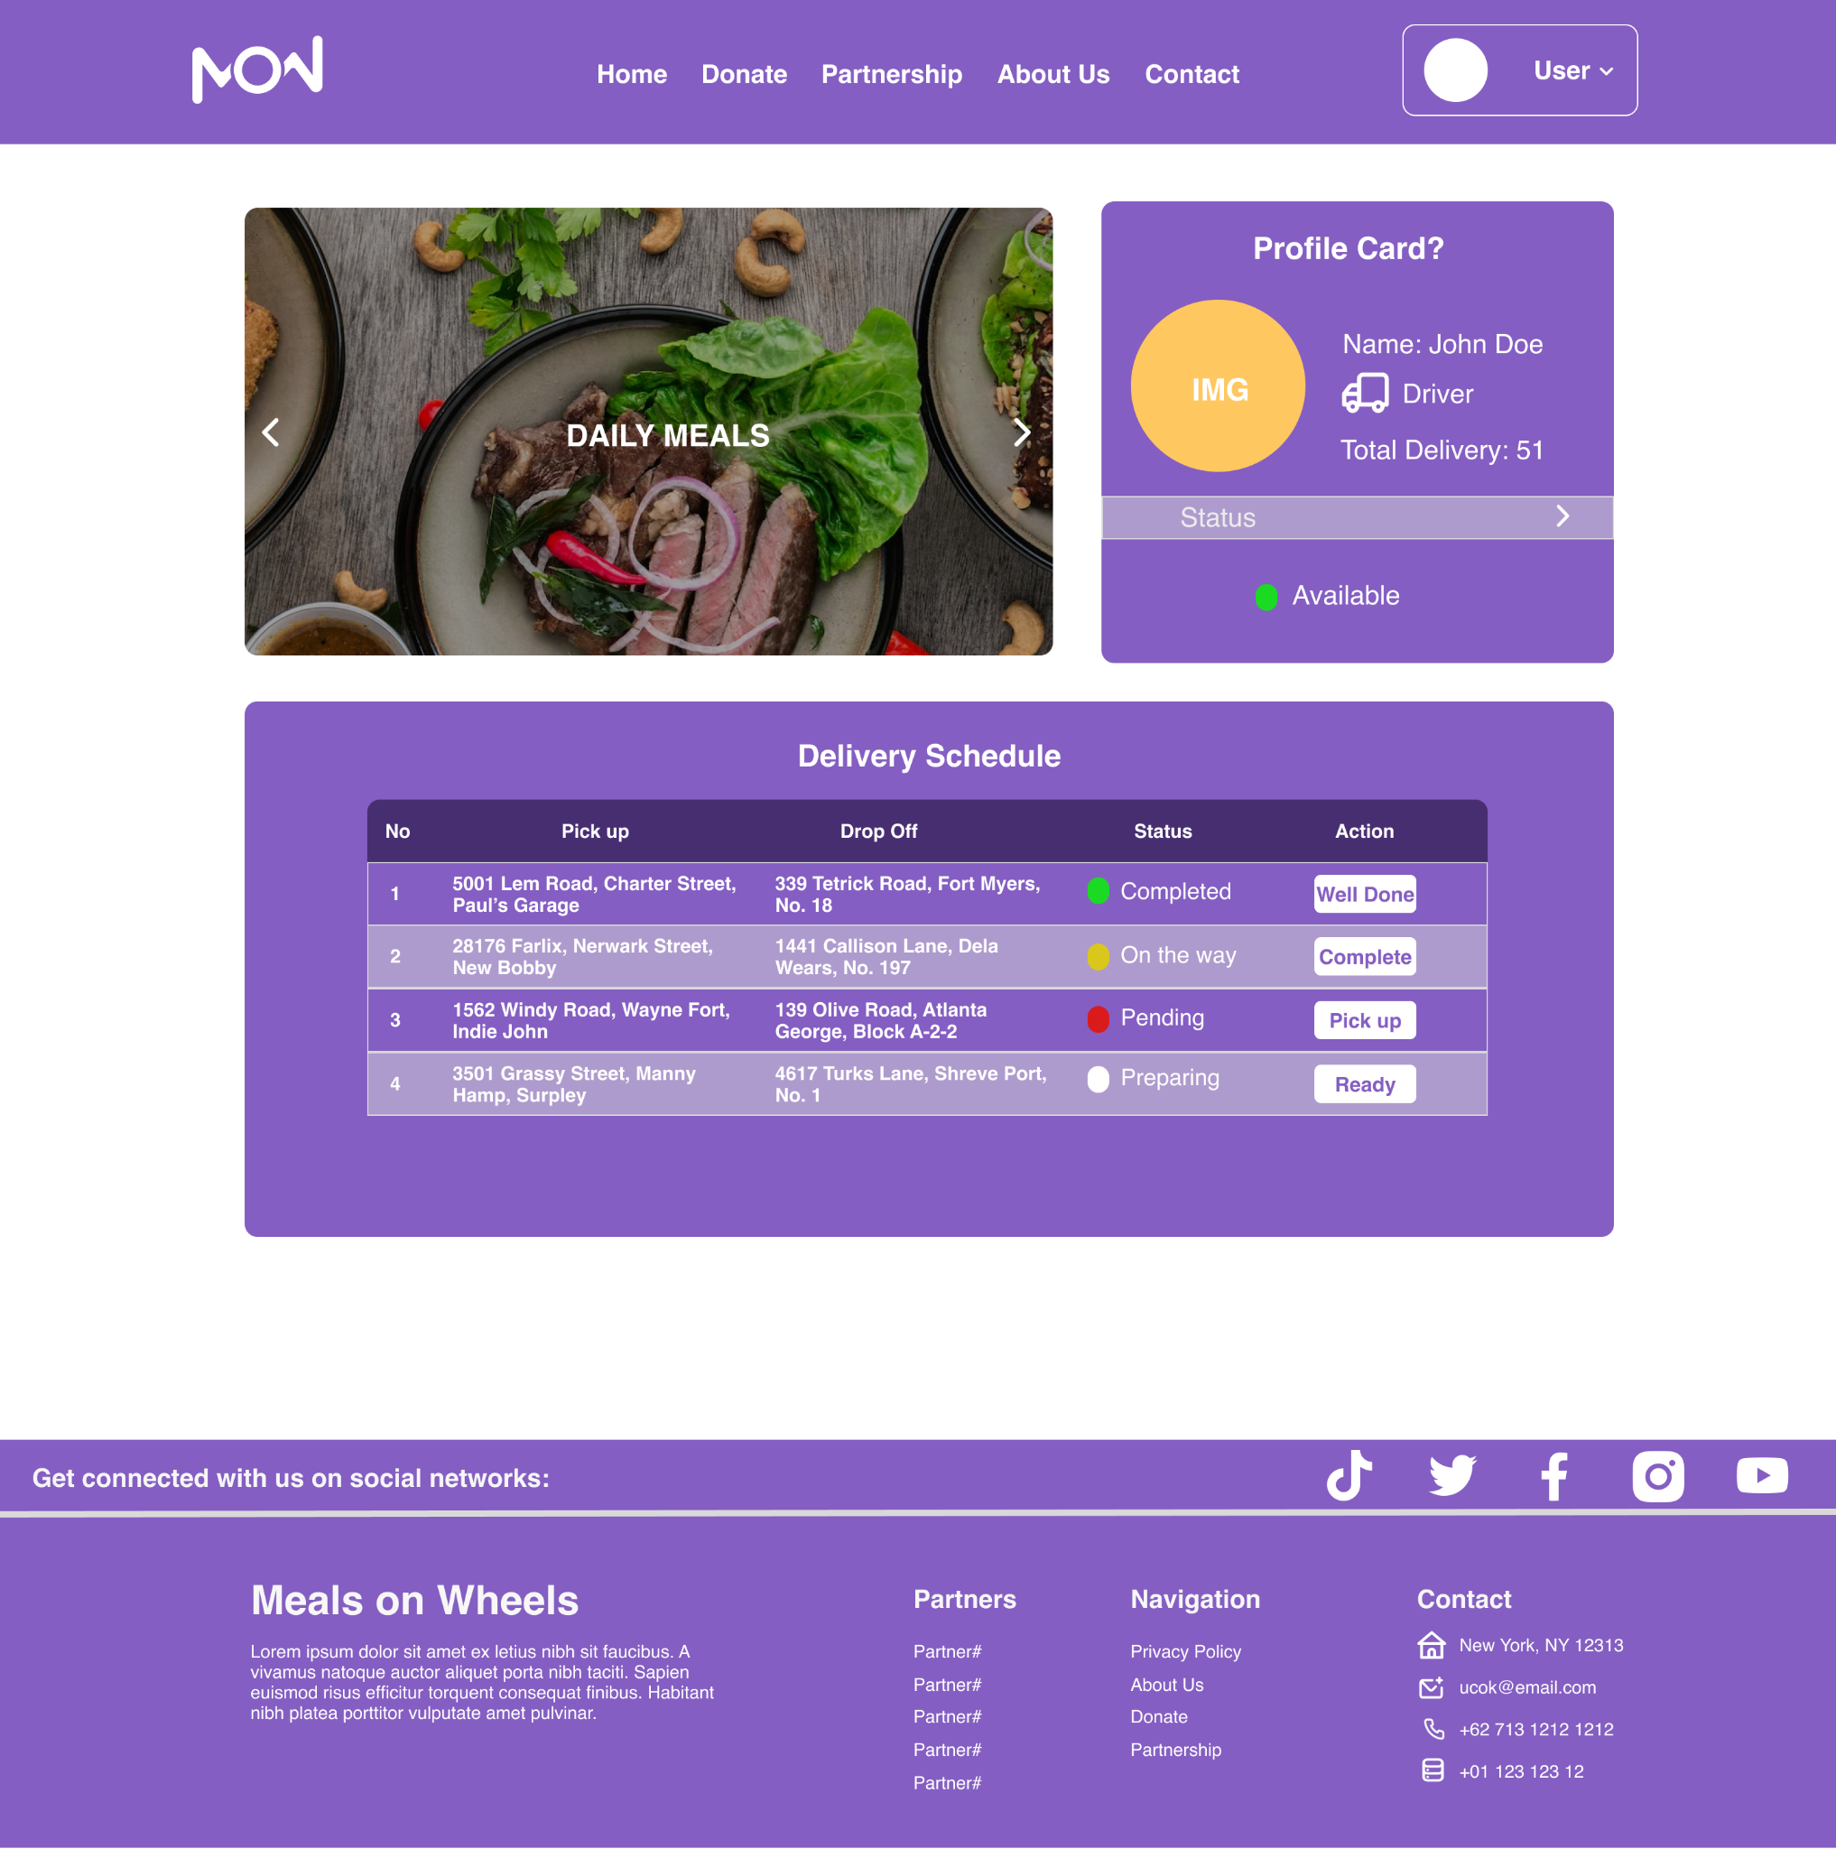

Caregiver: Homepage

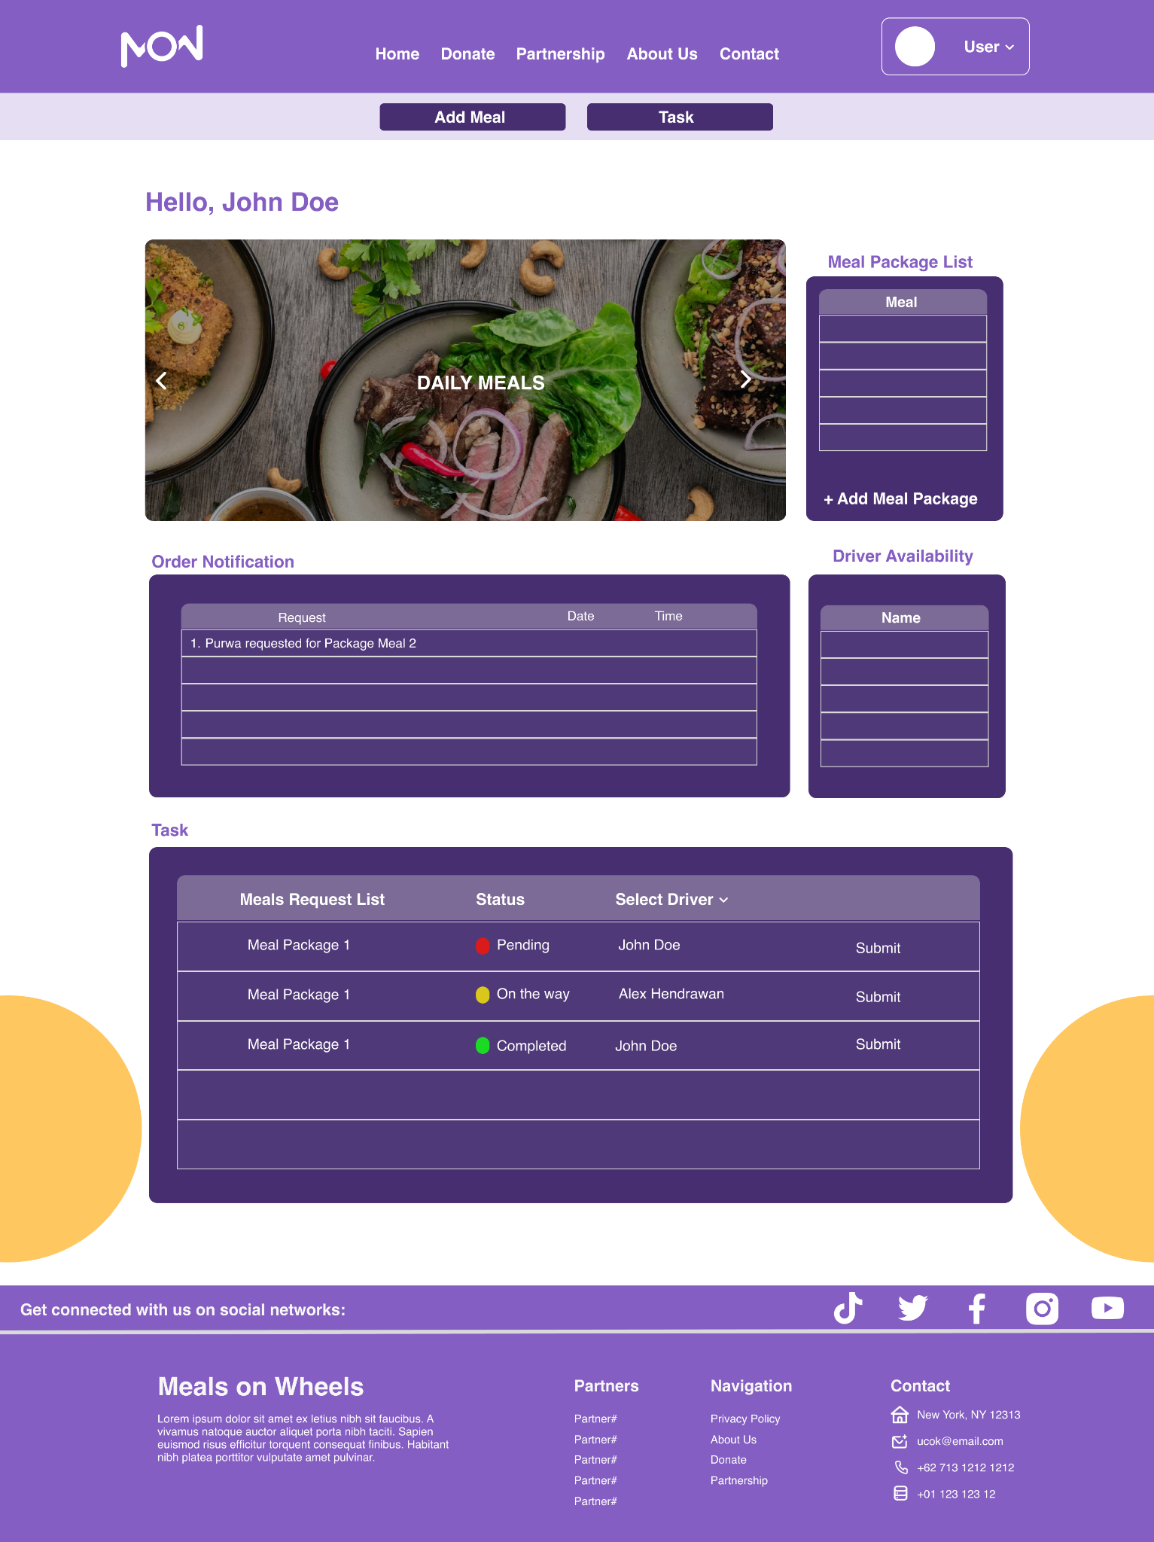

Caregiver: Add Meal Popup

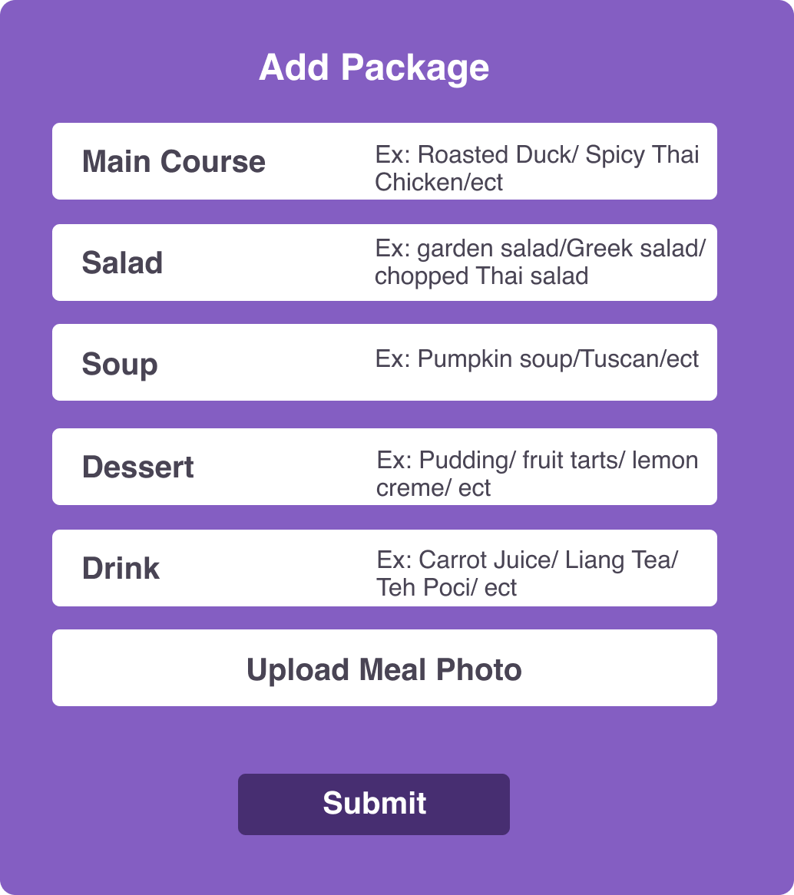

Admin: Homepage

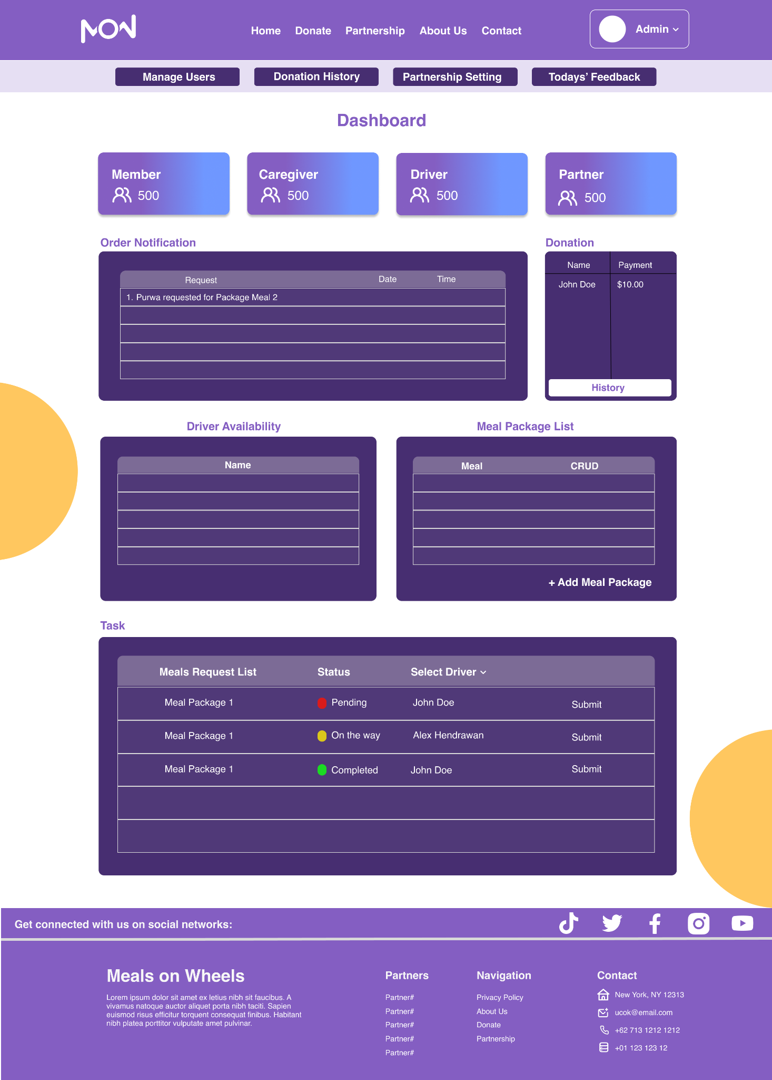

Admin: Donation Setting

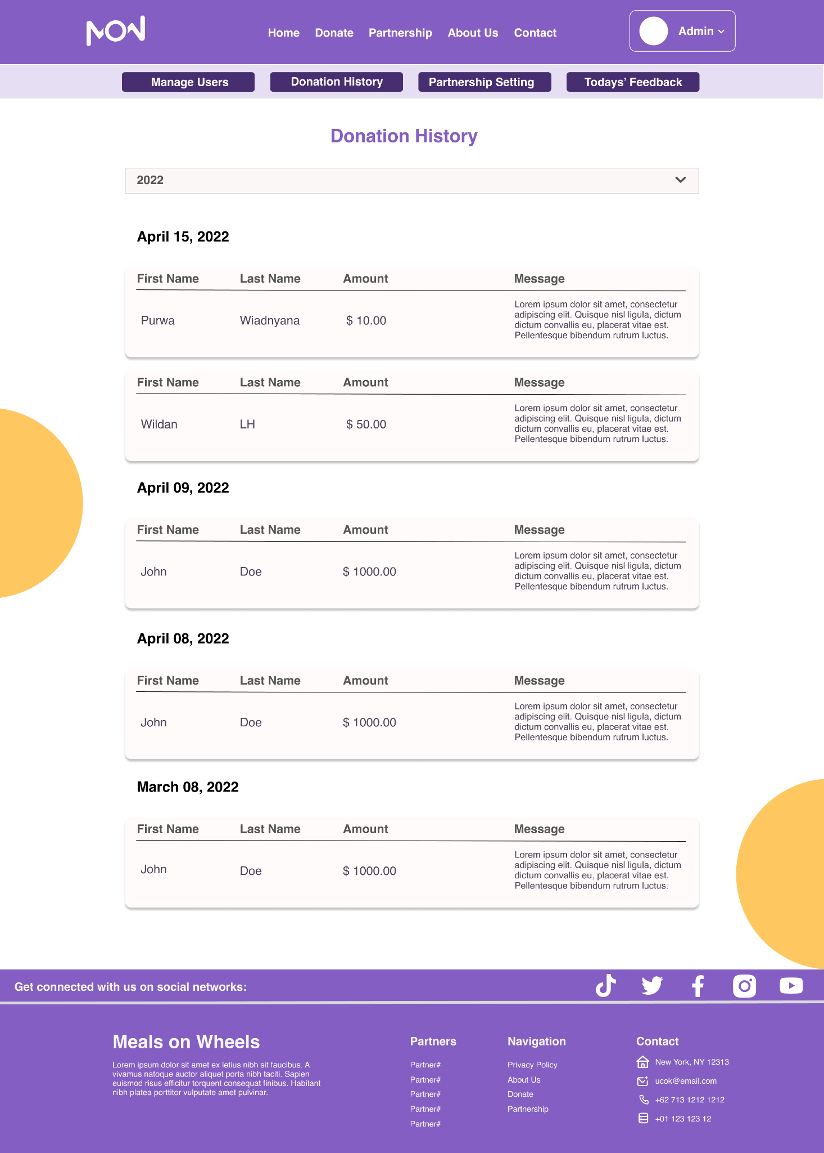

Admin: Partnership Setting

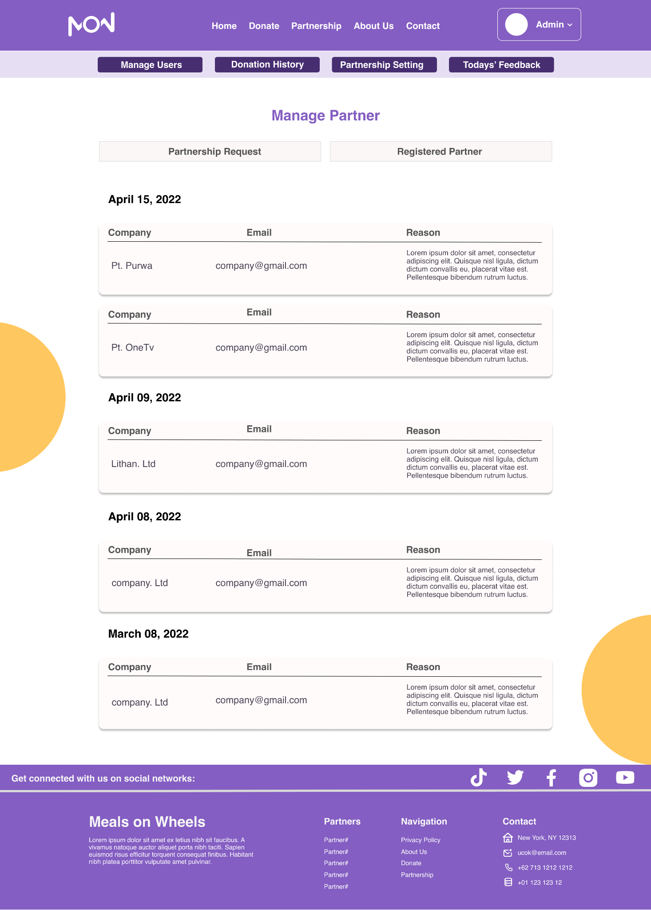

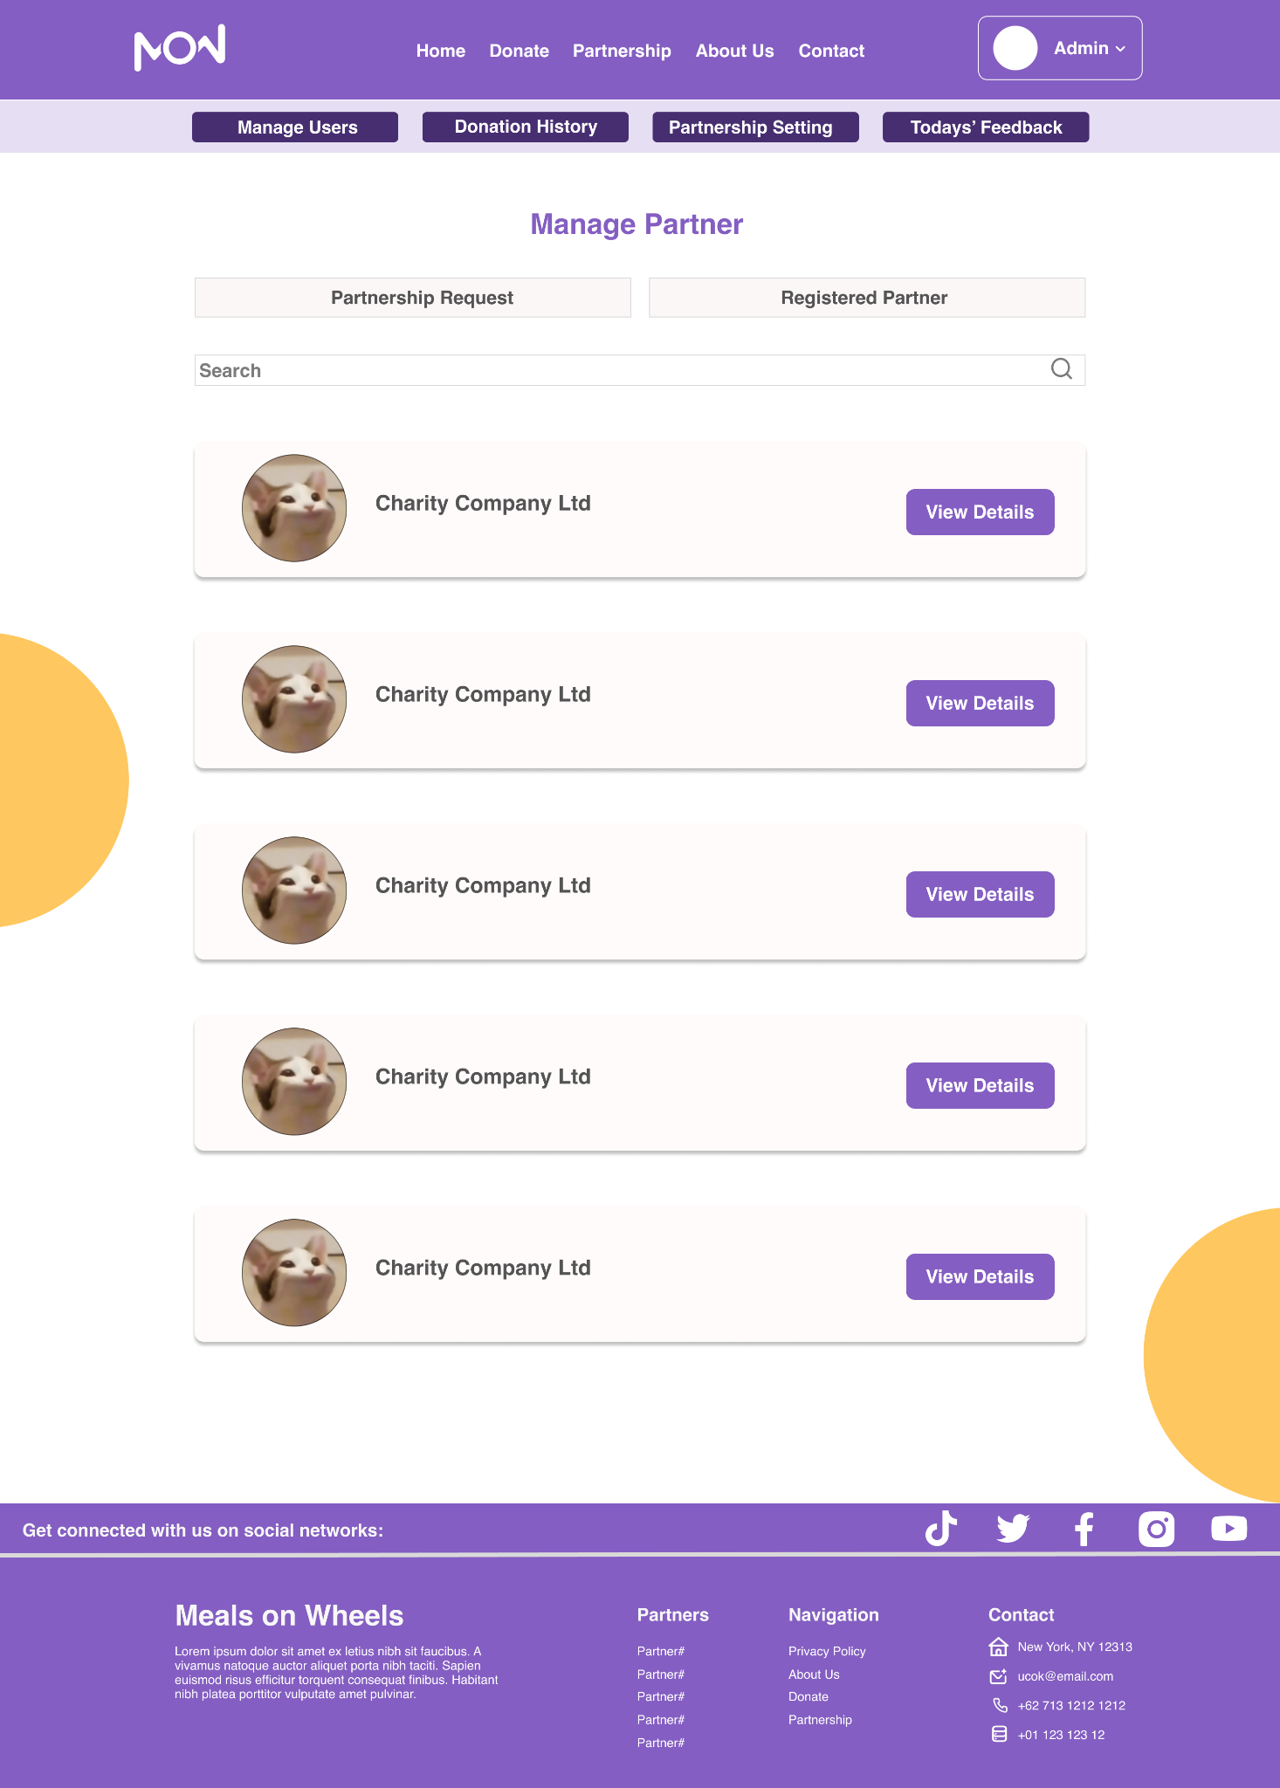

Admin: Manage All User Page



Admin: Today Feedback Popup & View Partner Details Popup

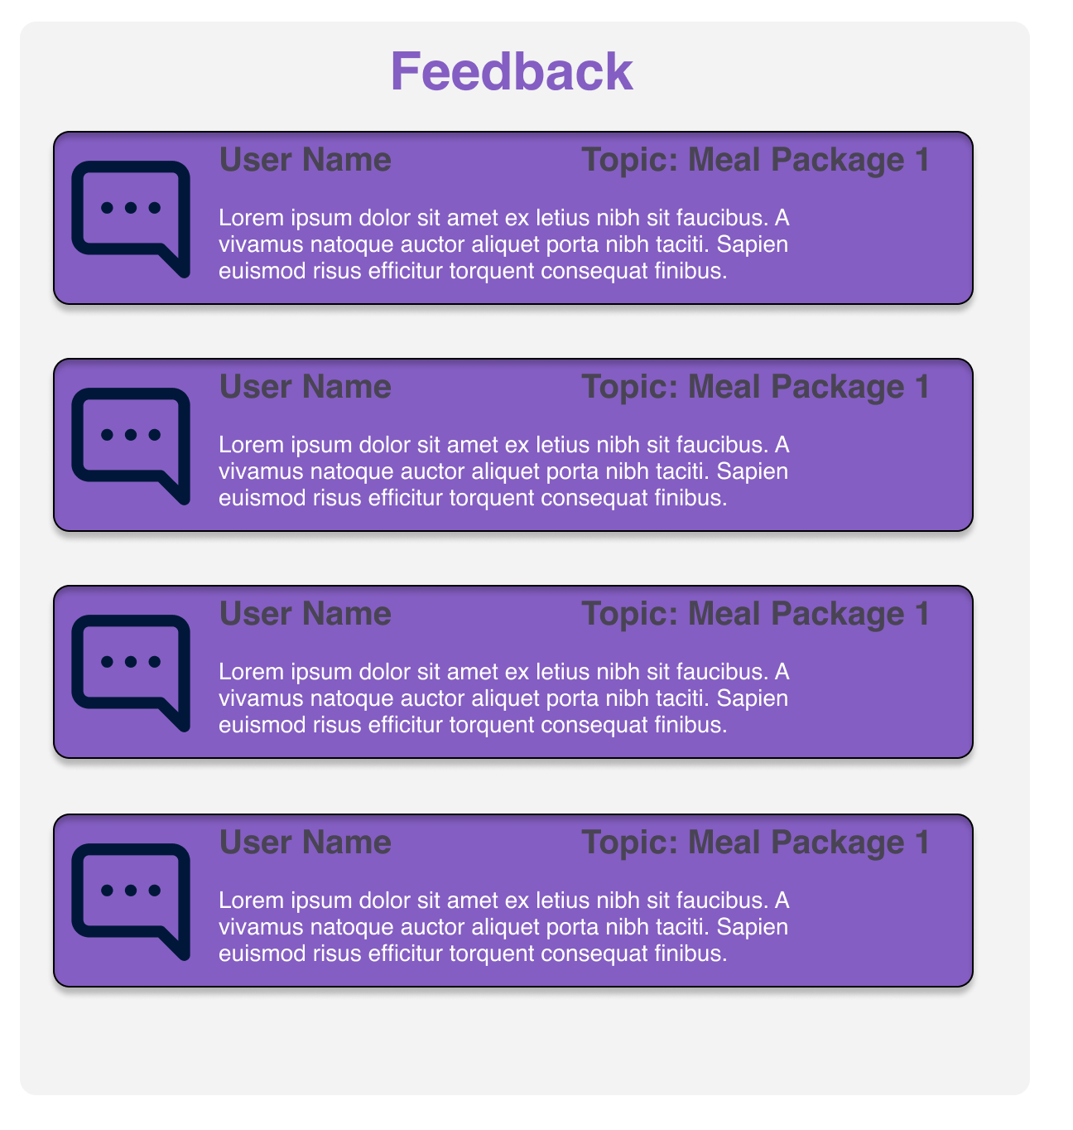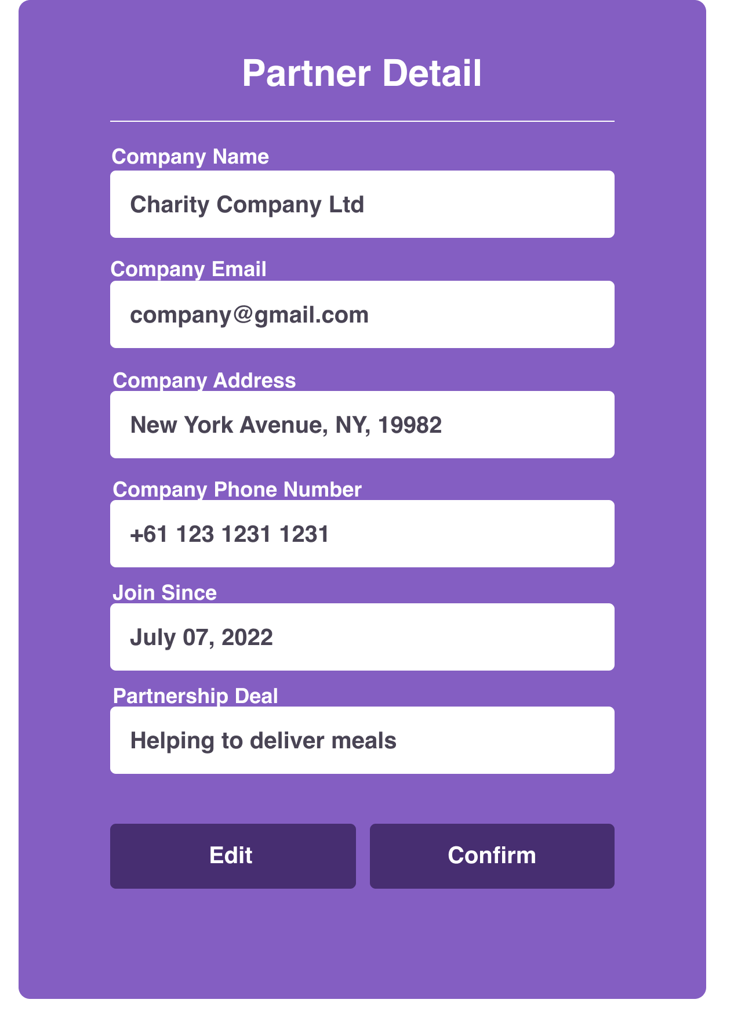

# Project Stakeholder Presentation

## **Stakeholders Review Statements & Document**

|  |  |  |  |  |
| --- | --- | --- | --- | --- |
| **Stakeholder** | **Specific Areas to be Improved** | **Actions to be taken to improve performance** | **Progress Status** | **Screen Capture** |
| Mr David from Unity One Solution, Merry Meal Representatives | No partner webpage | Add a partner page since partners need to receive information about meal requests and prepare it. | Achieved |  |
| Mr David from Unity One Solution, Merry Meal Representatives | Adult will able to request frozen meal since on weekend, MerryMeal will not open | Create frozen meal functionality & Add frozen meal package on the website | Achieved |  |
| Mr David from Unity One Solution, Merry Meal Representatives | Allow money transactions for the organization to be able to receive donations from others. | Using Third-Party Payment Transaction by implementing Stripe API. | Achieved |  |

# Project Execution

**Home Page  
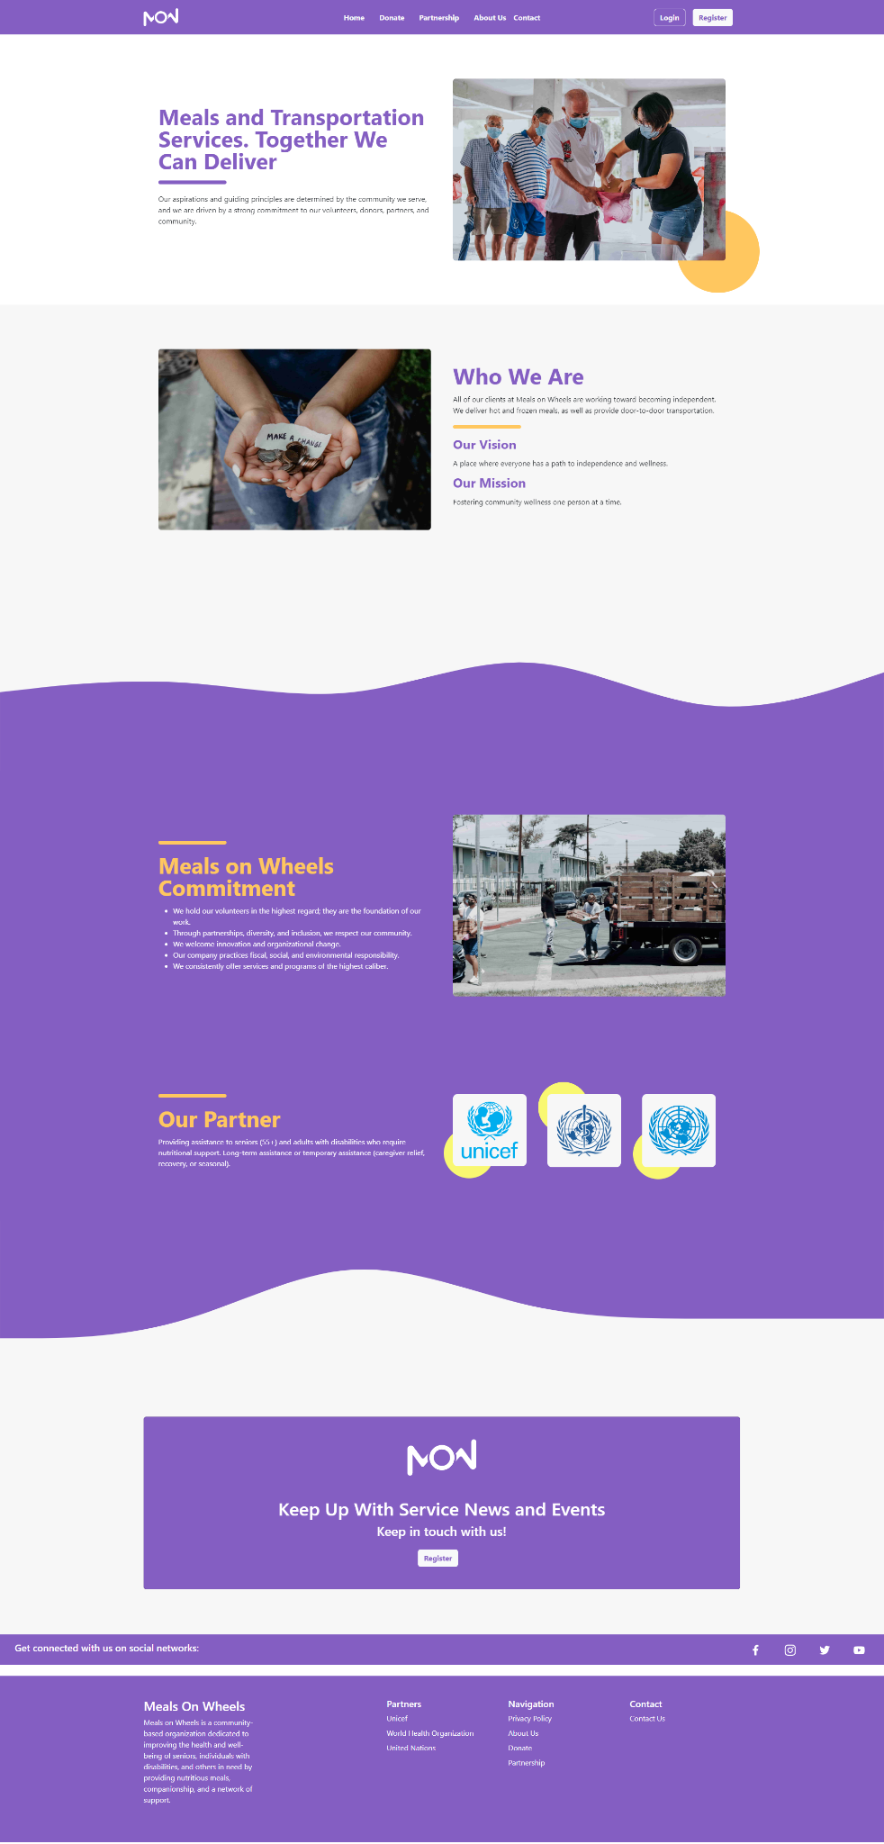**

**Donate Page  
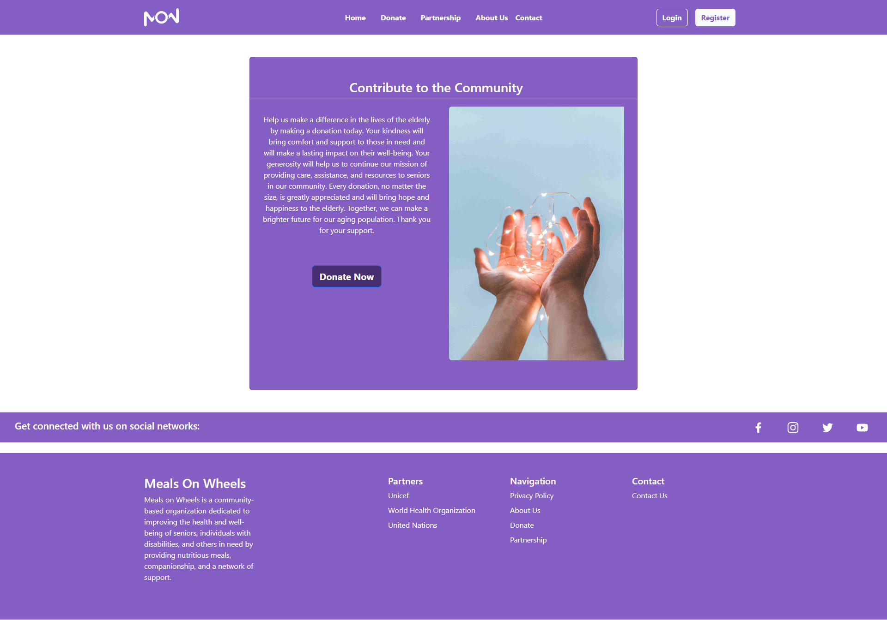**

**Partnership Page  
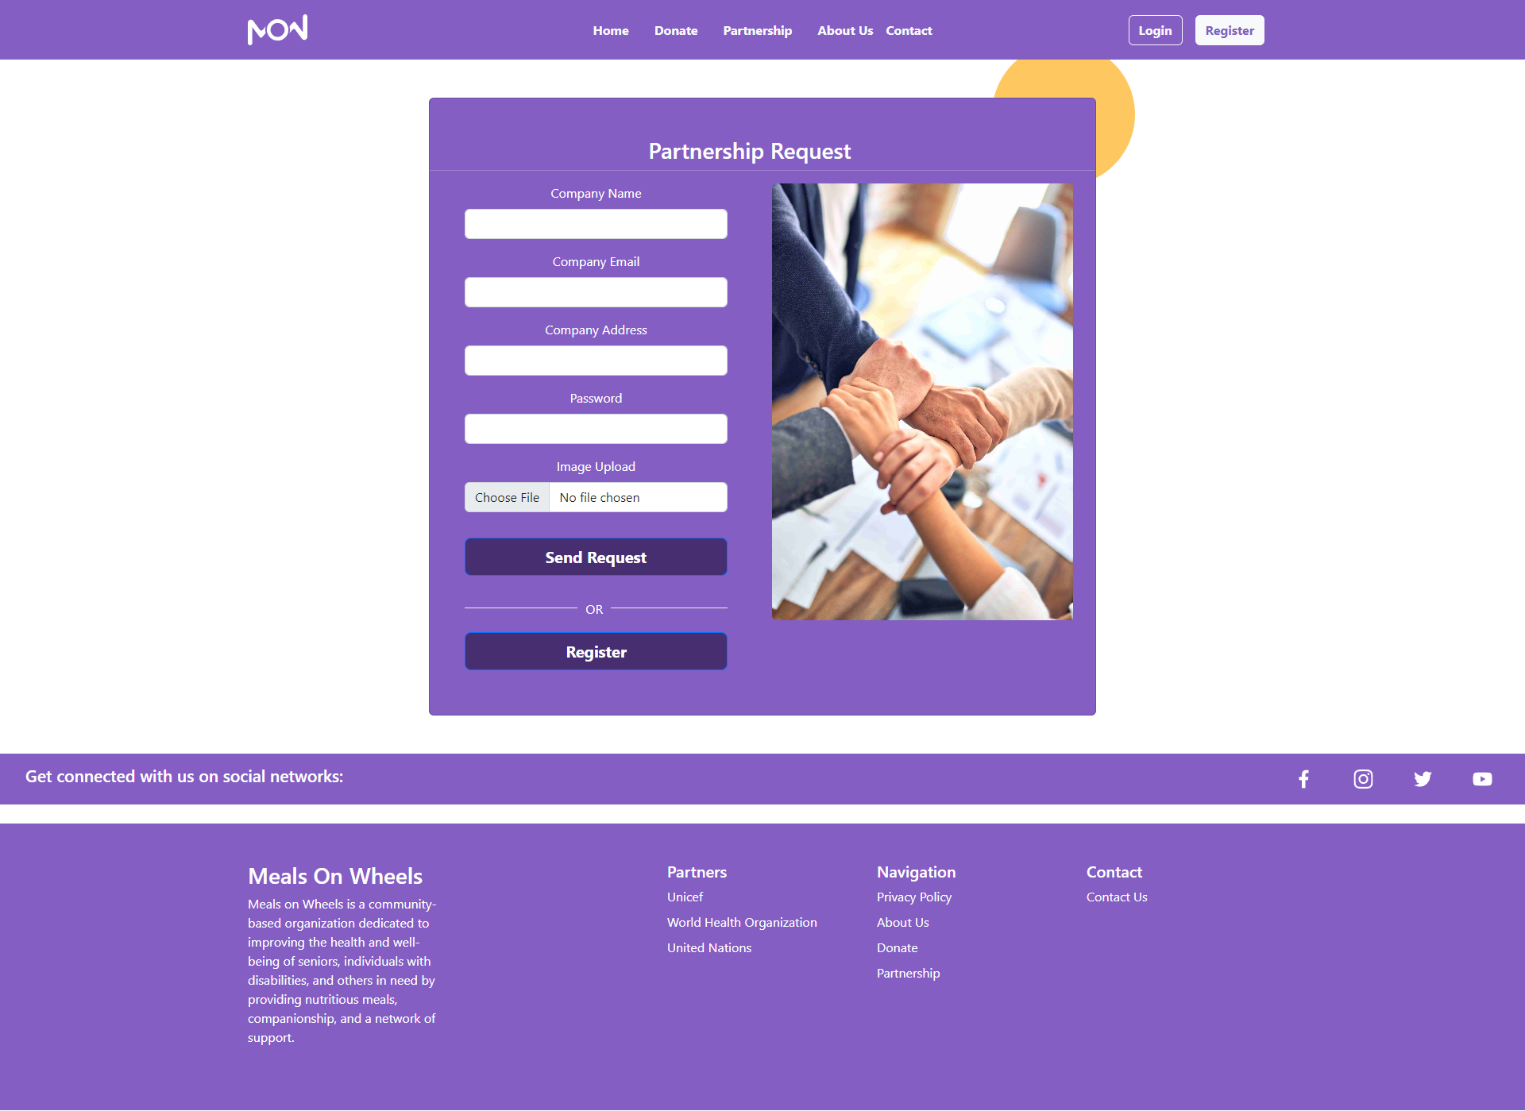**

**About Us Page  
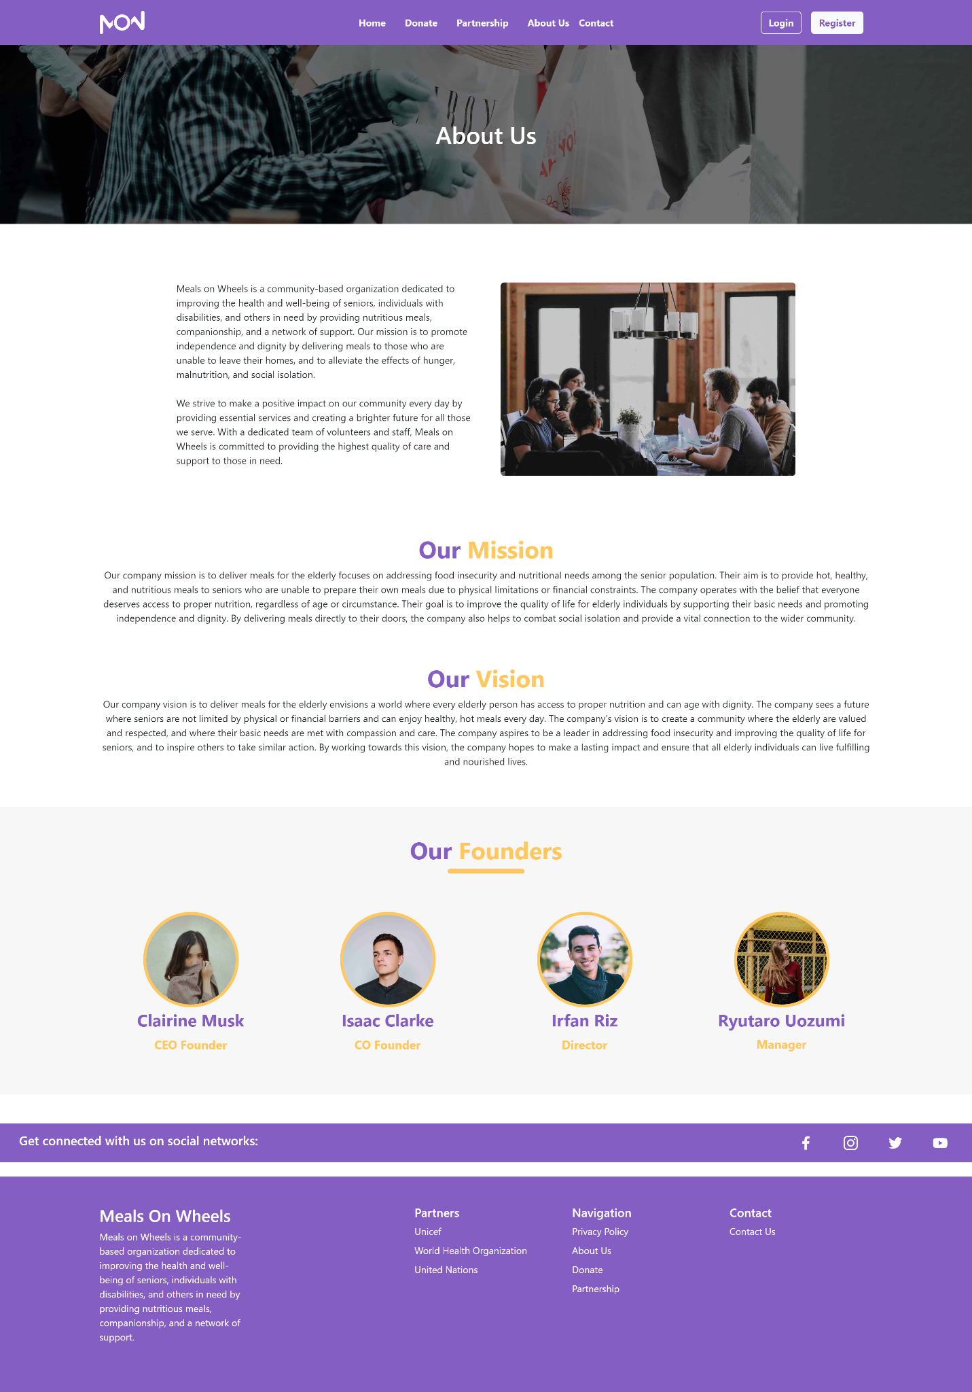**

**Contact Page  
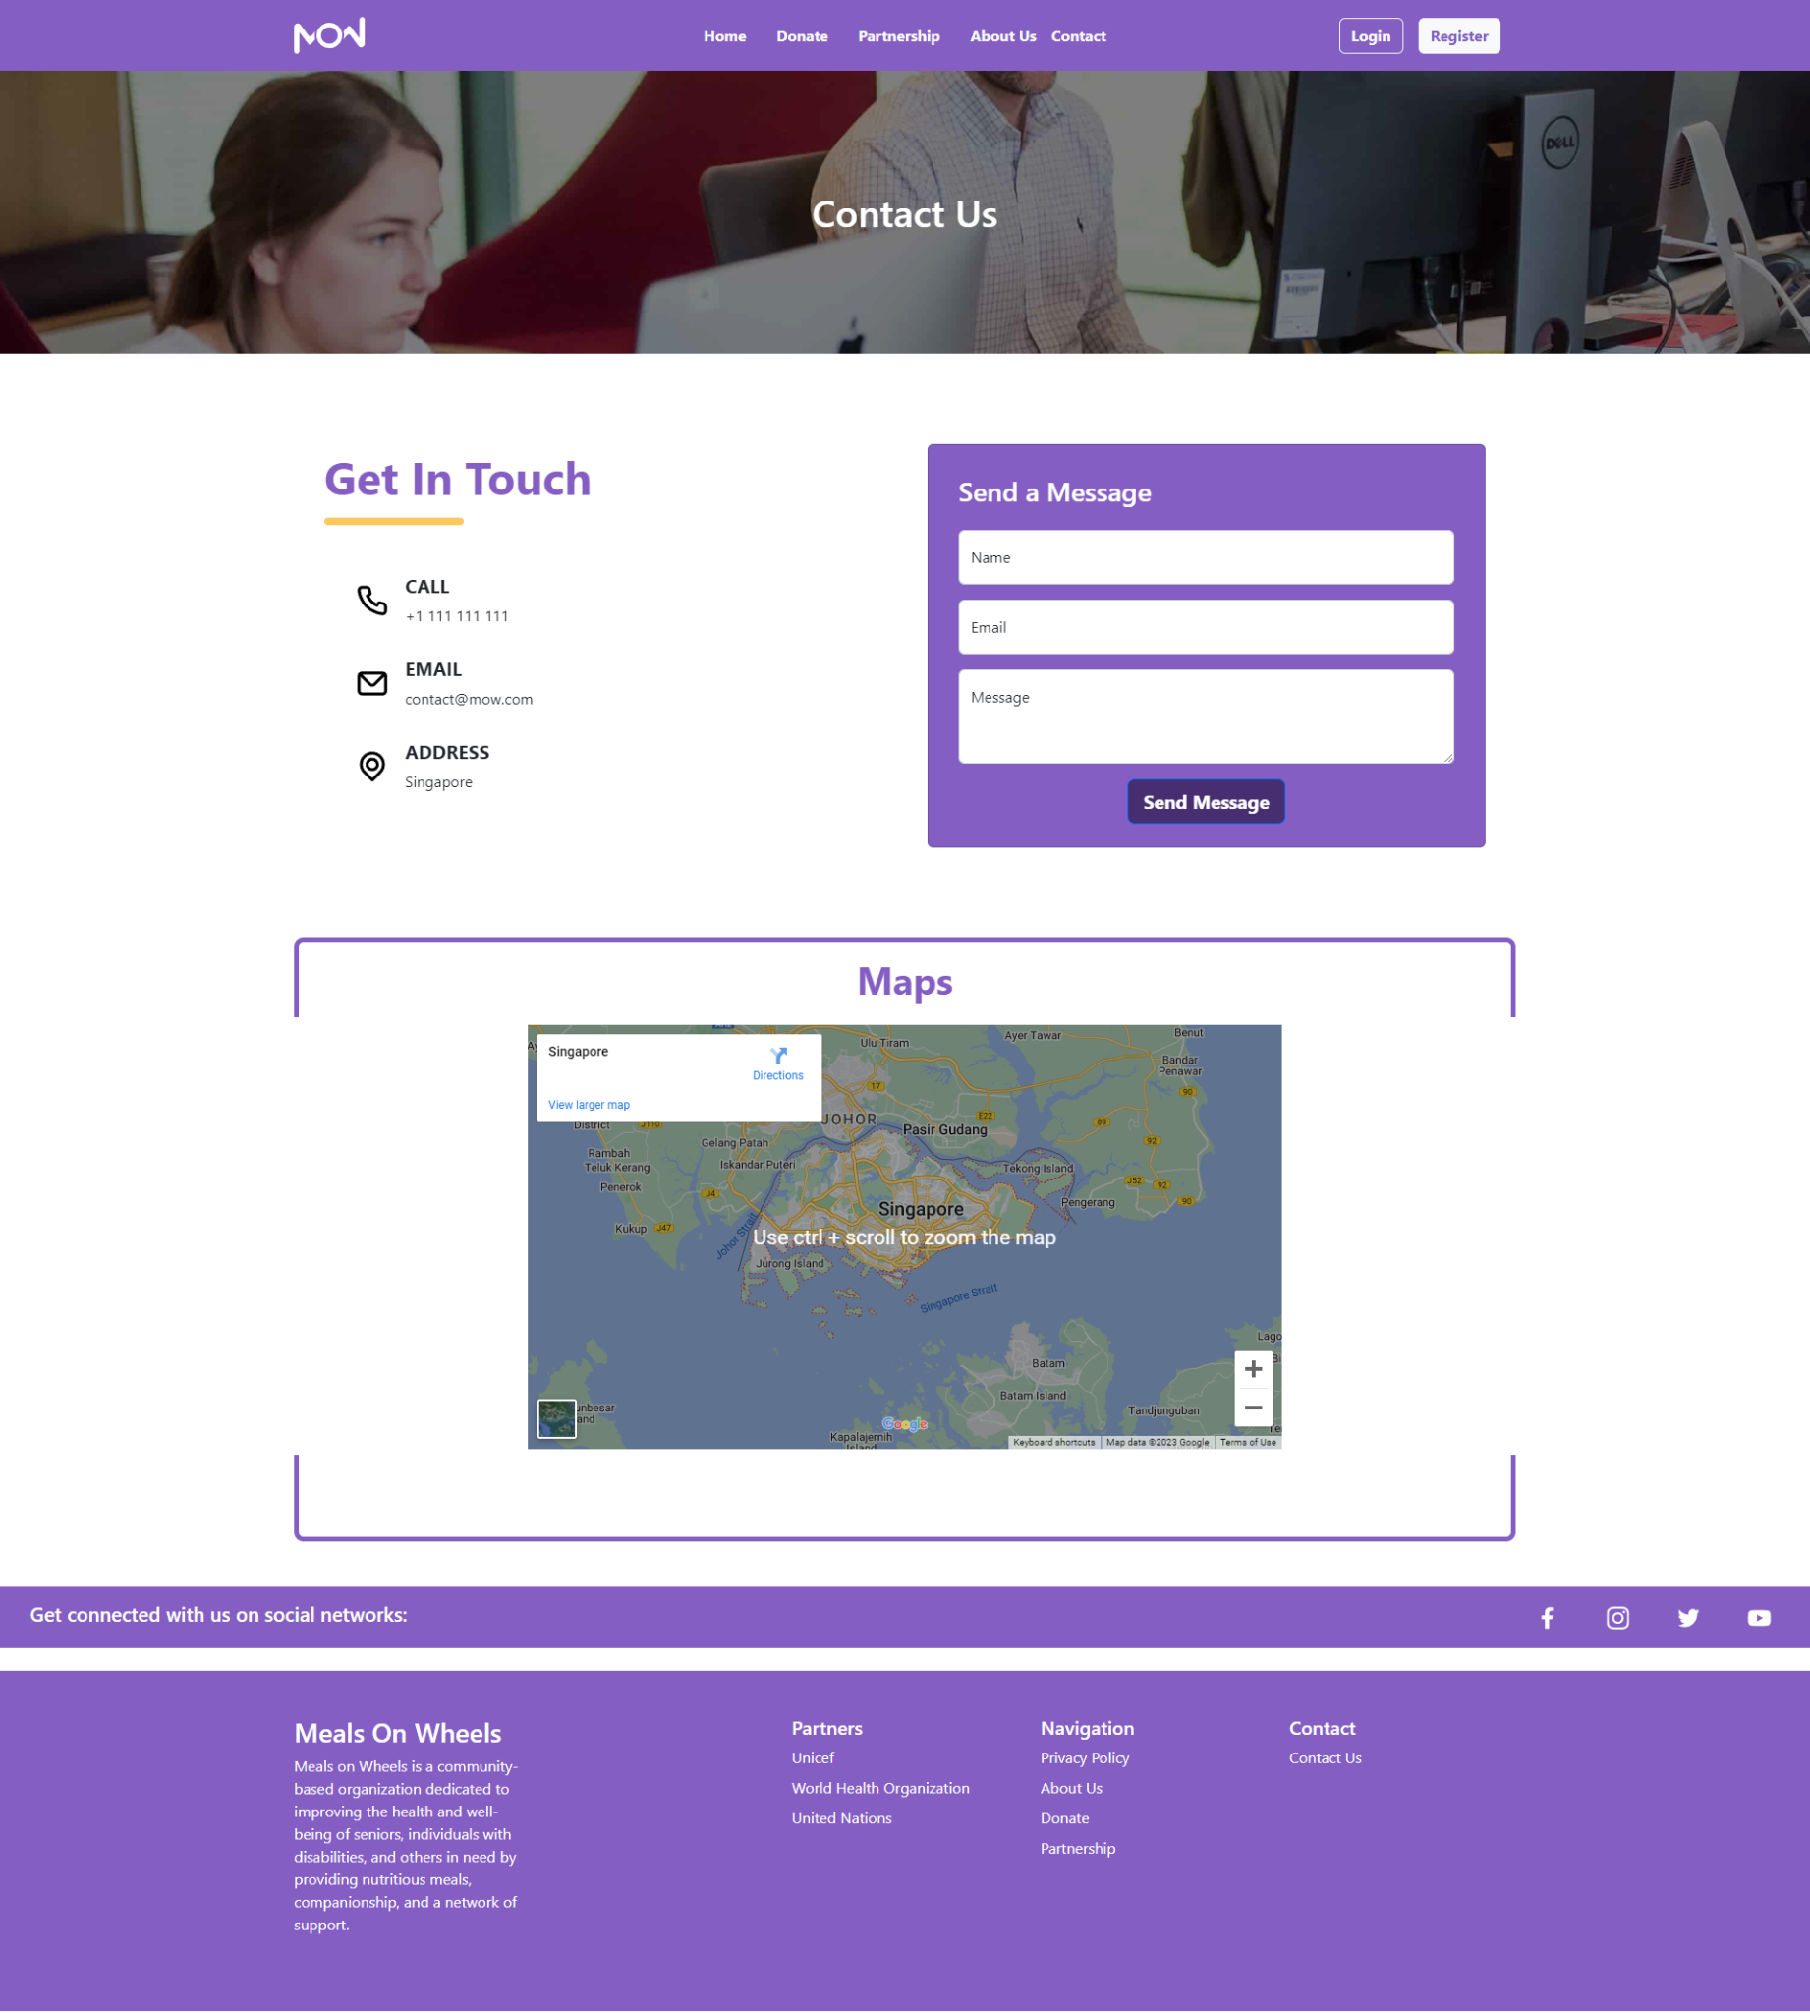  
Login Page  
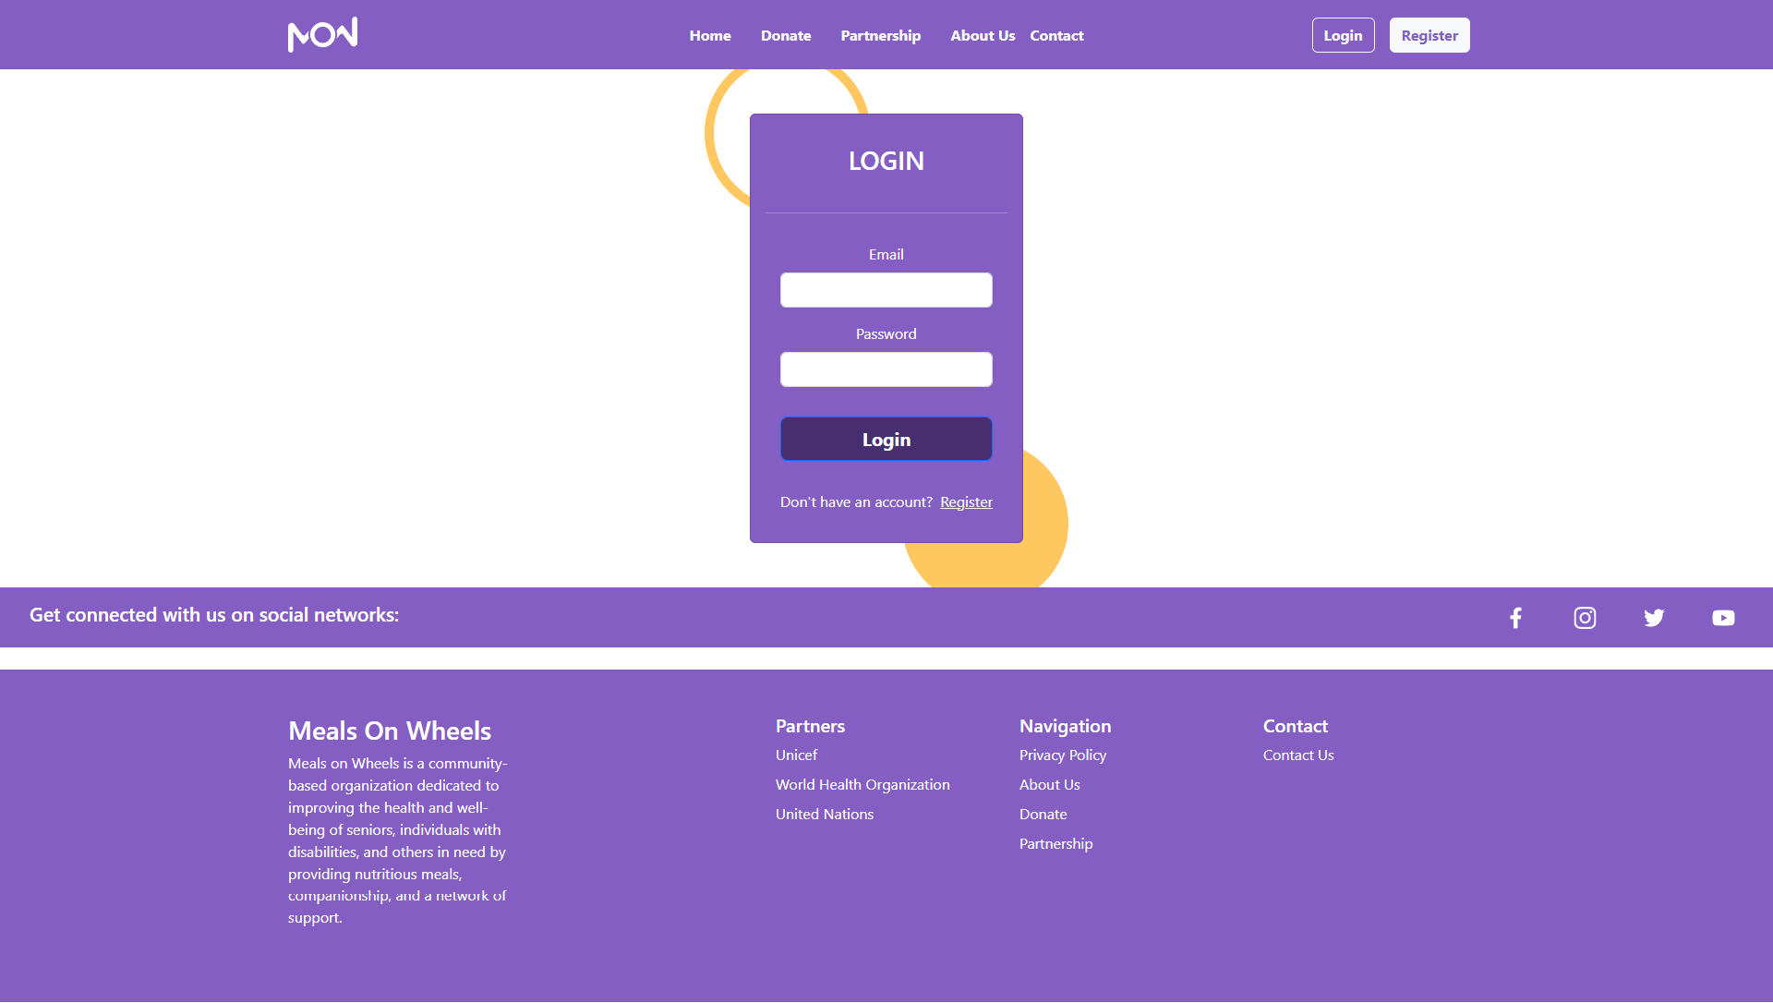**

**Register Page  
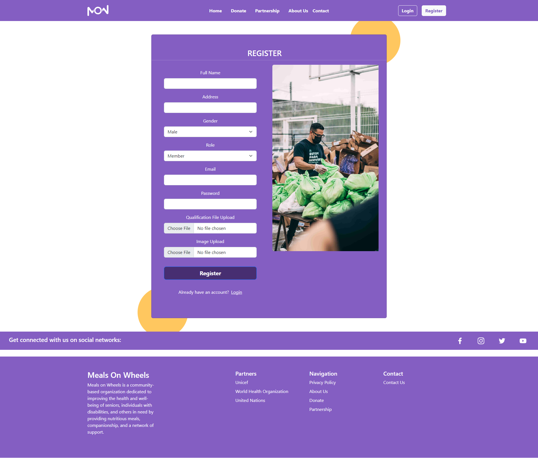**

**Member Home Page  
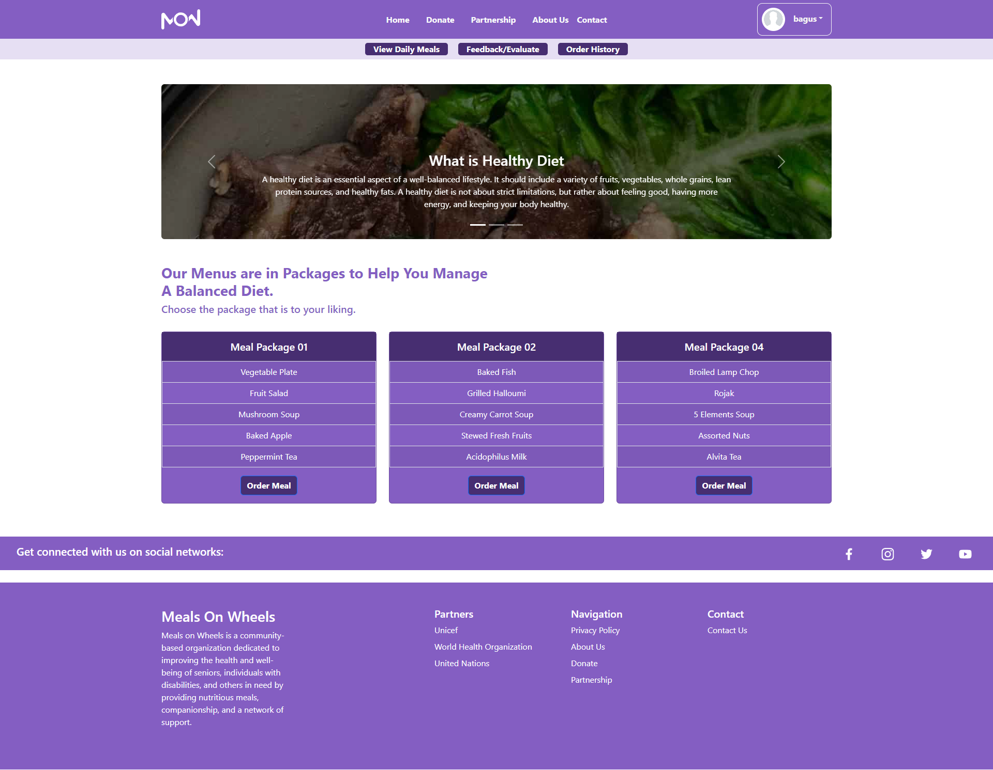**

**Member Order Meal Page  
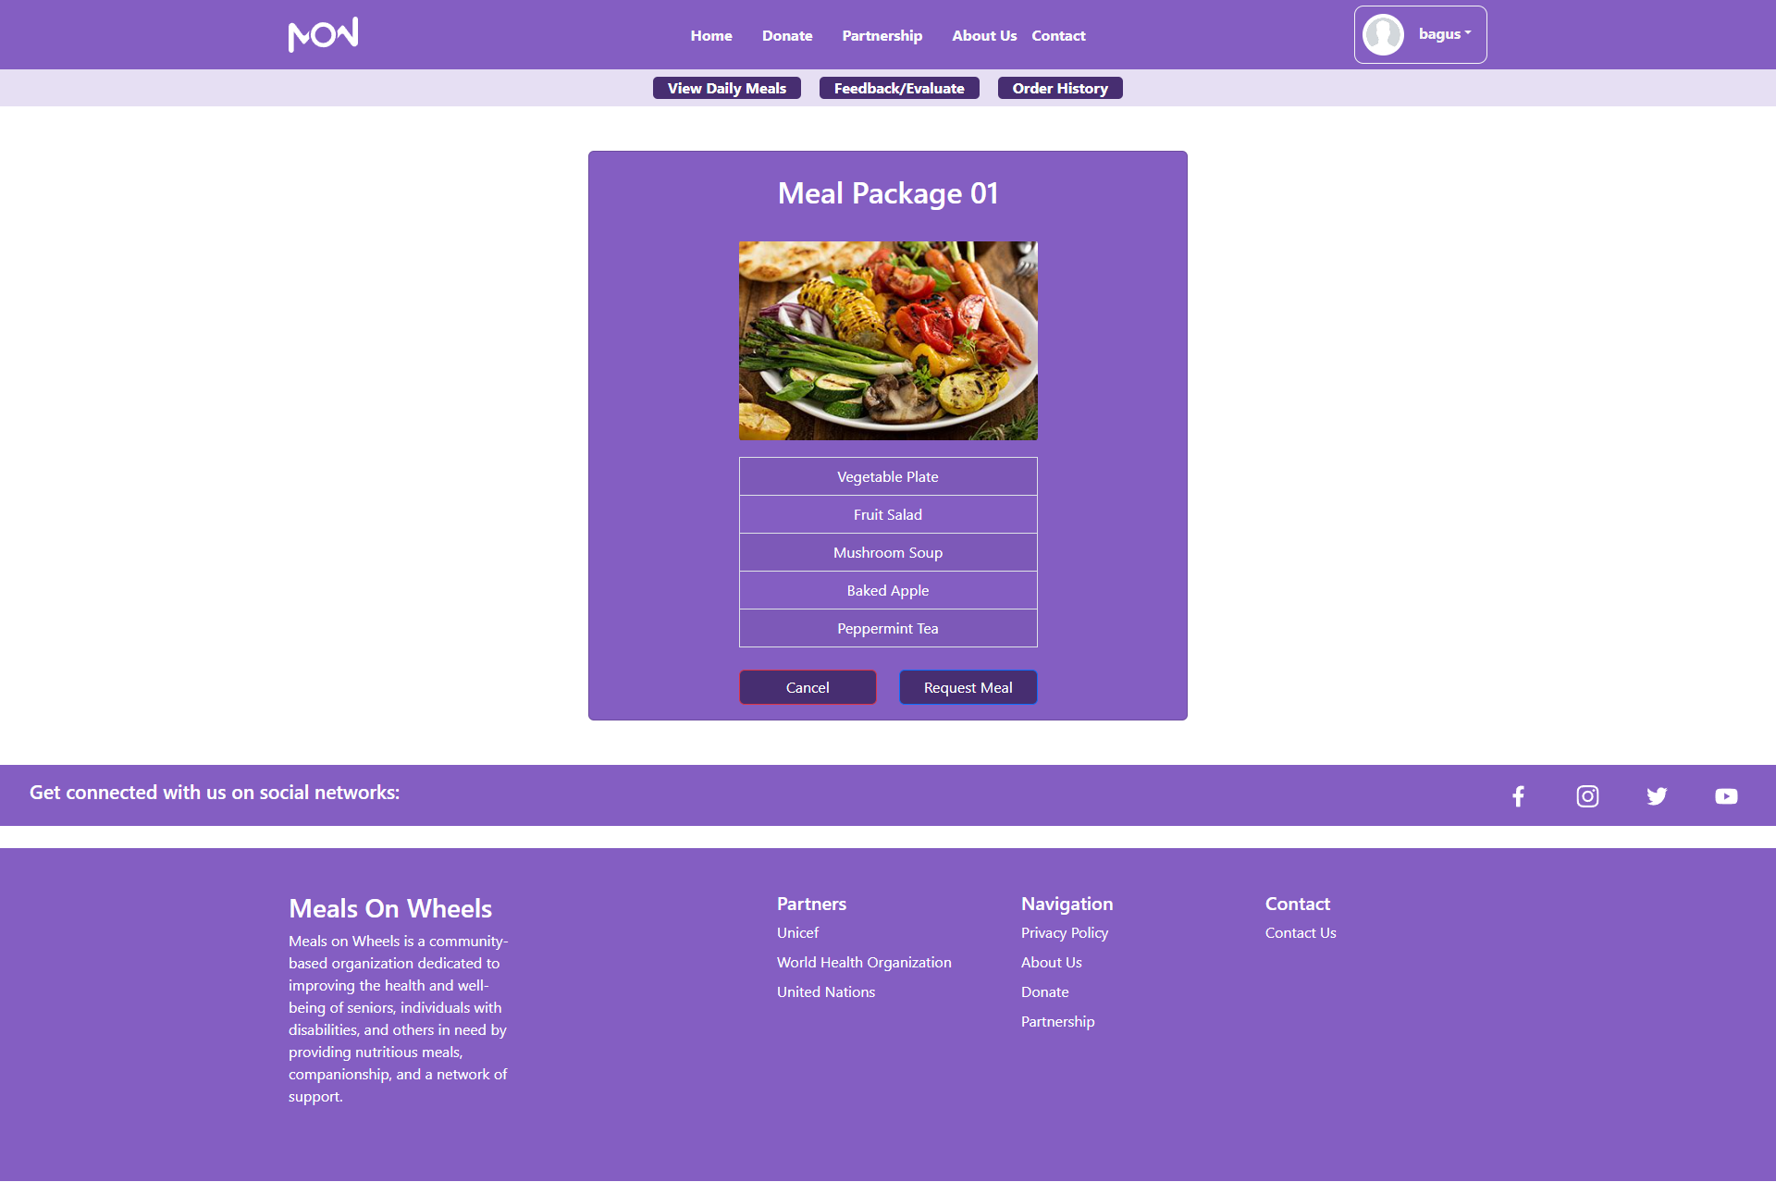**

**Member Feedback Page  
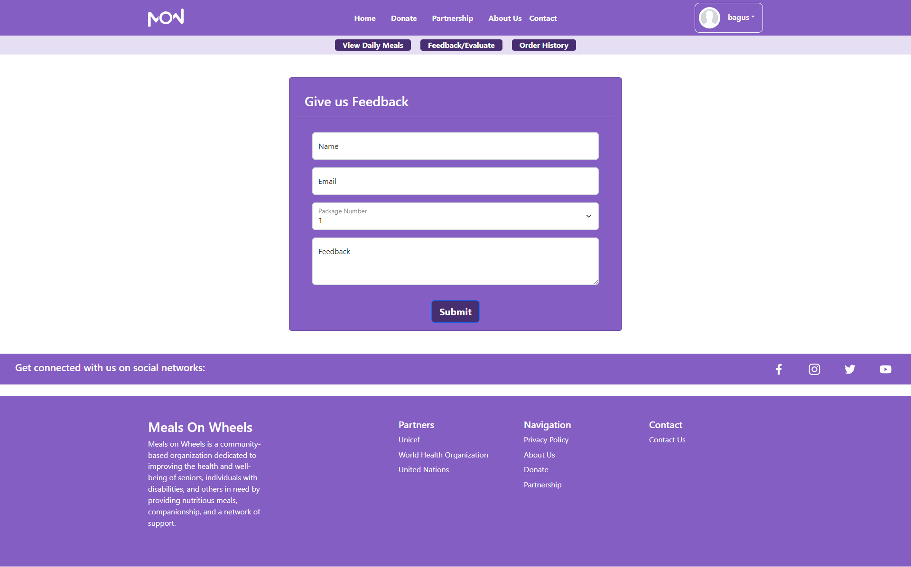**

**Member Order History Page  
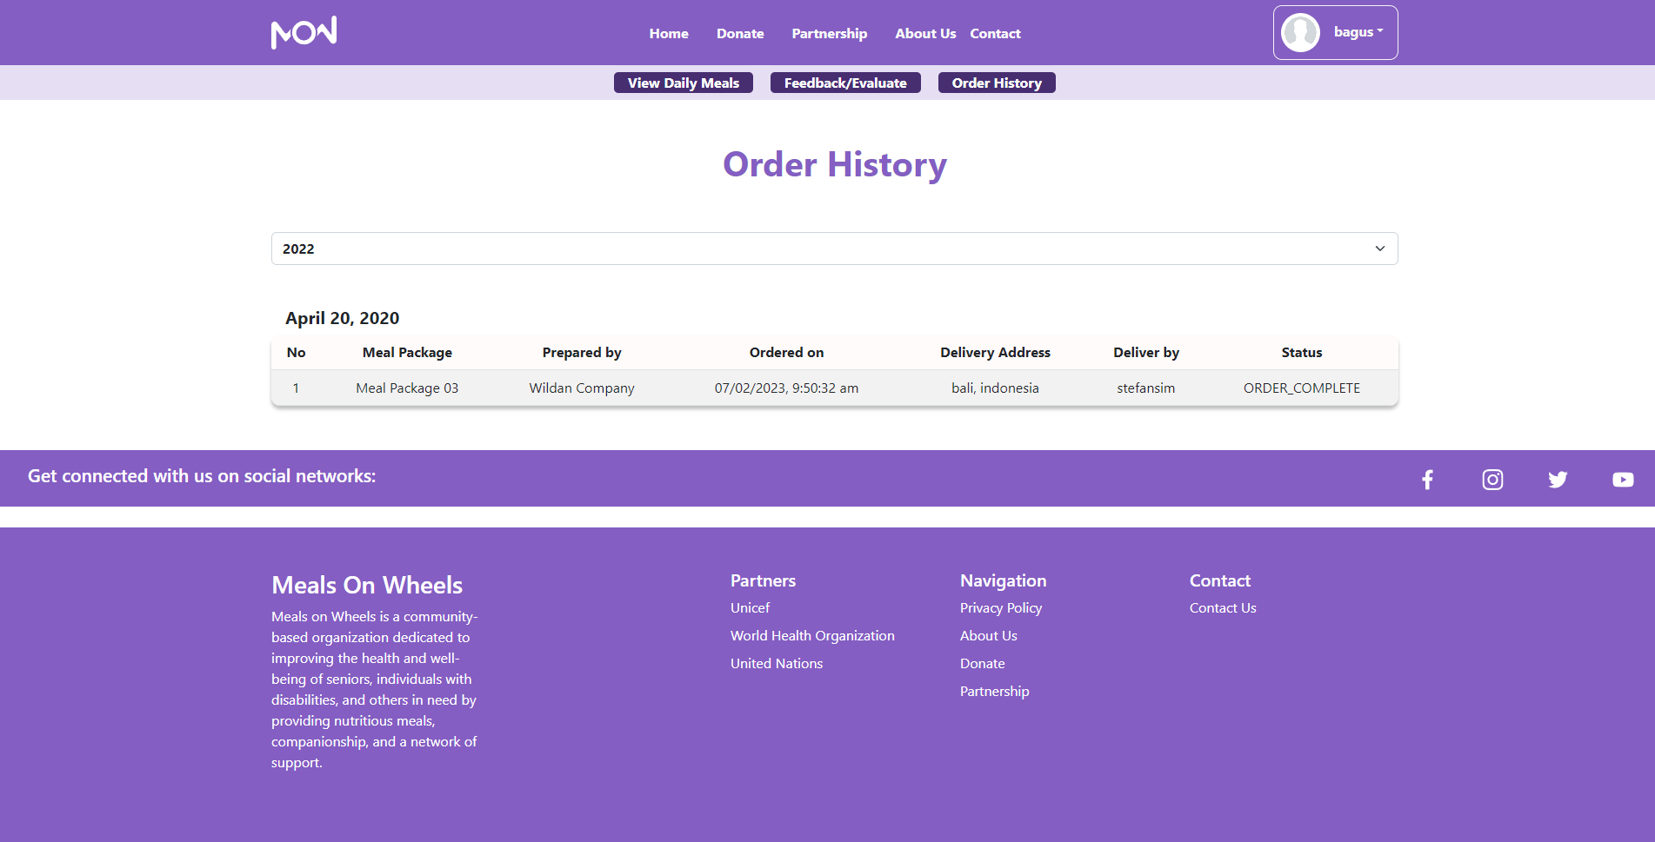**

**Driver Home Page  
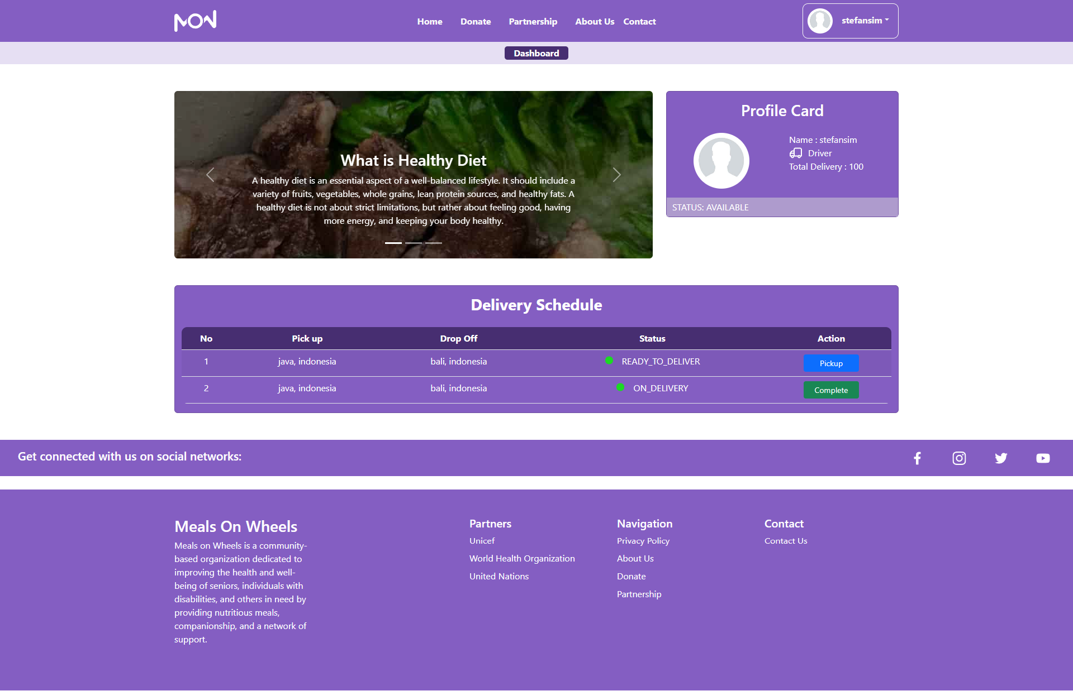**

**Partner Home Page  
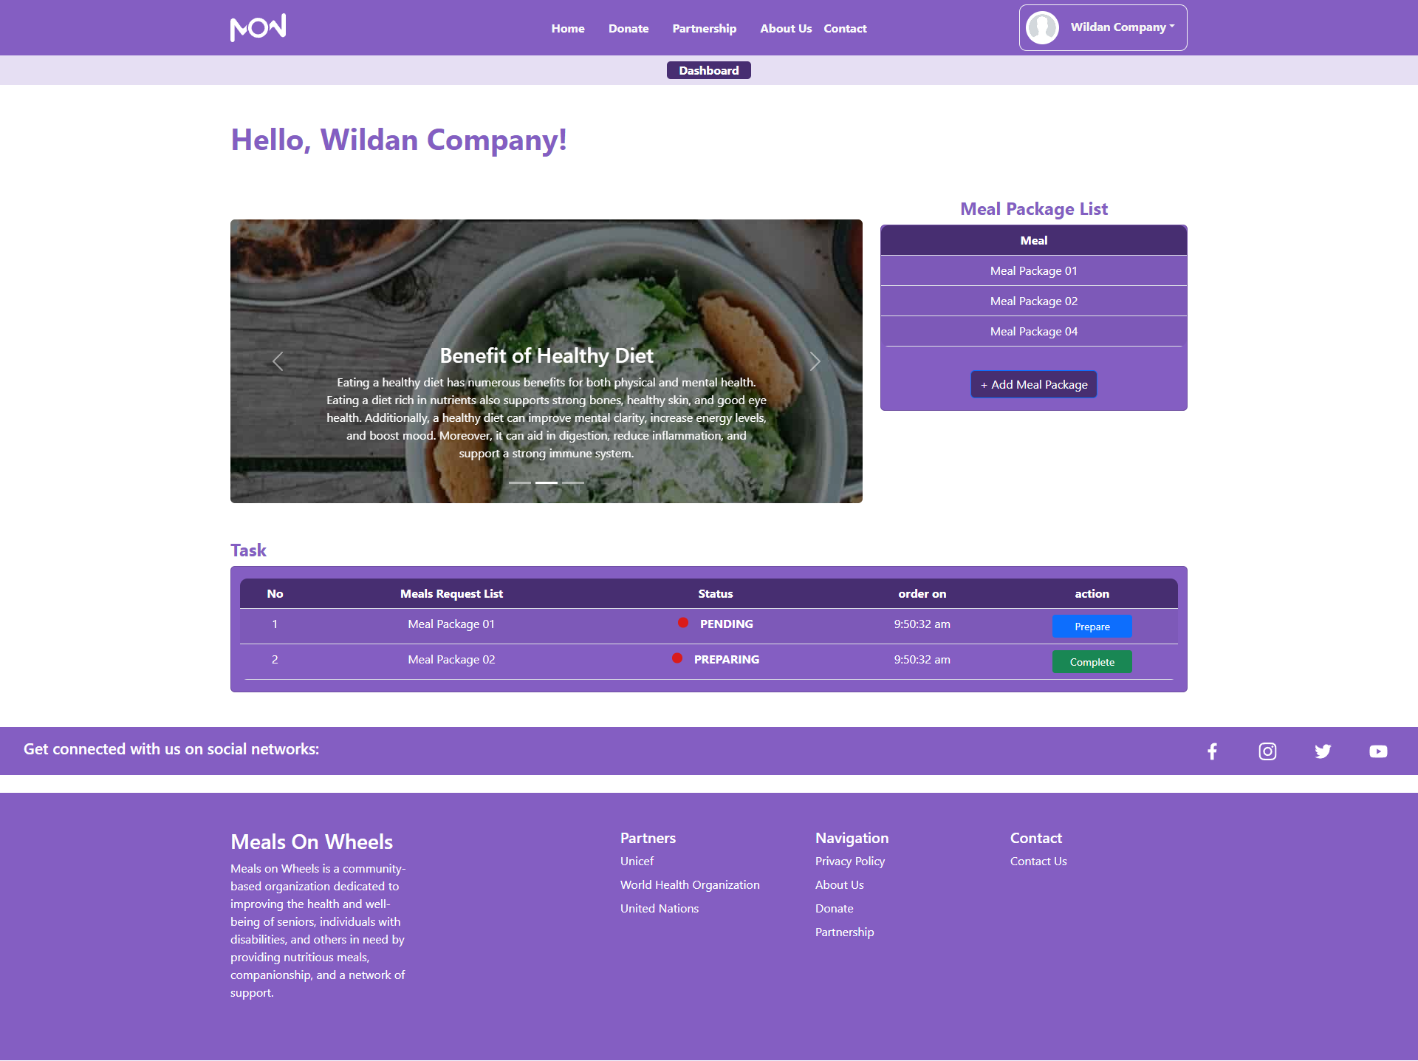**

**Caregiver Home Page  
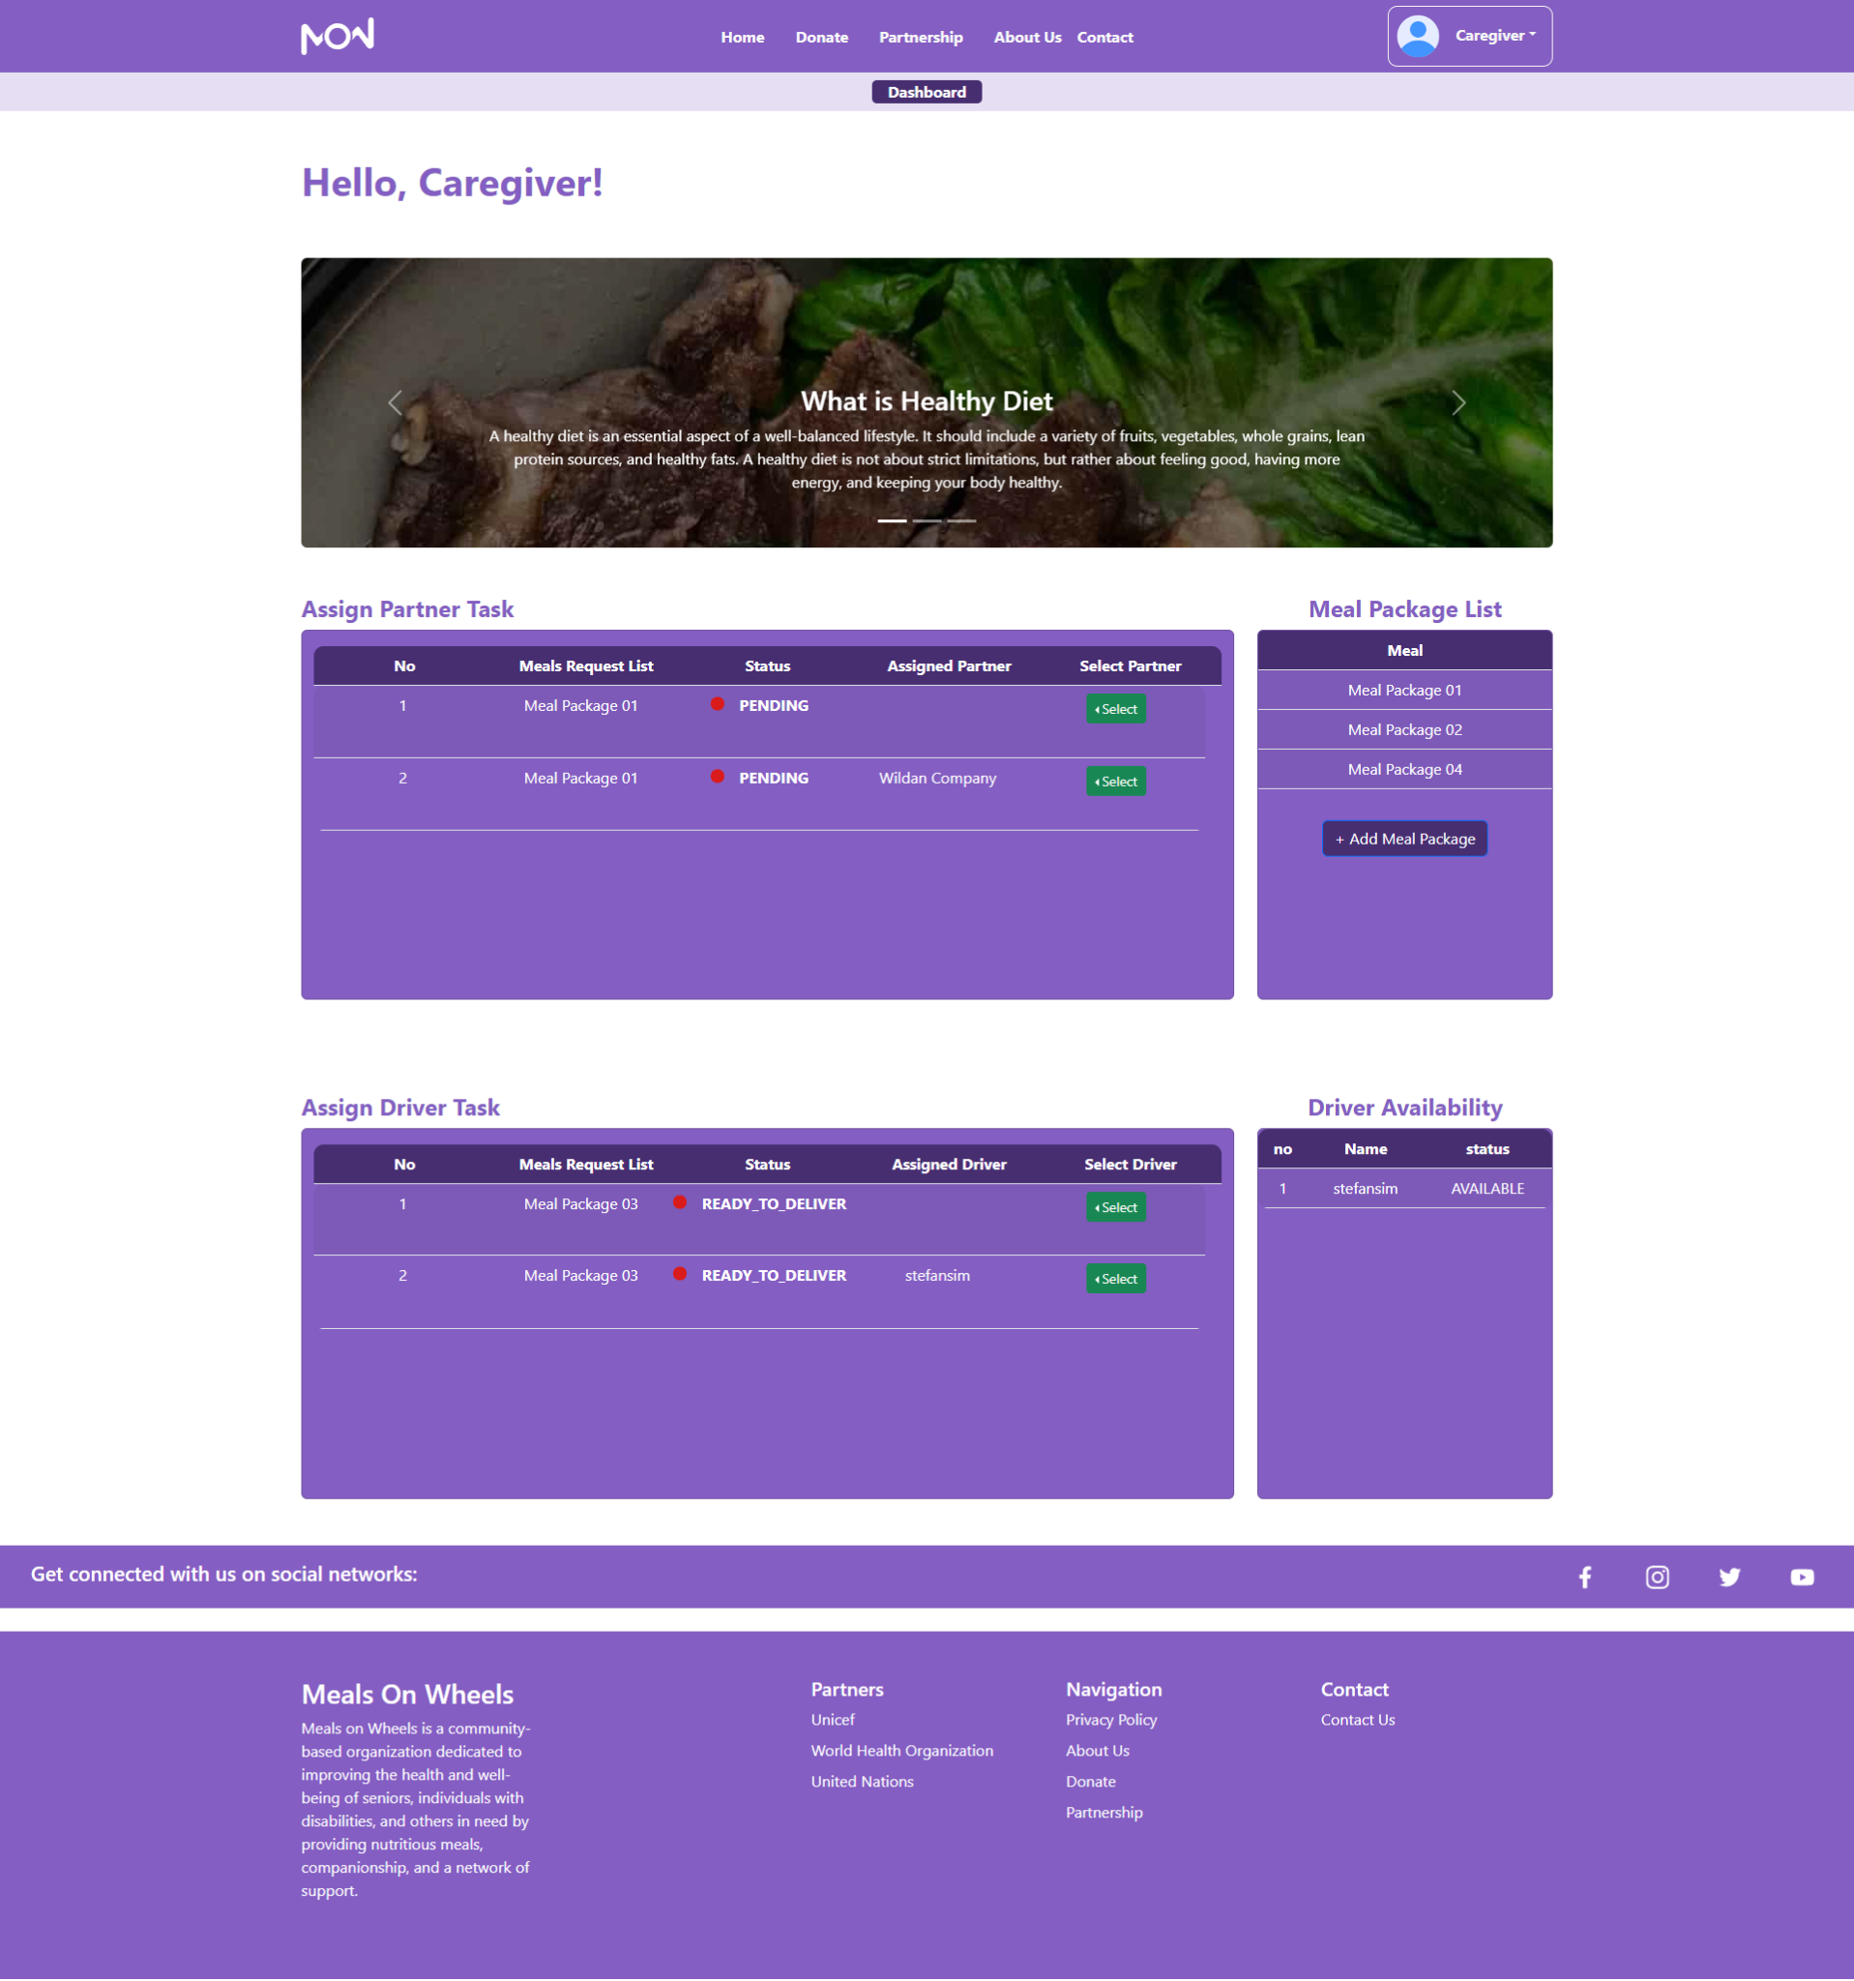**

**Admin Home Page  
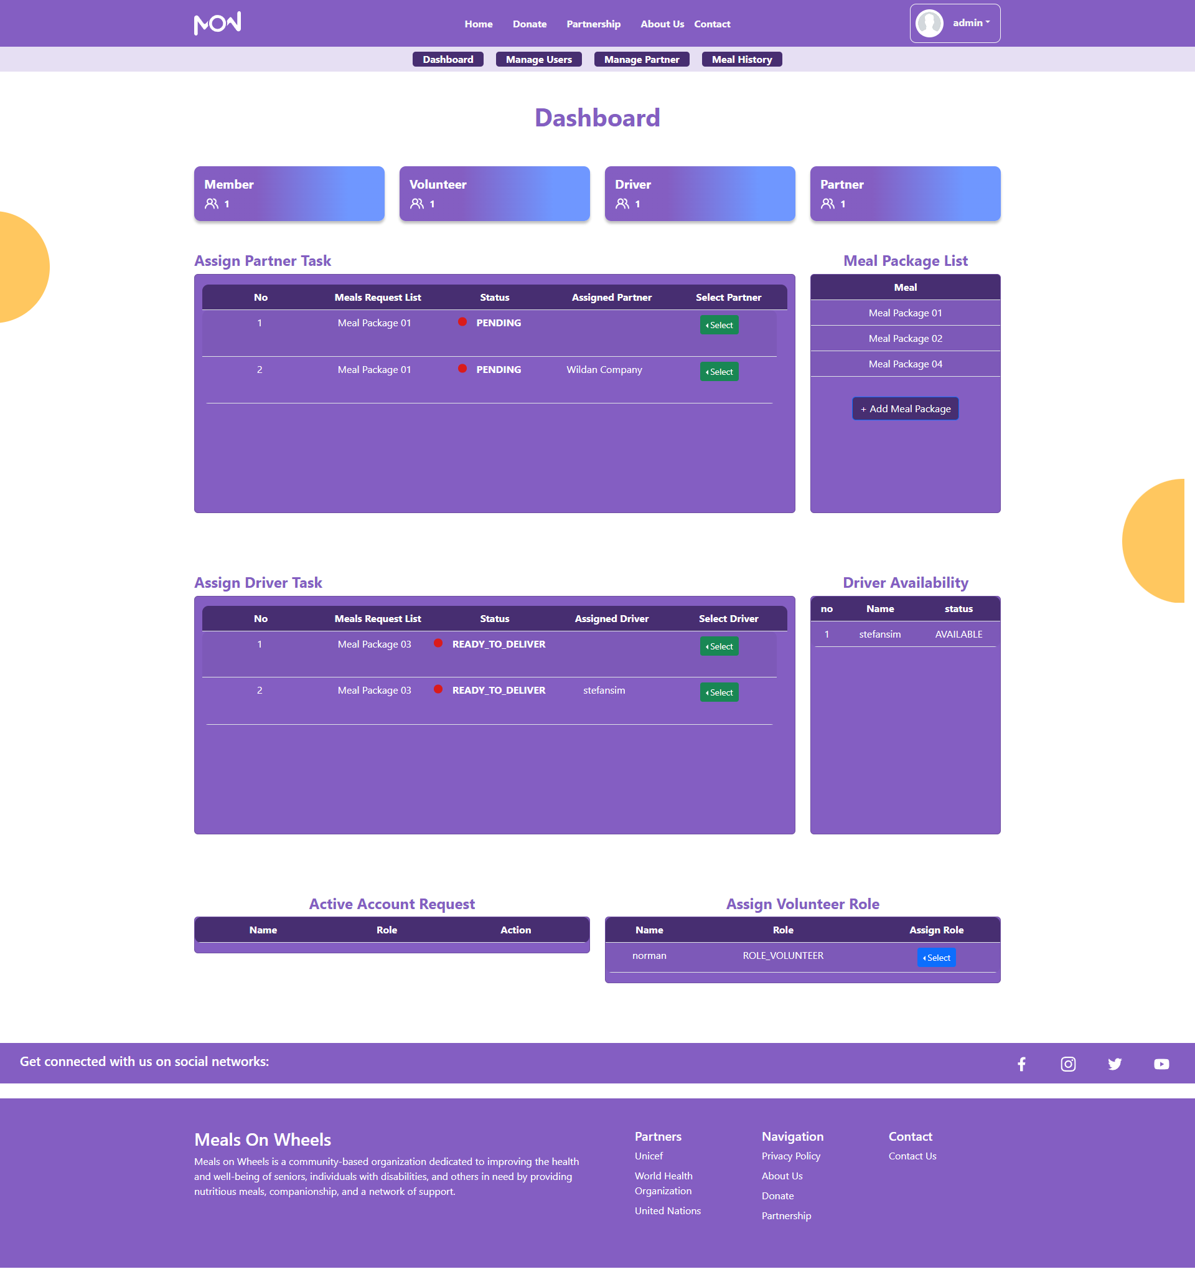**

**Admin Manage Users Page  
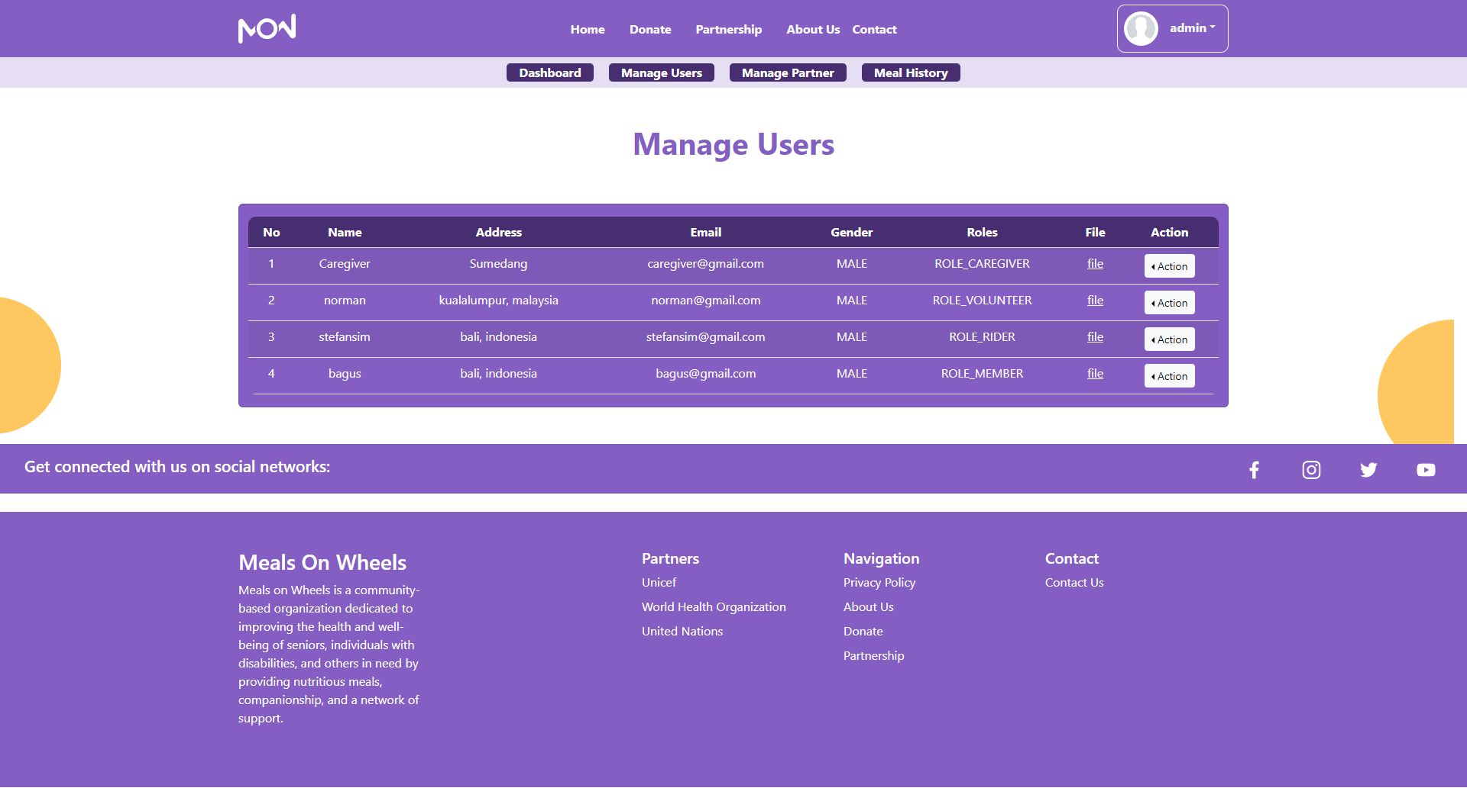**

**Admin Manage Partner Page  
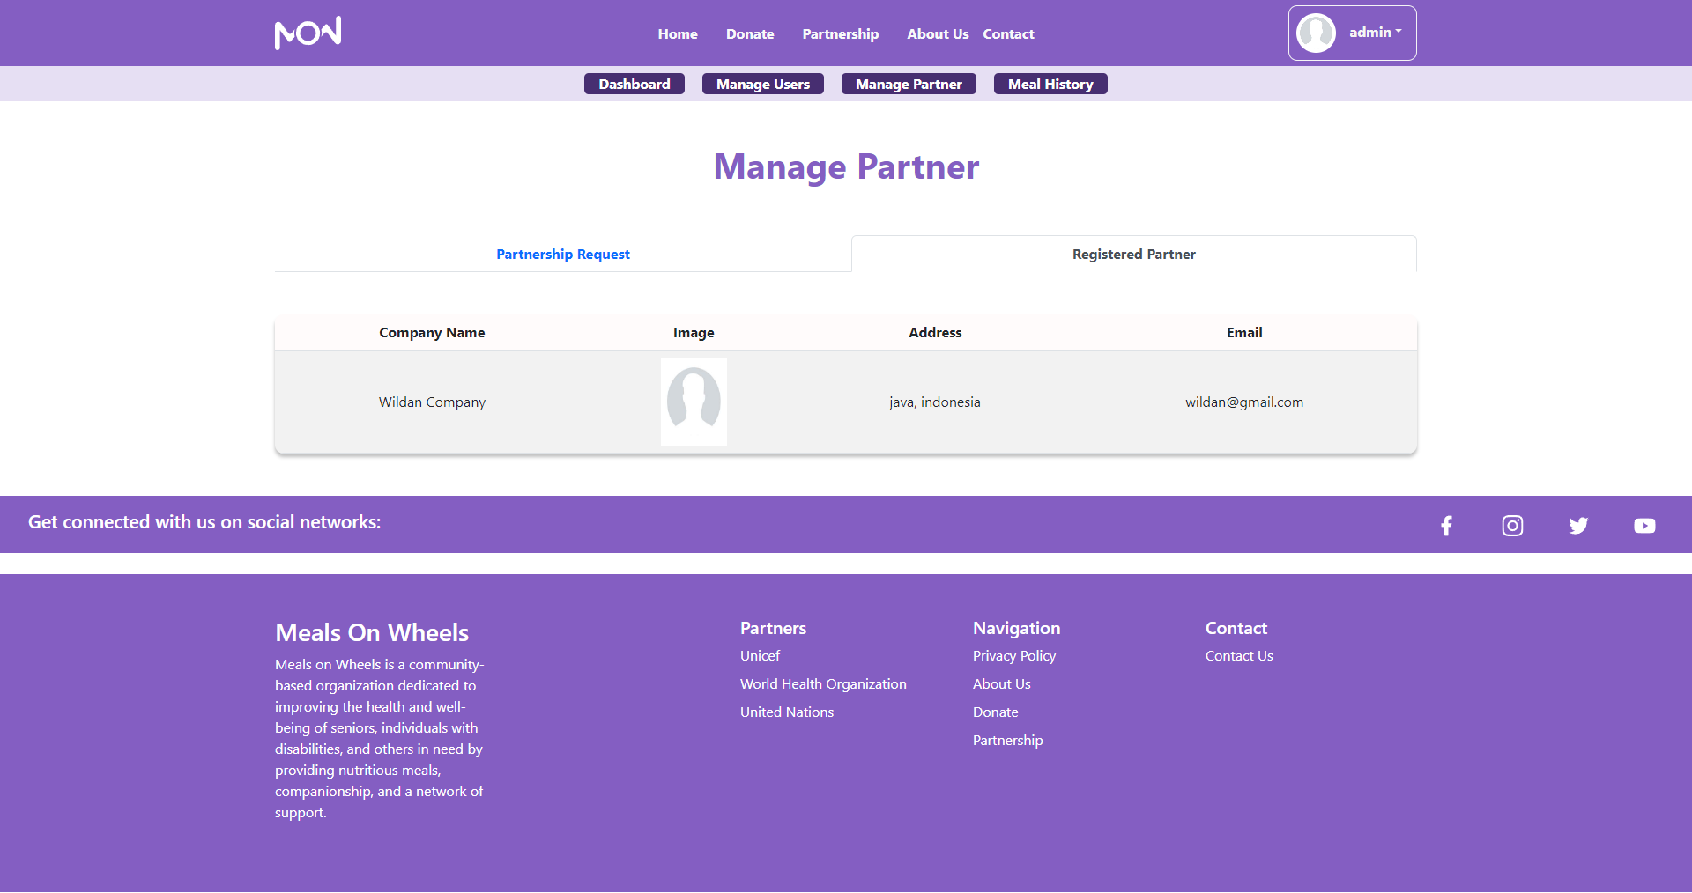**

**Admin Meal History Page  
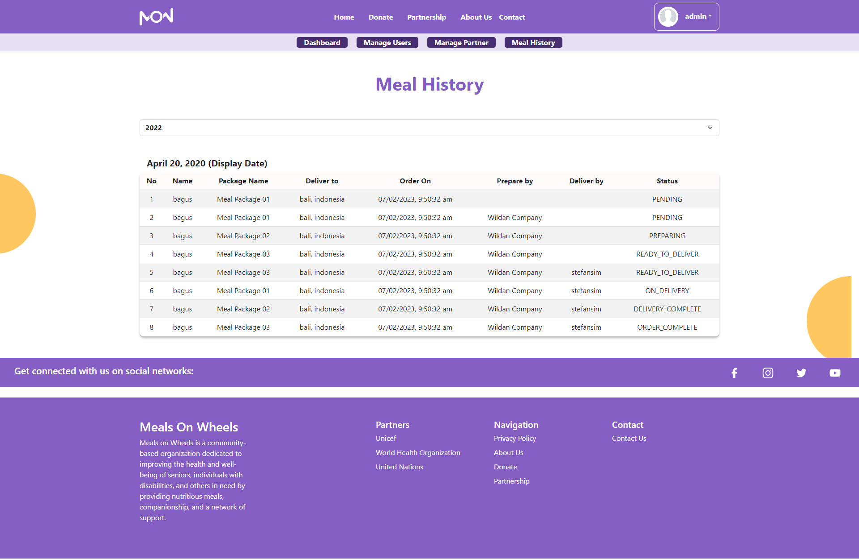**

# 

# 

# Module Testing

|  |  |  |
| --- | --- | --- |
| **Test Scenario ID** | **Test Scenario** | **Number of test cases** |
| TS001-Integration Testing | Ensure account authorization with JWT Token | 1 |
| TS002-UAT testing | 1. Ensure user navigation is easy | 3 |
| TS003-UAT testing | 1. Ensure caregiver can add meals easily | 1 |
| TS004-UAT testing | Ensure SQLI is prevented | 3 |
| TS005-Cross Browser testing | Ensure application works across multiple major browsers | 6 |

**Scenario 1: Integration Testing**

|  |  |
| --- | --- |
| **Test Scenario** | Ensure account authorization with JWT Token |
| **TS001** |
| **Test Cases** | Integration Testing |
| **IT001** | Check if the user can access the website if there is no bearer token. |

#### 

|  |  |  |  |  |  |  |
| --- | --- | --- | --- | --- | --- | --- |
| Test Scenario ID | Test Case | Risk | Preconditions | Expected Result | Actual Result | Final Result |
| TS001 | IT001 | 5 | * Open Postman API * Register to get Bearer token | The user without their bearer token authorization will not be able to access the website. | As expected | Pass |

**Test Data Table**

|  |  |  |
| --- | --- | --- |
| **Test Scenario** | **Test Case** | **Test Data** |
| TS001 | IT001 |  |

**Test Evidence**

|  |  |  |
| --- | --- | --- |
| **Test Scenario** | **Test Case** | **Screen Capture** |
| TS001 | IT001 |  |

**Scenario 2: User Acceptance Testing**

|  |  |
| --- | --- |
| **Test Scenario** | 1. Ensure user navigation is easy |
| **TS002** |
| **Test Cases** | UAT Test |
| **UAT001** | Check to see if member can navigate easily |
| **UAT002** | Check to see if caregiver can navigate easily |
| **UAT003** | Check to see if rider can navigate easily |

#### 

|  |  |  |  |  |  |  |
| --- | --- | --- | --- | --- | --- | --- |
| Test Scenario ID | Test Case | Risk | Preconditions | Expected Result | Actual Result | Final Result |
| TS002 | UAT001 | 3 | * Logged in as Member / Caregiver / Rider | Members can easily see meal card packages after they log in, and order meals if they choose based on the card, & they can send feedback on the meal. | As expected | Pass |
| UAT002 | 3 | Caregivers can see their dashboard, and add meals easily on the dashboard page also, and assign drivers & assign partners also. | As expected | Pass |
| UAT003 | 3 | Drivers can see any delivery request on their dashboard. | As expected | Pass |

**Test Data Table**

|  |  |  |
| --- | --- | --- |
| **Test Scenario** | **Test Case** | **Test Step** |
| TS002 | UAT001 | * Navigate to view meals page * Navigate to feedback page |
| UAT002 | * Navigate to dashboard * Add meal page button * Table Assign driver & assign partner |
| UAT003 | * Navigate dashboard * View delivery request |

**Test Evidence**

|  |  |  |
| --- | --- | --- |
| **Test Scenario** | **Test Case** | **Screen Capture** |
| TS002 | UAT001 |  |
| UAT002 |  |
| UAT003 |  |

**Scenario 3: User Acceptance Testing**

|  |  |
| --- | --- |
| **Test Scenario** | Ensure caregiver can add meals easily |
| **TS003** |
| **Test Cases** | UAT Test |
| **UAT001** | Check to see if the caregiver is able to add a meal package easily. |

#### 

|  |  |  |  |  |  |  |
| --- | --- | --- | --- | --- | --- | --- |
| Test Scenario ID | Test Case | Risk | Preconditions | Expected Result | Actual Result | Final Result |
| TS003 | UAT001 | 3 | Logged in as Caregiver | Caregivers can easily add a meal package by accessing a Popup card to add that package. | As expected | Pass |

**Test Data Table**

|  |  |  |
| --- | --- | --- |
| **Test Scenario** | **Test Case** | **Test Step** |
| TS003 | UAT001 | Go to dashboard and Click on Add Meal Button at Meal Package Card |

**Test Evidence**

|  |  |  |
| --- | --- | --- |
| **Test Scenario** | **Test Case** | **Screen Capture** |
| TS001 | IT001 |  |

**Scenario 4: User Acceptance Testing**

|  |  |
| --- | --- |
| **Test Scenario** | Ensure Login Validation |
| **TS004** |
| **Test Cases** | UAT Test |
| **UAT001** | Check to see if the login validation able to function properly |

#### 

|  |  |  |  |  |  |  |
| --- | --- | --- | --- | --- | --- | --- |
| Test Scenario ID | Test Case | Risk | Preconditions | Expected Result | Actual Result | Final Result |
| TS004 | UAT001 | 5 | Type in URL  Click on login  Enter fields with test data  Click submit | Login fail if the account is not activated yet & popup message will appear | As expected | Pass |
| UAT002 | 5 | Login fail if the input password or email is wrong & popup message will appear | As expected | Pass |
| UAT003 | 5 | Suggestion message appear if the user missing @ on email input | As expected | Pass |

**Test Data Table**

|  |  |  |
| --- | --- | --- |
| **Test Scenario** | **Test Case** | **Test Data** |
| TS004 | UAT001 | Email=”[registered@email.com](mailto:registered@email.com)”  password=”qwerty” |
| TS004 | UAT002 | Email=”[registered@email.com](mailto:registered@email.com)”  password=”wrong password input” |
| TS004 | UAT003 | Email= “tes”  password= “qwerty” |

**Test Evidence**

|  |  |  |
| --- | --- | --- |
| **Test Scenario** | **Test Case** | **Screen Capture** |
| TS004 | UAT001 |  |
| UAT002 |  |
| UAT003 |  |

**Scenario 5: Cross Browser Testing**

|  |  |
| --- | --- |
| **Test Scenario** | Ensure application works across multiple major browsers |
| **TS005** |
| **Test Cases** | Cross Browser Test |
| **CBT001** | Check to see if register works on Firefox |
| **CBT002** | Check to see if register works on Internet Explorer |
| **CBT003** | Check to see if register works on Google Chrome |
| **CBT004** | Check to see if login works on Firefox |
| **CBT005** | Check to see if login works on Internet Explorer |
| **CBT006** | Check to see if login works on Google Chrome |

#### 

|  |  |  |  |  |  |  |
| --- | --- | --- | --- | --- | --- | --- |
| Test Scenario ID | Test Case | Risk | Preconditions | Expected Result | Actual Result | Final Result |
| TS005 | CBT001 | 3 | Downloaded required browser | Register save data to database and redirect user to login page | As expected | Pass |
| CBT002 | 3 | Register save data to database and redirect user to login page | As expected | Pass |
| CBT003 | 3 | Register save data to database and redirect user to login page | As expected | Pass |
| CBT004 | 3 | Downloaded required browser | Login validate with database and redirect user to home page | As expected | Pass |
| CBT005 | 3 | Login validate with database and redirect user to home page | As expected | Pass |
| CBT006 | 3 | Login validate with database and redirect user to home page | As expected | Pass |

**Test Evidence**

|  |  |  |
| --- | --- | --- |
| **Test Scenario** | **Test Case** | **Screen Capture** |
| TS005 | CBT001 | In database: |
| CBT002 | In database: |
| CBT003 | In database: |
| CBT004 |  |
| CBT005 |  |
| CBT006 |  |

# **Result Analysis**

1. Information extraction: The developed application is able to extract relevant information needed such as email, address, gender, qualification files, and images. All this information meets the project objective in which the Merry Meal will need information about adults who are really in need of help and qualified to get the free meals. Address and email is required to know the location since MerryMeal work will mostly involve real life interactions.
2. Receive donation: Our group implements third-party payment using Stripe API to receive donation easily. This easily accessible donation will help anyone who wants to donate but is unable to donate it directly in real life. Also this method will improve Merry Meal funds.
3. Menu Planning: Our group creates a meal package which contains a 5 course meal (main course, dessert, drink, salad, soup). This package can be posted by a MerryMeal Organization partner. Then the member will be able to see & order that package. The caregiver will see the order requested and will work to inform the partner to prepare the meal, after preparation is complete, the caregiver will assign a driver to deliver it to the member (qualified adults).

# **Conclusion**

In conclusion, our developed application website is able to meet the general requirements of Merry Meal Organization’s objective. But there are several area that need improvements such as:

1. One who registered as a volunteer needs a set duration on how long they are going to volunteer (2 weeks or 1 month), since they are not full-time workers like caregivers or drivers.
2. Each user role on the website can’t edit their registered data, as a result they are unable to have a profile page and change the data on the website.
3. Need more polishing on the front-end design.

# **Application Future Recommendations**

As our team develops the website application, we discover several things that can be recommended for future development or updates.

1. Add Food Safety Management System
2. Add Order Notification for Caregiver, Partner, & Admin.
3. Add chat functionality for the member to chat with the caregiver or admin directly & instantly.

# **Bibliography**

Kholghi, B. (2022). The MOST analysis - easy explained with examples. *Retrieved from*<https://www.investopedia.com/terms/s/swot.asp> last access: January 20, 2023

Francisco, E. B. (2022). Risk analysis: a comprehensive guide. *Retrieved from* [*https://safetyculture.com/topics/risk-analysis/*](https://safetyculture.com/topics/risk-analysis/)Accessed January 23, 2023.

CTC (2022). Section 14. SWOT analysis: strenghts, weaknesses, opportunities, and threats. *Retrieved from* [*https://ctb.ku.edu/en/table-of-contents/assessment/assessing-community-needs-and-resources/swot-analysis/main*](https://ctb.ku.edu/en/table-of-contents/assessment/assessing-community-needs-and-resources/swot-analysis/main)Accessed January 20, 2023.

Cook, A. (2022). What is a MOST analysis? How to perform one. *Retrieved from* [*https://www.creative-asset.co.uk/insights/what-is-a-most-analysis*](https://www.creative-asset.co.uk/insights/what-is-a-most-analysis)Accessed January 20, 2023.

CIO. (2023). VMOST analysis. *Retrieved from* [*https://cio-wiki.org/wiki/VMOST_Analysis*](https://cio-wiki.org/wiki/VMOST_Analysis)Accessed January 20, 2023.

CIPD. (2021). PESTLE analysis: discover what PESTLE means. *Retrieved from* [*https://www.cipd.co.uk/knowledge/strategy/organisational-development/pestle-analysis-factsheet#gref*](https://www.cipd.co.uk/knowledge/strategy/organisational-development/pestle-analysis-factsheet#gref) Accessed January 21, 2023.

Martins, J. (2022). How to use a feasibility study in project management. *Retrieved from* [*https://asana.com/resources/feasibility-study*](https://asana.com/resources/feasibility-study)Accessed January 23, 2023.

JavatPoint. (2022). Advantages and disadvantages of SWOT analysis. *Retrieved from* [*https://www.javatpoint.com/advantages-and-disadvantages-of-swot-analysis*](https://www.javatpoint.com/advantages-and-disadvantages-of-swot-analysis) Accessed January 20, 2023.

Hikmawan, D. (2019). Feasibility study. *Retrieved from* [*https://www.slideshare.net/DhafaHikmawan/feasibility-study-138349826*](https://www.slideshare.net/DhafaHikmawan/feasibility-study-138349826) Accessed January 23, 2023.

Garrett’s. J. J. (2002). *The Elements of User Experience: User-Centered Design for the Web and Beyond (2nd Edition).*

Espy. L. (2018). How to create a project assumptions. *Retrieved from:* [*https://projectbliss.net/project-assumptions-list/*](https://projectbliss.net/project-assumptions-list/)last access Feb04, 2023

“Agile Model (Software Engineering) - javatpoint.” *Javatpoint*,<https://www.javatpoint.com/software-engineering-agile-model>. Accessed 25 January 2023.

“AngularJS: Developer Guide: Introduction.” *AngularJS: API*, [https://docs.angularjs.org/guide/introduction#](https://docs.angularjs.org/guide/introduction) . Accessed 25 January 2023.

Castro, Santiago. “5 Reasons Why MySQL Is Still The Go-To Database Management System.” *Jobsity*,<https://www.jobsity.com/blog/5-reasons-why-mysql-is-still-the-go-to-database-management-system> . Accessed 25 January 2023.

“Difference between Spring and Spring Boot.” *GeeksforGeeks*, 22 December 2022,<https://www.geeksforgeeks.org/difference-between-spring-and-spring-boot/> . Accessed 25 January 2023.

“Documentation for Visual Studio Code.” *Visual Studio Code*,<https://code.visualstudio.com/docs> . Accessed 25 January 2023.

Galik, Olga. “When and Why You Should Use React.” *Uptech*,<https://www.uptech.team/blog/why-use-react> . Accessed 25 January 2023.

“A Guide to Spring in Eclipse STS.” *Baeldung*, 16 April 2022,<https://www.baeldung.com/eclipse-sts-spring> . Accessed 25 January 2023.

“A Guide to Spring in Eclipse STS.” *Baeldung*, 16 April 2022,<https://www.baeldung.com/eclipse-sts-spring> . Accessed 25 January 2023.

“IntelliJ IDEA vs Eclipse: Which Is Better for Beginners.” *Tabnine*, 18 March 2019,<https://www.tabnine.com/blog/intellij-idea-vs-eclipse/> . Accessed 25 January 2023.

“Introduction.” *Vue.js*, https://vuejs.org/guide/introduction.html#the-progressive-framework. Accessed 25 January 2023.

Joshi, Mohit. “Angular vs React vs Vue: Core Differences.” *BrowserStack*, 23 December 2022,<https://www.browserstack.com/guide/angular-vs-react-vs-vue> . Accessed 25 January 2023.

“Memahami System Development Life Cycle – Accounting.” *Accounting*, 19 May 2020,<https://accounting.binus.ac.id/2020/05/19/memahami-system-development-life-cycle/> . Accessed 25 January 2023.

Patadiya, Jaydeep. “Angular vs React | Angular vs Vue | React vs Vue - Know the Difference.” *Radixweb*, 12 September 2022,<https://radixweb.com/blog/angular-vs-react-vs-vue> . Accessed 25 January 2023.

Pedamkar, Priya. “What is SDLC | Different Phases and Models of SDLC.” *eduCBA*,<https://www.educba.com/what-is-sdlc/> . Accessed 25 January 2023.

Raval, Nihar. “React vs Angular: Which One is Best for Your Next Front-end Project?” *Radixweb*, 18 October 2022,<https://radixweb.com/blog/react-vs-angular> . Accessed 25 January 2023.

“SDLC Models: Agile, Waterfall, V-Shaped, Iterative, Spiral.” *Existek*, 4 August 2017,<https://existek.com/blog/sdlc-models/#types> . Accessed 25 January 2023.

“SDLC Models - javatpoint.” *Javatpoint*,<https://www.javatpoint.com/software-engineering-sdlc-models> . Accessed 25 January 2023.

“What Developers Say About Us.” *JetBrains*,<https://www.jetbrains.com/company/customers/testimonials.html#product=idea> . Accessed 25 January 2023.

“What is Java Spring Boot?” *IBM*,<https://www.ibm.com/topics/java-spring-boot> . Accessed 25 January 2023.

“What is Java Spring Boot?” *IBM*,<https://www.ibm.com/topics/java-spring-boot> . Accessed 25 January 2023.

“What Is MySQL?” *Oracle*,<https://www.oracle.com/mysql/what-is-mysql/> . Accessed 25 January 2023.